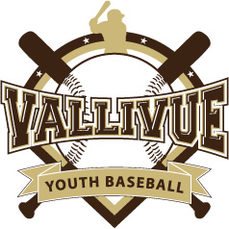

VALLIVUE YOUTH BASEBALL - A BABE RUTH / CAL RIPKEN LEAGUE
Vallivue Youth Baseball (VYB)
P.O. Box 9253
Nampa, ID 83652

www.vallivueyouthbaseball.com

Federal Tax ID#: 820419748

Dear Prospective VYB Sponsor:

Vallivue Youth Baseball (VYB) is a chartered, Cal Ripken/Babe Ruth Baseball organization that provides an exciting baseball experience for players 4 to 15 years of age. Our objective is to teach the fundamentals of baseball in a fun and enriching environment, while at the same time, enabling our players to develop physical fitness, self-confidence, discipline, and good sportsmanship that will benefit them throughout their lives. Throughout the years, we have taught thousands of children the importance of cooperation, team spirit and leadership in their community.

VYB provides this fundamental service to the children of our district at an affordable rate, but with all non-profit organizations, it takes a lot to maintain our league. Therefore, to continue to provide a fun and encouraging environment for our youth, VYB requires a tremendous amount of support from our community. As a team sponsor your donation will help in the maintenance of the fields, purchasing of new equipment and uniforms, expenses for umpires, and even assist in sponsoring a child who could not afford to play otherwise.

As a non-profit 501 (c) (3) organization, our ability to make this program work is dependent on contributions from generous sponsors like yours. VYB would not have been able to provide this opportunity in the past for the community’s youth to play baseball without the support of business like yours.

The Vallivue Youth Baseball Association thanks you in advance for your support and consideration. We look forward to having you as part of our team.
We accept any and all donations.
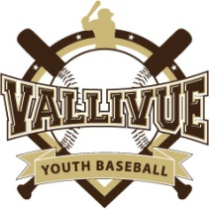
VALLIVUE YOUTH BASEBALL ASSOCIATION SPONSORSHIP FORM
Sponsor Name: Phone:

Sponsor Address:

Sponsor City, State, Zip:

Contact Person: Phone:

Level of Sponsoring: (Please Check the Box)

Tee Ball Sponsor - $150 (4-5 Year Old Division)
- Your company name imprinted on the back of a T-Ball team’s uniforms.
- Tax-Free Donation Letter

Coach Pitch Sponsor - $200 (6-7 Year Old Division)
- Your company name imprinted on the back of a Coach Pitch team’s uniforms.
- Tax-Free Donation Letter

Minors Sponsor - $250 (8-10 Year Old Division)
- Your company name imprinted on the back of a Minor League team’s uniforms.
- Your company logo with a link on VYB website
- Tax-Free Donation Letter
- Team Plaque at the end of the season

Majors 60’ Sponsor - $300 (11-12 Year Old Division)
- Your company name imprinted on the back of a Major League team’s uniforms.
- Your company logo with a link on VYB website
- Tax-Free Donation Letter
- Team Plaque at the end of the season

AAA 70’ Sponsor - $350 (11-12 Year Old Division)
- Your company name imprinted on the back of a AAA League team’s uniforms.
- Your company logo with a link on VYB website
- Tax-Free Donation Letter
- Team Plaque at the end of the season

Prep/Babe Ruth Sponsor - $400 (13-15 Year Old Division)
- Your company name imprinted on the back of a Prep/BR team’s uniforms.
- Your company logo with a link on VYB website
- Tax-Free Donation Letter
- Team Plaque at the end of the season

