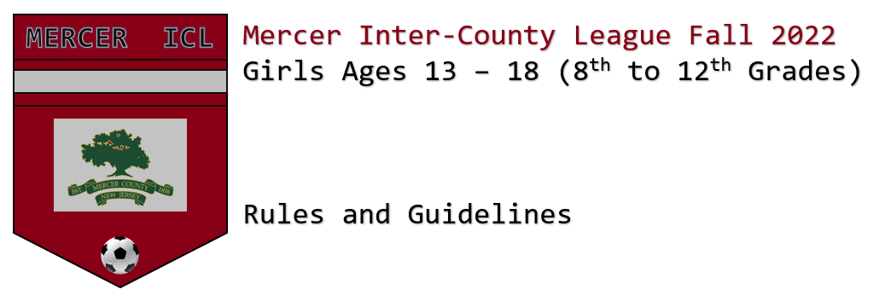

QUICK GUIDELINES:
We are planning to run this league in the format of 1 table – no playoffs, everyone plays each other at least 2 times. Number of games will be determined by the number of teams in the league. Whomever is at the top of the table after the league games wins the league.
Games start on Sunday September 12. Points are: 3 points for a win and 1 for a tie and 0 for a loss. If a team does not show or does not have enough players to play game will count as a 30 forfeit.
Game days will be on Sunday afternoons, with some games on WEDNESDAYS, Thursday and Friday evenings if necessary.
Game format is 11v11. All league games will consist of (2) 35-minute halves. There will be a
5-minute break between the halves.
Teams may substitute any number of players, when play is stopped for either team’s throw-ins, goals, goal kicks injuries and/or misconduct.
Coaches are expected to monitor and manage the game, so the score does not exceed a 6-goal differential.
A team will forfeit the game after a 10-minute grace period if they have fewer than 8 players on the field. In the event of a forfeit, teams will play a scrimmage after balancing the squads. If a club has more than one team competing in the league, the only instance where a player can play on another team within the same club is if the secondary team has already forfeited the match due to low numbers. There is no 'borrowing' of players of any kind without the game resulting in a forfeit. If a team 'borrows' a player that is not on their roster that team shall forfeit the game.

Just like the EPL, if teams are level on points, tie-breakers are applied in the following order:
- Goal difference for the entire season.
- Total goals scored for the entire season.
- Head-to-head results (total points)
- Head-to-head goals scored.
- if teams still tied, then they are then co-champions!

Games kick off Sunday September 11, 2022

DETAILED GUIDELINES:
The following guidelines are in place to maintain a safe and positive environment for the players participating in the Mercer Inter-County League. Everyone is encouraged to support the players, referees and coaches in the effort while enjoying the game.

League games are played and officiated according to the Laws of the Game published by FIFA and as recommended by US Youth Soccer, with the below modifications.

Standings
Standings are kept in all league games.

The league will look to schedule games so that each team plays each other at least twice. There are NO PLAYOFFS. Whomever is at the top of the table after all “league games” wins the league.
Points are awarded as follows:
Win – 3 points
Tie – 1 point
Loss – 0 point
Forfeit – 0 points

Forfeits: A team will forfeit the game after a 10-minute grace period if they have fewer than 8 players on the field. In the event of a forfeit, teams will play a scrimmage after balancing the squads. If a club has more than one team competing in the league, the only instance where a player can play on another team within the same club is if the secondary team has already forfeited the match due to low numbers. There is no 'borrowing' of players of any kind without the game resulting in a forfeit. If a team 'borrows' a player that is not on their roster that team shall forfeit the game. A forfeit will count as a 3-0 score in the standings.

Mercy rule: Coaches are expected to monitor and manage the games, so the score does not exceed a 6-goal differential. The ICL League is focused on player development, and as such, coaches have a responsibility to manage the game and not “run up scores”. In the event a team has reached a 5-goal lead, the referee will whistle for a 2-minute timeout to allow the coaches of both teams to reassign, reorganize and balance the game in the interest of not reaching a 6-goal lead.

Number of Players when a Team is Short Players:
Teams no longer must play with an equal number of players on the field. If a team does not have 11 players, their opponent is not mandated to play with the lower amount, but with the full 11 if present: NO REDUCE TO EQUATE, NO EXCEPTIONS. A team must have a minimum of 8 players present in order to avoid a forfeit but will be allowed to compete with 7 only if that number is created by loss of a player to injury or red card.

League Games & Officiating
The ICL league will be made up of full-sided 11v11 games on Sundays and if needed, select weekday nights.

All Sunday and weeknight full-sided games will count toward standings and utilize a 3-man referee system. If possible, there will be friendly matches scheduled during the course of the season which do not count toward standings. These matches will be indicated as “scrimmage” or “friendly” on the league schedule. It is the host club’s duty to schedule the referees and all referee fees will be paid by the club hosting the game(s).

Player eligibility
Players must currently be of middle school (8th grade) or high school age to participate in the league.

Standards of Play and Game duration
League games that count toward standings are full-sided (11v11). Teams that might be short on players on game day may compete with 8 players. Teams no longer must play with an equal number of players on the field. If a team does not have 11 players, their opponent is not mandated to play with the lower amount, but with the full 11 if present: NO REDUCE TO EQUATE, NO EXCEPTIONS. A team must have a minimum of 8 players present in order to avoid a forfeit but will be allowed to compete with 7 only if that number is created by loss of a player to injury or red card.

- All league games will consist of (2) 35-minute halves. There will be a 5-minute break between the halves. If weather conditions are such that both teams agree to play quarters (excessive heat), both coaches must consult with the referee, who has the authority to make this adjustment. In such instances, teams will play (4) 20-minute quarters with 2-minute breaks between the quarters and a 4-minute break at halftime.

- Offsides and FIFA rules regarding a player passing the ball back to their own goalkeeper will be enforced.

- All league games will use a size 5 soccer ball

- All players must wear shin guards.

- Players are not permitted to wear regular glasses on the field. Only approved sport glasses may be worn on the field of play. New Jersey state law requires players to wear approved sports glasses, if they must wear glasses as part of the activity. For more information please see: https://eyecare.org/site/new-jersey-law-on-
protective-eyewear-for-athletes/ and https://www.njleg.state.nj.us/2004/Bills/PL05/306_.pdf

- Teams may substitute any number of players, when play is stopped for: either team’s throw-ins, goals, goal kicks, injuries, and/or misconduct. Subbing is mandatory by a team if one of its players receives a yellow card. The player issued a yellow card must be subbed out for 10 minutes. All players entering the field during a substitution must line up at the center line and wait for the referee to signal them onto the field.

- All players should play a fair amount of the game, unless they receive an infraction from the referee requiring them to leave the field. It is highly encouraged that all coaches participating in the league allow each of their players to play at least half of the game. Managing a player’s playing time in the interest of winning a game, and not developing the player, is highly discouraged.

- Soccer cleats are recommended for all players, but not required. Shoes may not have metal spikes.

- No watches, barrettes, or jewelry of any kind may be worn by the players, including necklaces, hard or soft bracelets, earrings & posts. Hard casts must be padded and approved by the referee. Hair may be tied up with soft bands. In order to foster a safe atmosphere for the players, the following rules apply to the run of play for all league games.

- Sliding is allowed, but there is to be no slide tackling of another player on the field. Slide tackling a player will result in an automatic yellow card, and removal from the game.

- The referee will stop the game for any on-field injuries and waive the coach onto the field if needed. If a coach enters the field to attend an injured player, the injured player must leave the field of play and a substitute allowed to enter.

- Coaches for all teams must have a first aid kit, ice and emergency contact information for the players on their team at every game.

Player Infractions

1. Yellow Cards
Players issued a yellow card for physical or verbal behavior in a game are required to immediately leave the field of play and prohibited from playing for (10) minutes.

2. Red Cards
Players issued a red card for physical or verbal behavior in a game are required to leave the field of play and may not return to the game. Players receiving a red card are required to miss the next game of league play for their team. Any player who receives two red cards during the course of the season is suspended from all remaining league games immediately following the second offense. Said player may be allowed to participate in games against teams from the same club only, if their club allows for such exception.

Rainouts
With respect to possible rainouts, clubs who are hosting games on their fields will make the call as to whether their fields will be closed during inclement weather.
Once a determination is made that fields will be open or closed, the hosting club's point of contact for the league (designated with an * on the contact sheet) is the contact who will both share and receive this information on behalf of their club and forward it along to their respective coaches.

Any games cancelled due to inclement weather will be rescheduled during the rainout weekend at the end of the season, or on a mutually agreed date between the teams at least one week prior to the finals. If a game is deemed unplayable or stopped by the referee due to inclement weather, the score as of the time of stoppage will be recorded as the final score only if the first half has been completed. If a game has been started but the first half is not completed, the match will be rescheduled.

Tie-breakers

Just like the EPL, if teams are level on points, tie-breakers are applied in the following order:
- Goal difference for the entire season.
- Total goals scored for the entire season.
- Head-to-head results (total points)
- Head-to-head goals scored.
- if teams still tied, they are then co-champions!

