Shirley Youth Baseball and Softball – SYBS
2019 Board Members
Bill Manchester – President
Kevin Heinz – Player Development
Lisa Felix – Softball Coordinator
Mike McSweeney – MAC League Coordinator
Amy Lombardo – Concessions Coordinator
Bill Woodward – Field Maintenance Coordinator
Deb Merriam – Treasurer and Sponsorship Coordinator
Kellie Shakarian – Uniform Coordinator
Donny Consalvo – Umpire Coordinator
Erica Crawford – Player & Coach Safety Coordinator
Steve Crawford – Equipment Coordinator

Improvements / Upgrades
New Softball Field Dugouts / New Benches for Dugouts
New Bleachers
Irrigation which was installed 20 years ago at MS Field 1 – is UP and Running
Added 90 foot bases to MS Field 2
New HotDog machine and Fryer in Concession Stand
Thank Triumph – Another Connex Box & Mitrano Removal – Dumpster
Thank Our Sponsors – [Take Pictures]
Contact a Board Member if you are interested in becoming a SPONSOR
ANNOUNCE TEAMS & PLAYERS
American Legion – Shirley Post 183
[Last Year Jerry Wheeler / John Cardillo / Doris Wheeler] --- Holly Haas ?? – National Anthem
Baseball Prayer – 1st Pitch --- PLAY BALL

Coaches & Teams
TBALL – is Ages 4/5/6
Team Bull Run – Coached by Bill McTurk / Mikko Salokangas / Kenny Buddington
Team Piccolinos – Coached By Dennis and Cassandra Jones
Team ALL-Star Sports – Coached by Stephanie Hemenway / Daniel LaCruz
Team Mitrano Removal – Coached by Jason Thomas / Brad Price
Rookies – Coach Pitch Level – Mostly 7 & 8 year olds
Team Fidelity Bank - Coached by Kellie Shakarian
Team Majestic Painting Coached by Brad Price
Minors – Mostly 9 & 10 Year Olds
Team 1 Coached by Terry Tesak / Art Torres / Todd Carpentier
Team 2 Coached by Kevin Heinz / Angie Brideau / Tom Knox
Majors 60s – Mostly 11 & 12 Year Olds
Coached By Bill Manchester / Dan Meehan / Ty Meehan / Deb Merriam
Majors 70s – Mostly 12 Year Olds [We have some players from Ayer this Year
Coached by Tom Lagrutta / Mike McSweeney / Ken Lewis

We have Several Girls playing Softball at the 10U & 12U level in Ayer this Spring

16 U Softball – Coached by Tom Gamble / Lisa Felix /

Babe Ruth Baseball – Players from Both Shirley and Ayer – Ages 13-15
Team 1 – Coached by George Logan and Kevin Heinz
Team 2 – Coached by Greg Pepin and Bill Manchester

Senior Babe Ruth Team – Made Up of Players from Shirley and Ayer – Ages – 15-18
[They Start Season in June]
Coached by Donny Consalvo / David Woodland / Eric Johnson
Rest of Teams on Website

16U
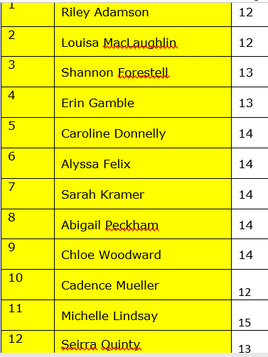
Softball to Ayer
Jamie Driscoll | 10
Paige heffernan | 12
Lindsey Iannacone | 10
Carolyn Mason | 11
Lily Trotter | 11
Jada Whitney | 12

