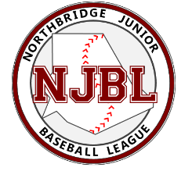

Lights Donation Form

Friends of Northbridge Baseball!

We are so close to being able to light our fields and our kids Night Games Dreams. Through donations from various organizations and private companies; We are as close as ever to having the poles up. Please let us know if you would be interested in helping our league to the final stage of having Night Games!!!!

Donation Options:
Full Donation: Cost $1000.00 / Light
This provides the league ONE LIGHT- In return your business/company name will be engraved on a plaque which will be hung at the complex. As an additional thank you, your company logo and a link to your company’s website will appear on www.northbridgebaseball.com.

Partial Donation: Cost $500.00 / Light
This provides the league funds towards one light.- In return your business/company name will be engraved on a plaque which will be hung at the complex. As an additional thank you, your company logo and a link to your company’s website will appear on www.northbridgebaseball.com.

For more information, please contact the Sponsorship Coordinator, Jill Meagher (meagher@northbridgebaseball.com) or Rich Paulhus (paulhus@northbridgebaseball.com).

Yes, I would like to make a Full Donation. (Cost: $1000.00)
- Yes, I would like to make a Partial Donation (Cost: $500.00)
- Yes, I would like to make a donation (Cost: $ )

Please provide the following:
Company/Business Name: Contact Name: Contact Email: Contact Phone: Web Address: Special Request:

Please return completed form and payment by October 31, 2021 to:
Northbridge Junior Baseball League
P.O. Box 154 Northbridge, MA 01534

Thank you for your continued support and commitment to NJBL!

