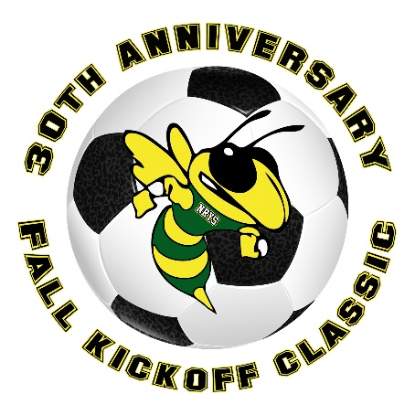

2021 NRYS FALL KICKOFF CLASSIC ROSTER
You must email electronic copies of this form along with electronic copies of each player’s
signed player liability release form.

Team type (circle one):
Girls Grade 7/8 Girls Grade 5/6 Girls Grade 3/4
Boys Grade 7/8 Boys Grade 5/6 Girls Grade 3/4
Team: Town:

Coach: Uniform Colors:

Player Name (Last, First) | Jersey Number | Phone | Date of Birth
1.
2.
3.
4.
5.
6.
7.
8.
9.
10.
11.
12.
13.
14.
15.
16.
17.
18.

I attest the above information is true and correct, I also agree to abide by the rules and regulations of the tournament.

Coach Signature Address Phone

Travel Coordinator or Town Registrar Signature:

