Copies routed to:
__ Coach
__ AD Football/Basketball/Baseball/Sluggers/Cheer
__ Divisional Director
__Facilities Manager
__ President __ VP __ Secretary __ Registrar __ Treasurer
__File
Accident/Incident Form

Date of Report: ____________________Person Reporting Incident: ___________________________________________________________
Accident/Incident Information:
Date of accident/incident: ________________
Time: _________A.M.__________P.M. Weather: __________________
Location: __________________________________________________________________________________________
____ Field #___ Gym: ___ @____________ Concessions: ___ Club House: ___ Donna Ross: __ Parking Lot: ___ Restrooms: __
Person(s) injured or involved in incident:
Name: _______________________________________ Age: _____________
Address: ___________________________________________________________________________________________
Telephone: ________________________Cell: ______________________ Email: _________________________________
Nature of Injury/incident: ____________________________________________________________________________________________________________________________________________________________________________________________________
Treatment Received: _________________________________________________________________________________
Ice__ AED___ Band aide ___ Splint___
WITNESSESS:
Name: _______________________ Address: ___________________________ Phone: ____________________________
Name: _______________________ Address: ___________________________ Phone: ____________________________
Name: _______________________ Address: ___________________________ Phone: ____________________________
During which activity did the accident/incident occur? Check one
____ Practice _____ Game _____ Meeting _____ Work Party _____ Concessions ______ Special Event _____ Fundraiser
What piece of equipment, if any, was involved in accident/incident? __________________________________________
Was there supervision at time of accident/incident? yes/no
By Whom: __________________________________________________________________________________________
What was injured person doing when injured? ____________________________________________________________
Did victim disregard rules of coach? Yes/no Explain:____________________________________________________________________________________________________________________________________________________________________________________________________

Type of suspected injury: (circle) Fracture/ Burn/ Sprain/ Abrasion/ Dislocation/ Concussion/ Other
Mark on diagram where injury is with an X
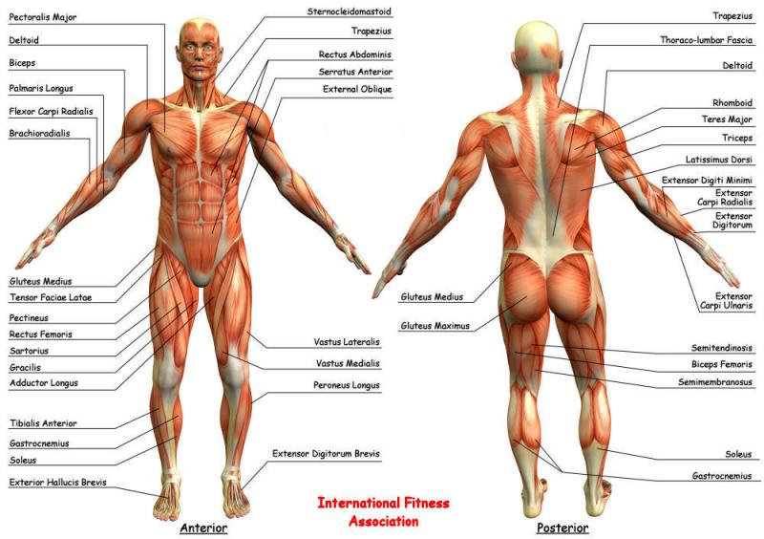

Specific description of accident/incident and treatment (add additional sheet if needed):_________________________________________________________________________________________________________________________________________________________________________________________________________________________________________________________________________________________________________________________________________________________________________________________________________________________________________________________________________________________________________________________________________________________________________________________________________________________________________________________________________________________________________________________________________________________________________________________________________
Name of person who accompanied injured person to medical assistance?_______________________________________
Were Police/Fire Services notified and respond? Yes/no
Responding Officer(s):_________________________________________Police #:________________________________
Was victim taken by ambulance? Yes/no
Was parent(s) notified if a minor? Yes/no Time: ____________ How: _________________________________________
Who was victim released to: ____________________________________ Relation to victim: _______________________
Person taking responsibility of victim phone #? ____________________________________________________________
Person’s Signature Making Report: __________________________________________Time Completed: _____________
Received doctor note to return to play: yes/no Date to return to play: ___________

