Dear Parents,
First and foremost, we hope that you and your loved ones are safe and healthy. We have received questions from the community about if and how COVID-19 will change this year’s athletic season. We know this outbreak has been stressful to many and recognize that exercising and participating in activities like sports can be a healthy way to cope with stress and connect with our community. After careful thought and planning, we are excited to let you know that we plan to resume youth sports while following PIAA, CDC, and PA state government considerations to protect players, families, and our community.

The health and safety of our athletes, staff, and volunteers remain our highest priority. Below, you will find a summary of actions we are taking to help ensure we are lowering COVID-19 risk as much as possible while also allowing our athletes to play. We are:

- Intensifying cleaning, disinfection, and ventilation within our facilities and premises
- Reducing physical closeness or contact between players, coaches, and spectators when possible
- Promoting healthy hygiene practices and screening players’ before each activity based upon the parent organization
- Coaches, athletes and spectators must wear face coverings unless they are outdoors and can consistently maintain social distancing of at least 6 feet. Athletes are not required to wear face coverings while actively engaged in workouts and competition that prevent the wearing of face coverings, but must wear face coverings when on the sidelines, in the dugout, etc. and anytime 6 feet of social distancing is not possible.
- Limiting the sharing of equipment
Anyone who is sick or has been in contact with someone who has COVID-19— including players, family members, coaches, staff and spectators — should not attend practices or games. Be on the lookout for symptoms of COVID-19, which include fever, cough, or shortness of breath. Call your doctor if you think you or a family member is sick. If your player has been in contact with anybody with a confirmed case of COVI19, we would ask that you contact your home organization immediately.
If someone does get sick during practice or at a game, they will not be allowed to participate in any team activities until cleared to return. If you have a specific question about this plan or COVID-19, please contact your home organization COVID rep for more information. You can also find more information about COVID-19 at www.cdc.gov.

Attached is our detailed return to play plan for the league that you and your player will be expected to comply with. The Board is aware there is some skepticism in the community about the need for health-related precautions and behavioral changes, but we can't take any chances with the health of our players and families. If you plan to contest ANY of the return to play policies, please instead just don't sign up this season. Anyone (players or spectators) that do not comply with the provisions identified in this document will be asked to leave the facility and/or be removed from the organization. As the COVID19 situation and government requirements change, the return to play plan will be modified as deemed necessary by the FBTAA board.
Thank you and stay healthy,
Freemansburg Bethlehem Township Athletic Association Board

FBTAA Return to Play Plan
- Education, Awareness and Communication
  - Eric Vernon – FBTAA President will be the primary point of contact for all questions related to COVID-19 concerns, incidents, and noncompliance with return to play requirements. My cell phone number is 610-597-5993 or you can reach me at fbtaabaseball@gmail.com. This information will also be posted on league website FBTAA.com
  - FBTAA has developed a written plan of action in the event any athlete, coach, or official falls ill with COVID19. The plan is section 6 below and will be made publicly available and posted on the league website FBTAA.com.
  - COVID19 education. All athletes, staff and parents must familiarize themselves with the symptoms of COVID19. More information can be found at www.cdc.gov.
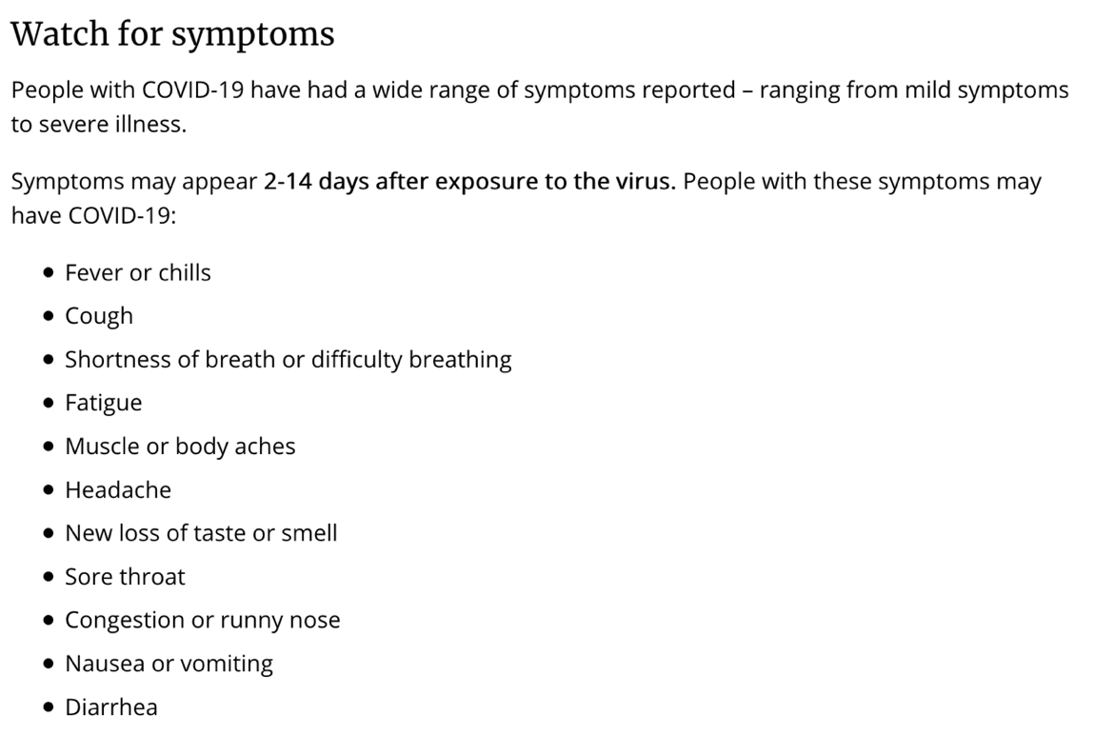
  - Before each practice or game, the team will be responsible for screening all athletes and coaches on their respective team and that they are not experiencing any of the symptoms listed in section 1.C of this document. When players arrive at the facility, they should keep their masks on, and the parent must not leave until this screening is given and is completed.
  - Sick individuals must not attend the youth sports activity. Players must not be participating in any events and must be kept home if they exhibit a fever or any COVID19 symptoms. It is the caregiver / parent’s responsibility to ensure a sick player or spectator in their family does not attend any events!
  - If a player is to have a fever in excess of 100.4, regardless of the cause they must not attend any team events for a minimum of 48 hours after the fever has broken without the use of fever reducing drugs.
  - Parents / Caregivers and volunteers should notify their organization COVID19 point of contact if they or their child become sick with COVID-19 symptoms, test positive for COVID-19, or have been exposed to someone with COVID-19 symptoms or a confirmed or suspected case. Necessary risk mitigation actions will be put in place per the COVID19 Response Plan.
  - Caregivers should assess levels of risk based on individual athletes on the team who may be at a higher risk for severe illness.
  - Each organization must certify that the rules for return to play have been distributed to all volunteers.
  - All participants (coaches, parents, and volunteers) must sign an FBTAA and league organization release of liability waiver. No additional Waiver will be needed if we play inhouse.
  - If the state of PA was to go back to Yellow or Red status all activities will cease while under this condition.

- Hygiene and Cleaning
  - Coaches, athletes and spectators must wear face coverings unless they are outdoors and can consistently maintain social distancing of at least 6 feet. Athletes are not required to wear face coverings while actively engaged in workouts and competition that prevent the wearing of face coverings, but must wear face coverings when on the sidelines, in the dugout, etc. and anytime 6 feet of social distancing is not possible.
  - All athletes, coaches, and officials must bring their own water and drinks to team activities. Team water coolers for sharing through disposable cups are not allowed. Fixed water fountains should not be used. All bottles must be labeled with player’s name to prevent possible mix up.
  - Activities that increase the risk of exposure to saliva must not be allowed including chewing gum, spitting, and licking fingers.
  - After each game/practice benches/dugouts and shared equipment will be sanitized with an appropriate disinfectant or 10% bleach solution.
  - Hand Sanitizer will be available near the benches/dugouts. Each team is responsible for supplying their own hand sanitizer and players should be encouraged to regularly sanitize their hands during games and practices. Players should also be encouraged to bring their own sanitizer supply with their equipment.

- Social Distancing
  - No post or pre-game meetings with the team unless players are physically separated by a minimum of 6 feet distance or everyone is wearing a mask. After the game is over teams can line up on the baselines and tip their caps to each other.
  - Avoid shaking hands, fist bumps, or high fives before, during or after games and practices. No lining up for customary team lines at the conclusion of any game.
  - At the conclusion of each game players and spectators must leave the field in a timely fashion to prevent possible overlap with the next game.
  - Seating areas must adhere to social distancing requirements of at least 6 feet of spacing for anyone not in the same household.
  - Nonessential visitors, spectators, and volunteers should be limited when possible, including activities with external groups or organizations.
  - Caregivers or spectators should not enter the field of play or bench/dugout areas unless in the case of a medical emergency
  - A Covid19 Rep volunteer is required for each event. They are required to monitor and uphold the plan implemented in this document and the league rules provided by the sport league they are associated with. With out one a practice or game cannot take place.

- Equipment
  - Personal items and equipment must be separated and not shared.
  - Any shared equipment must be sanitized after ever practice or game with a 10% bleach solution.
  - All player’s equipment must be properly labeled to minimize the chance of player accidentally using another player’s equipment.
  - If you can not afford equipment, let us know and we will see if you can loan you something.
  - Catcher’s gear if shared will consist of 2 helmets. If players need to share the equipment when the player is done catching with the helmet it must be sprayed and the other mask will be used so the bleach solution can kill any germs.

- Facility Guidelines
  - When possible, signage will be hung throughout the facility and reminders of hygiene and our return to play policies
  - Bathrooms
    - Bathrooms will be limited to 1 person(family) at a time
    - Facilities will be cleaned and sanitized on a daily basis after the fields have been used and after each game during the weekends.
  - Snack Stands
    - If opened the stand will be limited to 1 or 2 workers only
      - 1 person working – they will take and serve orders from the same window
      - 2 people working – there will be a window to take the order and a window to be served that are separated by more than
    - All workers must wear masks while working in the stand.
      - Workers are required to clean and disinfect any heavily used areas such as counters, cash registers, and the serving services where people order.
      - The stand must be sprayed with a 10% bleach solution after each use of the snack stand.
    - Only prepackaged foods, candies, drinks, and ice cream will be served.
  - Traffic patterns and staggered start and stop times will be posted for each field and sport to help increase our social distancing efforts
  - For practices no spectators are allowed near the practice area. Parents can either drop of your athlete and come back or remain in your car during practice. More detailed directions will be supplied by the coordinator of each sport.
  - A COVID19 Game / Practice Checklist will be filled out daily by the Covid-19 Rep, Coordinator, or coach. These checklists will be dated, collected and kept on file.
      - COVID-19 Check list will contain
        - Players, Coaches, and Volunteers screening is completed
        - Check to make sure everyone has face covering
        - Shared equipment cleaned
        - Facilities cleaned with a 10% bleach solution daily
        - Documented who the Covid19 Monitors were for the event

- Plan of Action
  - Possible Scenarios
    - Athlete, coach or official exhibit COVID-19 symptoms at home:
      - Athlete, coach or official must not be participating in any events and must be kept home if they exhibit a fever or any COVID-19 symptoms.
      - Athlete, coach or official shall notify the COVID-19 team rep, who in turn shall notify the Organization/League Reps
      - Athlete, coach or official should not be allowed to return to activity until they have met the CDC criteria to discontinue home isolation. (see below)
    - Athlete, coach or official exhibit COVID-19 symptoms during event (game, practice, etc.):
      - If an athlete, coach or official exhibits symptoms during an event, they should immediately be separated and sent home or to a health care facility depending on the severity of the symptoms. • The event must be ended immediately.
      - The COVID-19 team rep shall notify the Organization/League Reps
      - Any areas, surfaces, or shared objects used by a sick person should be closed off and not used until after cleaning and disinfecting. If possible, it is recommended to wait at least 24 hours before cleaning and disinfecting.
      - Athlete, coach or official should not be allowed to return to activity until they have met the CDC criteria to discontinue home isolation. (see below)
    - Athlete, coach or official has close contact to a person with COVID-19:
      - Anyone with close contact (<6’ away for >15 min) to a person exhibiting symptoms should also be kept home and should follow CDC guidelines for self-monitoring and procedures for community related exposures.
      - Athlete, coach or official shall notify the COVID-19 team rep, who in turn shall notify the Organization/League Reps
      - As of the printing of this document, the CDC guidelines say that athlete, coach or official who has had close contact with someone with COVID-19 should stay home for 14 days after exposure, based on the time it takes to develop illness.
  - When to Return
    - Athlete, coach or official who think or know they had COVID-19 and had symptoms: Athlete, coach or official can be with others after: 3 days with no fever, and symptoms improved, and 10 days since symptoms first appeared.
    - Athlete, coach or official who tested positive for COVID-19 but had no symptoms: Athlete, coach or official can be with others if they continue to have no symptoms after 10 days have passed since test. Depending on healthcare provider’s advice and availability of testing, they may get tested to see if they still have COVID-19.
    - Athlete, coach or official under the care of a healthcare provider: Depending on healthcare provider’s advice and availability of testing, Athlete, coach or official might get tested to see if they still have COVID-19. If they are to be tested, they can be around others when they have no fever, symptoms have improved, and they receive two negative test results in a row, at least 24 hours apart.
  - Miscellaneous Provisions
    - If 3 or more team members (player or coach) test positive for COVID-19, the team shall discontinue operations for the remainder of the season.
    - Canceling Games (out of concern): There shall be no penalty for teams that choose to NOT play a team with a confirmed case of COVID-19, provided the game is cancelled at least 24 hours in advance.
    - Canceling Games (sick players): There shall be no penalty for teams that choose to not play games because they have unhealthy players. Teams will not be penalized for taking precautions to quarantine in the event they have a positive case.

