WHARTON WOLVES SOCCER CLUB

BOARD MEETING AGENDA

horizontal line **06/17/2025 7:30pm / Virtual**

BOARD MEMBERS: Start- 7:30

* Jennifer Parsells, President- Present
* Michelle Molde, Vice President- Present
* Jennifer Joana, Treasurer- Present
* Stephanie McCabe, Secretary-Present
* Grace Martinez, Player Agent(Rec)- Present
* Mike Molde, Player Agent (Travel)- Present
* Board Minutes
  + Board minutes are on the Wharton Soccer Club Website under the “Club Info” tab.
* Correspondence
  + Incident with E-Team was reported via email
  + Ms. McCollough emailed the club about a reimbursement- her grandson never attended any practices or games. The club can give her a credit for the Fall season. Ms. McCollough will be contacted with this information.
* Treasury Report
  + TD Bank Account Balance: (as of 6/16/2025) $13,830.23
  + Town Account Balance: (Spring 2025) $8300
    - Jenn P to submit Field lining invoice for reimbursement
  + Outstanding Invoices/Receipts:
    - 3/17: Dover Sports Plex (corrected invoice/receipt) $810.00
    - 4/7: BJs $8.99
    - 6/13: Performance Trophies $1556.90 (paid by Jenn Parsells)
  + Pending Transactions:
    - CK#350 - Edgar Identogo reimbursement - $26.98 paid 6/1
    - CK#351 - Wharton BOE Custodian OT (payment 2 of 2) - $67.50 paid 6/1
    - CK#353 - Chris Pinto $1500 - paying 6/21
    - Performance Trophies & Medals $1556.90 - How was this paid? It did not hit the account. Jenn P paid directly - will cut her a check for reimbursement.
* Committee Report
  + Uniforms: None
  + Fundraising: Michelle Obiedzinski- will follow up with The Miner’s Apron about fundraiser funds
  + Concessions: Season total: $212 profit ($322 in sales minus $110 in backfill)
  + Maintenance:
* Travel Report
  + Need to modify Rec concept to make Travel more enticing- Chris presented and shared a slide show with the club. We need to follow up with this.
  + Finding tournaments for the travel team
* Delegates
  + MCYSA : prep for Fall has begun. 7/31 cutoff for all new teams
* Unfinished Business
  + Turf field application for the Fall is still tabled from the Wharton BOE

* New Business
  + Travel and Summer Registration are Open (Week 1: 3, Week 2: 2 / Travel: 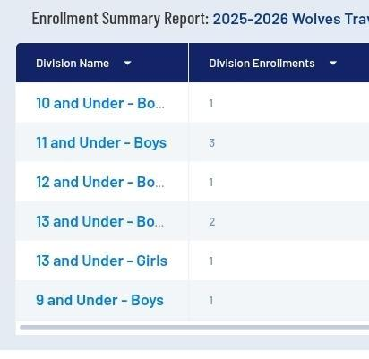
  + Bench with shade for game fields on upper field- the club is in agreement that me need to upgrade the benches.
  + Scrimmage Policy- needs to be put into writing
  + Sponsorship Letters to Local Businesses
  + Graduating senior scholarship opportunity - the club will look into this.

Meeting adjourned at: 8:30

Next Meeting is July 15, 2025 at 7:00 the Robert Street Park Field House