8U, 9U, and 10U (7v7) Rules and Regulations I. The Field
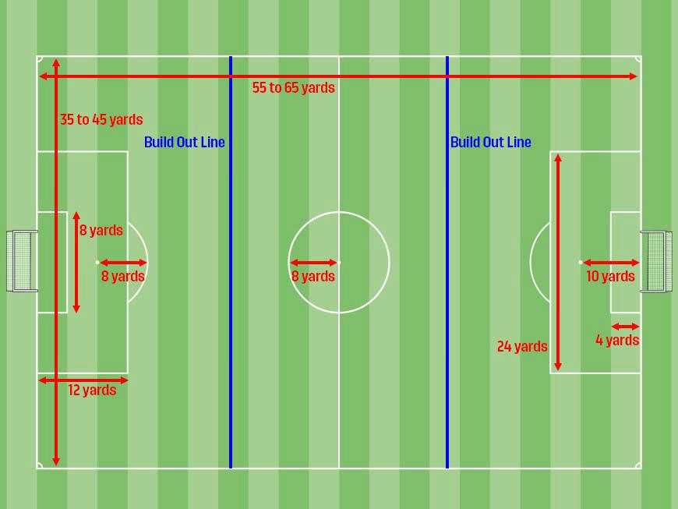

- The field of play is to be a rectangular, its length should not be longer than 65 yards and its width is to not be any wider than 45 yards. Length should exceed the width.

- Goals: Goals are to be 6 feet tall by 12 feet wide.

II. The Ball

A size 3 ball shall be used for 8U. A size 4 ball shall be used for 9U and 10U age groups. The ball should always be properly inflated.

III. Number of Players

- Players on the field at one time is seven (7). This includes 6 field players and one goalkeeper.
- The minimum number of players to start or continue a game is 5.

- Coaches should loan players to a team short of the minimum in order to allow kids to play and have fun.

IV. Substitutions
- At the quarter break.

- For an injured player, once the play has been stopped.
- If a player “needs it” due to physical distress, overheating, etc.

V. Players Equipment

- A player must not use equipment or wear anything that is dangerous to himself or another player. (Including brimmed hats or any kind of jewelry) with the exception of medical bracelets.

- The home team will wear white jerseys. The home team is listed with a house icon on the schedule. The visiting team wears the blue jersey.

- Players should wear shin guards covered by long socks.

- Cleats are recommended but not required. No shoes with toe cleats for example; baseball cleats. No metal cleats.

VI. Referees

Referees will be provided for these age groups.

VII. Length of Game
Game will consist of four, twelve (12) minute quarters. With a two (2) minute break in between quarters and a five (5) minute break at half-time.

VIII. Rules

- Beginning the game:

  - A coin toss between captains of the opposing teams will be conducted by the referee. The team winning the toss shall select end of the field to defend. The team losing the toss shall kickoff first.

  - Following a goal, restart with a kickoff by a player of the team losing the goal.
  - After halftime, the teams change ends and the kickoff is taken by a player of the team opposing that which took the kickoff at the start of the game. For a violation of this Law, the kick shall be retaken, except in the case of the kicker playing the ball a second time before it has been touched or played by another player: for this offense an indirect free kick is awarded to the opposing team.

  - A goal cannot be scored directly from a kickoff (directly means no one other than the kicker

touches it before it goes into the goal). If the ball is kicked directly into the goal, award a goal kick.

*NOTE: If anyone (either team) touches the ball after the kickoff, but before it goes into the goal, then the goal is good. (This includes the opposing goalkeeper.)

- Ball in and out of play
  - The ball is out of play: i) when it has entirely crossed the goal line or touch line, either on the ground or in the air ii) when the game has been stopped by the referee

  - All balls out of play over the touch line will be restarted with a throw-in, awarded to the opponents of the player who last touched the ball.

- Free Kicks
  - Direct and Indirect Free Kicks are awarded in U8, U9, and U10.
  - An Indirect Free Kick is a kick free from interference by the opposing team and from which
  - goal cannot be scored unless the ball is touched or played by a second player before passing through the goal. An Indirect Free Kick is awarded for the following technical fouls – goalkeeper handles the ball after it has been deliberately passed by a teammate or directly from a thrown-in by a teammate. Also to a player who – plays in a dangerous manner, impedes the progress of an opponent or the goalkeeper from putting a ball back into play OR commits any other offense, not mentioned for which play is stopped to caution or dismiss a player.

  - All opposing players must retire six (6) yards from the ball (in all directions).

  - The kicker may not play the ball a second time until another player has touched or played the ball.

  - A direct free kick does not need to be touched by another player before it enters the goal. A direct free kick is awarded due to the following penal fouls against an opponent: kicking, tripping, jumping at, charging, striking, pushing, tackling (contacting opponent first), holding, spitting or intentionally handling the ball. The action must be considered to be careless, reckless or using excessive force.

  - A foul committed in a team’s own penalty area will result in a Penalty kick 10 yards from the goal line. All players except the defending goalie and kicker shall be six (6) yards from the penalty mark.

- Goal Kick

  - When the ball has completely crossed the goal line, except through the goal, either on the ground or in the air, and was last played or touched by a player of the attacking team, it shall be kicked into play from any point inside the goal area (including the goal area lines) by the defending team.

  - All opposing players behind the build out line.
  - The ball does not have to leave the penalty box.

  - The goalkeeper cannot pick up the ball directly from a goal kick.
  - The kicker cannot play the ball a second time until it has been touched or played by another player. The punishment for this, except in cases where (c.) applies, will be an indirect free kick awarded to the other team at the point the ball was played a second time.
  - After the ball is released from the kicker’s possession and crosses the penalty area, the opposing team may cross the build-out line and play resumes as normal.

- Goalkeeper Punts

  - No punting is allowed.

  - The Goalkeeper can distribute the ball using his/her hands (throwing/rolling) and can place the ball on the ground and pass the ball.

c. If a goalkeeper punts or drop kicks the ball, an indirect free kick should be awarded to the opposing team from the spot of the offense.

d. If the punt or drop kick occurs within the goal area, the indirect free kick should be taken on the goal area line parallel to the goal line at the nearest point to where the infringement occurred.

- Corner Kick

  - When the ball has completely crossed the goal line, except through the goal, either on the ground or in the air, and was last played or touched by a player of the defending team, it shall be kicked into play from the corner arc on the side of the goal on which it went across the goal line by the attacking team.

  - All opposing players must be at least six (6) yards from the ball.
  - The ball must travel its own circumference before it is considered in play. If it does not, retake the kick.

  - The kicker cannot play the ball a second time until it has been touched or played by another player. The punishment for this will be an Indirect Free Kick awarded to the other team at the point the ball was played the second time.

  - A goal can be scored directly from a corner kick.
- Build Out Line
  - The build out line promotes playing the ball out of the back in a less pressured setting.

  - When the goalkeeper has the ball in his or her hands during play from the opponent, the opposing team must move behind the build out line until the ball is put into play by leaving the penalty area.

  - Once the opposing team is behind the build out line, the goalkeeper can pass, throw or roll the ball into play (punts and drop kicks are not allowed).

  - After the ball is put into play by the goalkeeper by leaving the penalty area, the opposing team can cross the build out line and play resumes as normal.

  - The opposing team must also move behind the build out line during a goal kick until the ball is put into play by leaving the penalty area.

- Offside
  - The offside law will be applied for 8U, 9U and 10U. A player is in an offside position if he is nearer to his opponents’ goal line than both the ball and second last opponent.

  - The build out line will also be used to denote where offside offenses can be called.
  - Players cannot be penalized for an offside offense between the halfway line and the build out line.

  - Players can be penalized for an offside offense between the build out line and goal line.

  - For any offside offense, the referee awards an indirect free kick to the opposing team at the side of the infringement.

- End of Play

  - The referee will blow his whistle several times to indicate that play is suspended for half-time breaks and the end of the game.

  - At the end of game the players from each team should line up and shake hands.

IX. Parental Responsibilities

- Parents should respect the commitment made by their coach and try to make all practices and games. Please be on time.

- Parents and other spectators should be respectful of the players and coaches/referees. They should cheer and encourage all players and should leave the coaching to the coach.

- Teams and parents should not enter a field if another game is in progress.
- No one should cross a field in use during a game.
- Parents should help their children pick up all trash and dispose of it properly as well as reminding them to pick up their belongings after games and practices.

- Parents MUST be on the opposite side of the field from the Coaches/Team Area!

