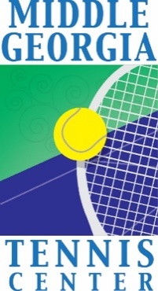
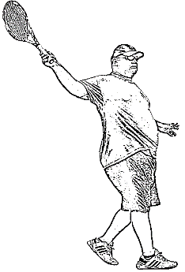

3rd Annual James Moss Memorial Tennis Tournament
Middle Georgia Tennis Center
111 Hicks Dr, Perry Ga
October 28-30, 2022

==================================================================
DIVISIONS: Men’s and Women’s – Doubles and Mixed; Junior’s -- Singles and Mixed Doubles

Junior divisions will be singles either A (typically #1 or 2 on HS team or state ranking) or B (lower on a HS team or no ranking)

Junior Mixed Doubles- Teams can be G/G, B/B or G/B and will play against any of those groupings.

Adult divisions will be doubles 9.0, 8.0, 7.0 and 6.0 (combined player ratings) Limit two divisions

FEE: $35 for one event per person, $45 for two events per person

INFORMATION: Call Erin Fisher @ 305-731-3365
or email middlegatenniscenter@gmail.com Subject: 3rd Annual James Moss
Tournament Information

Registration will be online at this link: https://app.courtreserve.com/Online/Public/EmbedCode/6046/22122

TIME: Large divisions may play first match on Friday, October 28, 2022 starting at 6:00pm

Saturday matches will start at 9:00am.

DRAWS: Draws will be posted on October 26th by 5pm. Please check your first match times at www.middlegatenniscenter.com.

MATCH PLAY: Play will be best two of three sets with the 3rd set being a super tiebreak.

PRIZES: One t-shirt to each participant. Awards will be given to 1st and 2nd place in each division.

DEADLINE: * * * * * * * FRIDAY, OCTOBER 21, 2022, Midnight * * * * * * *

ENTRY FORM
3rd Annual James Moss Memorial Tennis Tournament

NAME_________________________________ PHONE__________________________

ADDRESS_________________________________________________________________

CITY, STATE, ZIP____________________________________________________________

EMAIL_____________________________________________________________________

Payment (circle): $35.00 one event / $45.00 two events CourtReserve or Request payment @ Check in
EVENTS: Please circle the event(s) you are entering (limit 2 events):

BOYS JUNIOR SINGLES A B
GIRLS JUNIOR SINGLES A B
JUNIORS MIXED DOUBLES
WOMEN’S DOUBLES 9.0 8.0 7.0 6.0
MEN’S DOUBLES 9.0 8.0 7.0 6.0
MIXED DOUBLES 9.0 8.0 7.0 6.0

DOUBLES PARTNER_______________________________EMAIL________________________________

MIXED PARTNER_________________________________EMAIL______________________________

Circle T-SHIRT SIZE: S M L XL 2XL Other______________

________________________________________________________________________________
NOTE: USTA RULES OF CODE AND CONDUCT WILL APPLY. TOURNAMENT DIRECTORS RESERVE THE RIGHT TO MOVE PLAYERS TO A DIFFERENT DIVISION IF NEEDED AND DISQUALIFY ANY PLAYER WHO DOES NOT FOLLOW USTA RULES OF TENNIS.
Disclaimer: COVID-19 Assumption of Risk and Waiver of Liability* The novel coronavirus, COVID-19, has been declared a worldwide pandemic by the World Health Organization. COVID-19 is extremely contagious and is believed to spread mainly from person-to-person contact. As a result, federal, state, and local governments and federal and state health agencies recommend social distancing and have, in many locations, prohibited the congregation of groups of people. Middle Georgia Tennis Center (“MGTC”) has put in place preventative measures to reduce the spread of COVID-19; however, MGTC cannot guarantee that you or your child(ren) will not become infected with COVID-19. Further, attending MGTC could increase your risk and your child(ren)’s risk of contracting COVID-19. By signing this agreement, I acknowledge the contagious nature of COVID-19 and voluntarily assume the risk that I and my child(ren) may be exposed to or infected by COVID-19 by attending MGTC and that such exposure or infection may result in personal injury, illness, permanent disability, and death. I understand that the risk of becoming exposed to or infected by COVID-19 at MGTC may result from the actions, omissions, or negligence of myself and others, including, but not limited to, MGTC employees, volunteers, and program participants and their families. I voluntarily agree to assume all of the foregoing risks and accept sole responsibility for any injury to myself and/or my child(ren), including, but not limited to, personal injury, disability, and death, illness, damage, loss, claim, liability, or expense, of any kind, that I or my child(ren) may experience or incur in connection with or attendance at MGTC or participation in MGTC programming (“Claims”). On my behalf and on behalf of my children, I hereby release, covenant not to sue, discharge, and hold harmless MGTC, its employees, agents, and representatives, of and from the Claims, including all liabilities, claims, actions, damages, costs or expenses of any kind arising out of or relating thereto. I understand and agree that this release includes any Claims based on the actions, omissions, or negligence of MGTC, its employees, agents, and representatives, whether a COVID-19 infection occurs before, during, or after participation in any MGTC program.

As a condition of participation this tournament, I declare that myself and/or my child is in good physical health and has had a physical check-up by a certified physician within the last calendar year. Participant/Parent/Guardian:

Signature: _______________________________________________________Date:___________

