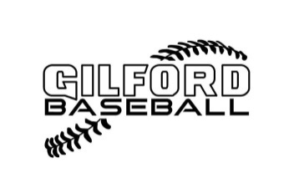
Gilford Cal Ripken Parents and Spectator Code of Conduct
The Parent and Spectator shall support the players,coaches,umpires and league officials.Parents and Spectators shall not”coach” or “officiate”.Parents and Spectators shall:
*Parents and Spectators will be positive role models

*Parents and Spectators will display and instill in all players the principals of good sportsmanship and team play.

*Parents and Spectators will conduct themselves in a manner that best serves the interest of the players.

*Parents and Spectators will do their best to provide the players a positive experience.

*Parents will make certain that their children show respect for all other players,coaches,officials and spectators.

*Parents and Spectators will not ridicule or demean players,coaches or umpires.

*Parents will inform the coach of any disability or ailment that may affect the safety of their child.

*Parents and Spectators will treat all players,coaches and umpires fairly and with respect.

*Parents and Spectators will comply with the decisions of league officials and observe all rules,policy and procedure as established or endorsed by the GCRB league.

*Parents and Spectators will not question an umpires call.

*Parents and Spectators will respect the opponent and avoid any confrontation with opposing players,spectators or coaches.

*Parents and Spectators will be drug and alcohol free while at anyGCRB athletic event.

*If a situation arises with a parent where they feel they must speak to a coach they must speak to the respective player agent FIRST!!
MAJORS PLAYER AGENT:Kris Genakos
MINORS PLAYER AGENT:Scott Clark
ANY BREACH OF CODE OF CONDUCT CONTRACT WILL RESULT IN IMMEDIATE BOARD REVIEW AND POTENTIAL DISCIPLINARY ACTION.

NAME(Printed) Signature

