When: Saturday, August 18th (12:00pm- 1:30pm)
Where: H-F Varsity Baseball Field
Grades: 5th-8th
Cost: $10
HF Baseball Skills Camp will be a highly informative and energetic camp focusing on the basic skills of baseball to make your son a better all-around baseball player. Major skills developed will be hitting fundamentals along with a better understanding of defensive positions. MLB Draft Picks Kyle Salley (Duke) and Zaid Walker (Michigan State) will be signing autographs before the Skills Camp starting at 11:45 am.

Make checks payable to H-F Baseball

Questions: Contact Coach McCarthy
Email: jmccarthy@hf233.org

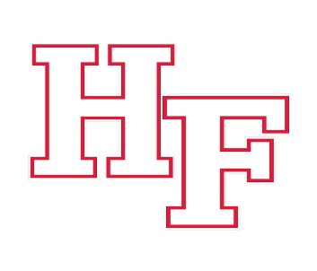

Name:
Phone:
Email:
Grade:
Position(s)

I authorize my son to participate in the 2018 H-F Youth Skills Camp on Saturday August 18th. I assume full medical, including dental, responsibility for any injuries received during the clinic.
Sign: ______________________________________ Date: _______

