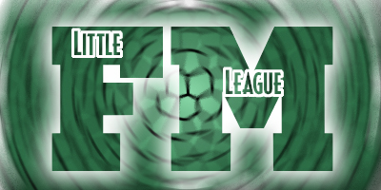
HARDBALL EVALUATIONS

WHO? - All League Age 8 – 12 Yr. Olds who
did not play on a Spring Major League team in 2022 and any 7 yr. old who wishes to be evaluated for AA
WHEN? – SUNDAY, March 19, 2023
WHERE? – 481 SPORTZONE – NOTE LOCATION
(6841 Collamer Rd, East Syracuse, NY 13057)

- All 12Year olds – 11:00 am

- 10 and 11 Yr. Olds with last name beginning with:
A – M – 11:45
N – Z - 12:15 pm

- 9 Yr. Olds with last name beginning with:
A – M – 1:00 pm
N – Z 1:30 pm

- 7/8 Yr. Olds with last name beginning with:
A – M – 2:00 pm
N – Z – 2:30 pm

Players Must be evaluated on March 19TH.
Failure to attend evaluations means that your child may not be placed at the appropriate level. In fairness to all,
NO EXCEPTIONS will be made.
Please read the reverse side for details
THE DETAILS:

There are NO evaluations for the following ages:
- Ages 4, 5, 6- or 7-year-olds (who wish to remain in Coach/Pitch).
- Any 11 or 12 yr old who played on a Spring Major League team in 2022.
- Jr./Sr. League (13yr. old – 16yr.old) evaluations will be held later April. Players will be contacted directly.

All Others must be evaluated on March 19th.
There are no “cuts” in Little League, but evaluations are needed to achieve a proper skill balance among leagues and teams.

Failure to attend evaluations means that your:
- 7-year-old will not be considered for AA and will remain in Coach/Pitch.
- 9-year-old will not be considered for AAA and will automatically be placed in the AA Hardball League.

- 10 and 11-year-olds will automatically be placed in the AAA and will not be considered for the Major League.

- All 12-year olds will be automatically placed in the Major League, unless a parent requests placement in AAA. For 10- and 11-year-olds, placement in the Major League is based solely upon tryout scores.

ONCE AGAIN – IN FAIRNESS TO ALL –
NO EXCEPTIONS WILL BE MADE

If you have questions or cannot come at your designated time – email: Len @ fmlittleleague@aol.com

