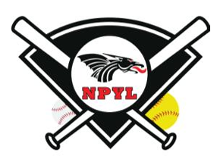
2026 NEW PALESTINE YOUTH LEAGUE
SEASON SPONSORSHIP OPPORTUNITY

Showcase your business as a proud supporter of local youth sports to more than 20,000 people per season!

 | GRAND SLAM! | HOMERUN! | TRIPLE | DOUBLE
Backstop Banner | 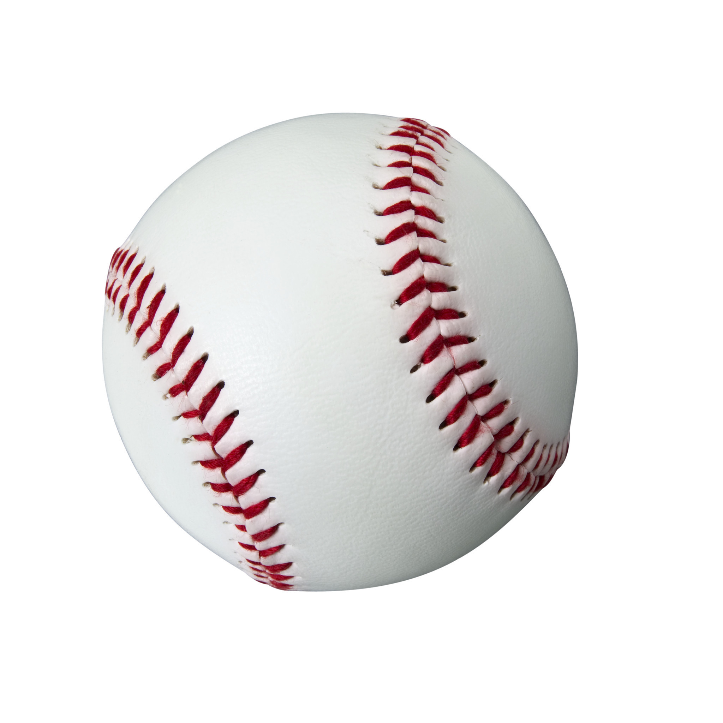
eBlast / Social Media
Parking Lot Sign
*Back of Uniform | 6 Teams | 3 Teams | 2 Teams | 1 Team
Sponsor Plaque
NPYL.com Website | Front Page | Front Page | Front Page | Logo
Amount | $3,300 | $1,750 | $1,000 | $600

Notes:
a) *Back of uniform team number is a total 2026 number. Teams will be allocated in the spring season. Any additional team inventory will be included in the fall season. Additional fall teams available for purchase at $300/team.
b) Banner/digital promotions included in spring and fall season.
d) Custom promotions available for an additional investment
e) Want to support, but don’t see a package that fits your budget? Email us to discuss the Bunt option.

Business Name: ______________________________________________
Business Address: ___________________________________________________________________________ Contact Name: _______________________________________________
Phone: __________________________ Email: ____________________________________________________ Total 2026 Sponsorship Amount $ ___________________

Do you have children playing? Y/N _______________
Child Name: ______________________________Age: _______ Division: ______________
Child Name: ______________________________Age: _______ Division: ______________
Child Name: ______________________________Age: _______ Division: ______________

Signature: _____________________________________________________ Date: _______________________

Email this document along with your business logo (.eps format)
Make checks payable to: NPYL
Mail to: P.O. Box 202, New Palestine, IN 46163

Join Us! Email to Sponsor@NPYL.com

