2021
SAFETY MANUAL
FOR
MANAGERS AND COACHES
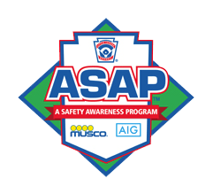

Table of Contents
2021 MANAGER PRESEASON SAFETY CHECKLIST 4
INTRODUCTION & POLICY STATEMENT 5
MISSION STATEMENT ON SAFETY 6
The Safety Plan 6
The Four E's 6
RESPONSIBILITIES 7
Manager and Coaches – Overview 7
Manager and Coaches - Safety and Conduct 8
Manager and Coaches - Practices & Games 10
The Umpire - Prior to the Game 11
The Umpire – During the Game 11
The Umpire – After the Game 12
Safety Officer 13
CODE OF CONDUCT 15
CCLL SAFETY CODE 17
FIRST AID 20
Prevention 20
Decision Making 22
9-1-1: When to Call or Not to Call 22
What to Do if a Player is Hurt 24
General Guidelines to Follow for Injuries 24
Head/Neck/Back 24
Facial/Soft Tissue 25
Nose Injury 25
Dental Injury 26
Lacerations, Abrasions, Punctures, Bruises 26
Severe Bleeding 27
Suspected Broken Bones 27
Heat Exposure 28
Heat Cramps 29
Heat Exhaustion 29
Heat Stroke 29
INJURY DECISION MAKING TREE 30
COMMUNICABLE DISEASE PROCEDURES 31
CORONAVIRUS MITIGATION PROTOCOL 32
GOOD SAMARITAN LAWS 39
INCIDENT REPORTS 40
Injury Reporting Procedures 41
What to Report 41
How to Make the Report 41
LIGHTNING FACTS AND SAFETY PROCEDURES 42
"Flash-Bang" Method 42
Rule of Thumb 42
Where to Go 43
Where not to Go 43
First Aid to Lightning Victims 43
SNACK BAR SAFETY 44
STORAGE SHEDS AND EQUIPMENT 45
EMERGENCY EVACUATION PLAN 46
FINAL THOUGHTS 47
EMERGENCY PHONE NUMBERS 49
EMERGENCY EVACUATION - MAP 51
Incident Report Form 52

2021MANAGER PRESEASON SAFETY CHECKLIST

1. Read the Safety Manual and keep this checklist with your First Aid Kit.

2. Select a Team Safety Officer (TSO).

3. Make copies of Medical Authorization forms and the Incident Report form (pg. 47).
Additional forms are maintained in the office at the complex.

4. Designate a location and back-up plan for the First Aid Kit, Safety
Manual, and Medical forms in the case of a volunteer’s absence.

5. Train your team volunteers on where to locate the First Aid Kit, Safety
Manual, and Medical Authorization forms for games and practices.

6. The First Aid Kit is issued with each equipment bag. Check the First
Aid Kit to confirm the following contents: Plastic bandages; gauze pads;
antiseptic wipes; triple antibiotic ointment; tape; cold packs; and gloves.

7. Plan with coaches to ensure both the manager and the coaches
attend one Skills session and one First Aid session every three years.
(The annual Manager’s meeting fulfills the First Aid requirement.)

8. All Incident Report forms are to be turned into the Safety Officer via
the Director on Duty within 48 hours of any incident.

9. Review the Code of Conduct with parents at your Parent Meeting.

10. Conduct an inventory of your First Aid supplies on a monthly basis.
Replace needed supplies by contacting the Director on Duty at the
complex or ordering replacement supplies with the league equipment
manager, Jorge Diaz, email: jorgediazccll1@gmail.com

11. Make sure all Team Volunteer Applications are turned into the CCLL
Vice President, Scot Mahotz, email: Scot.Mahotz@ccll.org; telephone
(661) 313-7980, on or before TBD. This is done online through JDP.

NOTES:

*********TEAR THIS SHEET OUT FOR YOUR REFERENCE*******

Canyon Country Little League Safety Plan

INTRODUCTION & POLICY STATEMENT
The 2021 Board of Directors welcomes you to another year of exciting Little League baseball and softball with the youth participants and adult volunteers at Canyon Country Little League (CCLL). Please understand that this manual has been assembled for you, the frontline volunteer at CCLL. It will serve you and our participants for the season. Safety is a priority set forth by the Board of Directors which dictates that volunteers at CCLL follow the safety rules in this manual. The safety training that you receive, along with reading this safety manual, are to ensure that the CCLL safety guidelines are met for every practice and game.
Our fields and facilities are in excellent shape after several improvements were made during the off-season. The Board of Directors continues to look for ways to maintain and improve our complex. In the past off-season, every field on the complex has received new infield dirt. Field #2 has received repairs and paint to the bleachers and Field #5 has received new covers over the player dugouts. During the upcoming Spring season, the league will be installing lighting at various locations throughout the complex for the safety of players and parents. CCLL has excellent facilities and with your help we look forward to another great year!!
Keeping everyone safe is our expectation and it starts with this safety manual. It is a mandatory read and an excellent guide for the coaches. As you read the complete safety manual, familiarize yourself with the steps to take for incidents that can arise during the season. Please note the section on Concussion Awareness and the quick online course to be completed. A copy of the completion certificate should be turned in to CCLL Vice President, Scot Mahotz e-mail: Scot.Mahotz@ccll.org; phone 661-313-7980.Planning and being ready to take action is what this safety program is about for every member of CCLL. So, be ready to handle the safety of our precious resources – our children, families, and friends.

MISSION STATEMENT ON SAFETY

CCLL (“the League”) commits itself to providing the necessary organizational structure to develop, monitor, and enforce the aspects of this Safety Plan in developing guidelines for increasing the safety of activities, equipment, and facilities through education, compliance, and reporting.

The Safety Plan
The Safety Plan, includes the League’s Safety Code, the League’s Code of Conduct, and the League’s Safety Manual. The combination of these documents outlines specific safety issues and the League’s policies or procedures for each issue. All participants, volunteers, employees, spectators, and guests are bound by the guidelines set forth in these documents.

The Four E's
The four cornerstones for building an effective safety program, known as the four "E's " of safety, are described as follows:

EDUCATION- Including suitable safety precautions in instructions, training, communications, drill work and follow-up.

EQUIPMENT– Maintain safe upkeep and use of physical property, fields, personal protective equipment, bleachers, bats, balls, etc.

ENTHUSIASM- Selling this important ingredient called safety, which can prevent painful and disabling accidents.

ENFORCEMENT- An incentive for skillful ball playing rather than as disciplinary action. Far better results can be obtained by praise and recognition than by forcing players into line. Tactful guidance must be backed by firmness and justly used discipline.

Thank you in advance for your cooperation.

RESPONSIBILITIES

The administration of an effective safety program is the responsibility of those who operate the Little League system on all levels. The inexperience and dependence of young children on adult guidance make it imperative that all levels of authority make safety an integral part of their behavior, transaction of league affairs, and instructions to the players.

Manager and Coaches – Overview
Everyone's approach to the program of accident prevention must be from a positive point of view for it to be effective. We should be concerned primarily with controlling the causes of accidents, which can be eliminated without taking any action, speed, or competition out of the game. An attitude of alertness, hustle and enthusiasm without antagonism should be encouraged. Good equipment and proper instruction more than outweigh the risk of injury. A lively spirit of competition encourages that extra effort needed for development of skills.

To minimize accidents, particularly during the initial learning period, instruction in the basic skills should be approached gradually. This applies particularly to fundamentals such as running, ball handling, batting, and sliding, which produce the majority of our accidents.
Also, very important to the safe development and continuing use of baseball skills is the understanding and practice of teamwork and good sportsmanship. These intangibles have a direct bearing on accidents involving other people and can be made a part of the game by the following:

Adults must set a good example, as well as a courteous and considerate attitude. Many of the players will need to be instructed in cooperation between teammates and good sportsmanship toward opponents.

Manager and Coaches - Safety and Conduct

The Manager will:

1. Always be responsible for the team's conduct, observance of the official rules and
deference to the umpires.

2. Be responsible for the safety of the players. The Manager is also responsible for
the designated coaches and the Team Parent / Team Safety Officer (TSO).

3. Designate a coach as a substitute Manager should the Manager need to leave
the field for any reason. The designated coach shall have all the duties, rights,
and responsibilities of the Manager.

4. Take possession and become familiar with this Safety Manual.

5. Ensure that a Volunteer Application is submitted for all volunteers associated with
the team. This should include the Manager, all Coaches, the Team Parent, and
the TSO; along with photo ID. Done online through JDP.

6. Take possession of the team equipment bag and team First Aid Kit from the
League Equipment Manager before performing any team practices or games.
Inform all team members and volunteers that the team First Aid Kit is to be kept in
the team equipment bag at all times.

7. Appoint a volunteer parent as the TSO. The TSO must be able to be present at
all games and preferably have a cell phone for emergencies. Ensure that the
TSO checks the team folder before each game for important information regarding events and safety.

8. Ensure that the manager and coaches attend the required Coaches and First Aid
training. All managers and coaches must attend at least one Skills and one First
Aid session every three years. At least one adult representative from each team
must attend at least one Skills and one First Aid session each year.

9. Cover the basics of safe play with his/her team before starting the first practice.
Encourage the use of mouth guards and face guards on helmets.

10. Return a signed CCLL Code of Conduct and CCLL Safety Code sheet to a
selected CCLL Board Member at the end of the training session.

11. Teach players the fundamentals of the game, the Code of Conduct, and always
advocate safety.

12. Ensure all parents are aware of and comply with the Code of Conduct provided at
the Parent/Team Meeting and on page 15 of this manual.

13. Review the team equipment and First Aid supplies on a consistent basis. Contact
the CCLL Equipment Manager to replace faulty equipment and restock necessary
supplies.

14. Check the Canyon Country Little League Home Page frequently. It has important
information about team standings, upcoming events, safety tips and general
information. http://www.ccll.org

15. Not expect more from a player than that player’s ability.

16. Be open to ideas, suggestions or help.

17. Enforce the message that prevention is the key to minimizing the number of
accidents.

18. Always have on hand the First Aid Kit, the Player Application Forms which
contain the Authorization for Medical Treatment and Waiver, and the Safety
Manual.

19. Use common sense.

20. Make sure all players are healthy, rested and alert prior to any practice or game.

21. Read and be familiar with the Corona virus Mitigation Protocol, starting on page
on page 32 of this manual.

Manager and Coaches - Practices &Games

The Manager will:

1. Prior to the game, walk the field and, with the opposing manager, agree on the
fitness of the playing field before the game starts. In the event the two managers
cannot agree, the League President or a duly designated league representative shall make the determination.

2. Prior to the game, enforce the rule that no bats or balls are permitted on the field
until warm-ups.

3. During the game, make sure the players carry all gloves and other equipment off
the field and to the dugout when their team is at bat.

4. Be organized; maintain discipline and keep the players alert.

5. Ensure a manager, coach, or volunteer is in the dugout to supervise the players
at all times.

6. Ensure the catchers are wearing the proper equipment during the game, as well
as warm-ups.

7. Encourage everyone to think Safety First.

8. Observe the “no on-deck” rule (12 and under) for batters and keep players behind
the fences at all times. No player should handle a bat in the dugout at any time.

9. Not play children that are ill or injured.

10. Not leave the field after a game until a known family member or friend has picked
up every team member.

11. After each game, discuss any safety problems, which occurred before, during, or
after the game, with the TSO and coaches.

12. After each game, return the field to its pre-game condition, per CCLL policy.

13. After each game, document any injuries on an Incident Report form and
submit/leave with a league official for the safety officer.

The Umpire - Prior to the Game

1. Check all equipment in the dugouts of both teams. Any equipment that does not
meet specifications must be removed immediately.

2. Make sure the catchers are wearing approved helmets and throat protectors,
when warming up the pitchers.

3. Make sure all bats meet Little League specifications and have grips.

4. Make sure there are foam inserts in the helmets and that all helmets meet Little
League supported NOCSAE specifications.

5. Check the field for hazards and obstructions (e.g. rocks and glass, holes in the
playing surface, fence protrusions etc.).

6. Check the players to see if they are wearing jewelry or metal cleats and address
per Little League regulations.

7. Secure official baseballs for play from the home team or office.

The Umpire – During the Game

8. Govern the game as mandated by Little League rules/regulations.

9. Check baseballs for discoloration and/or scuffs and declare these balls as unfit
for play; if they exhibit these traits.

10. Act as the sole judge as to whether and when play shall be suspended during a
game because of unsuitable weather conditions or the unfit condition of the
playing field; as to whether and when play shall be resumed after such suspension; and as to whether and when a game shall be terminated after such suspension.

11. Call the game whenever, in the umpire's opinion, darkness makes further play
hazardous.

12. Make sure the catchers are wearing the proper equipment.

13. Make the calls loud and clear; signaling each call properly.

14. Make sure the players and spectators keep fingers out of fencing.

The Umpire – After the Game

15. Check with the managers of both teams regarding any safety violations or issues
that may have occurred during the game.

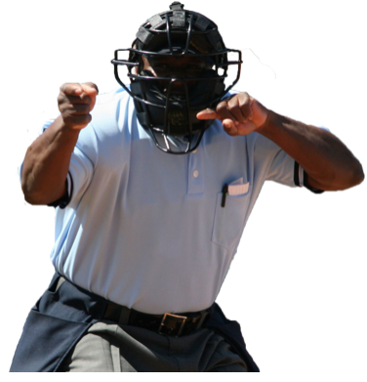

Safety Officer

The Safety Officer is a board member who acts as CCLL's primary point of contact for the creation and enactment of the Safety Plan. The Safety Officer authors or modifies the League's Safety Plan, Code of Conduct, Safety Code, and Safety Manual each year, as necessary. These documents are then presented to the Board and District for approval and ratification (usually in January) for the upcoming season.

The ultimate responsibility for ensuring compliance of the Safety Plan lies with the Safety Officer.

The main responsibility of the Safety Officer is to develop and implement the League's Safety Program.

The CCLL Safety Officer is the link between the CCLL Board of Directors and its managers, coaches, umpires, players, spectators, and any other third parties on the complex in regards to safety matters, rules and regulations.

The CCLL Safety Officer's responsibilities include:

1. Coordinating the individual Team Safety Officers (TSO), in order to provide the
safest environment possible for all.

2. Ensuring all board members, managers, coaches, team parents and other
volunteers who have access to players submit Volunteer Application forms and
photo ID’s and ensure nationwide background checks are completed for all.

3. Assisting parents and individuals with insurance claims and will act as the liaison
between the insurance company and the parents and individuals.

4. Explaining insurance benefits to claimants and assist with filing the correct
paperwork.

5. Keeping a First Aid Log. This log will list where accidents and injuries are
occurring, to whom, in which division (senior, major, minor, farm, Tee ball), at
what times, and under what supervision. Correlating and summarizing the data in
the First Aid Log to determine proper accident prevention in the future.

6. Ensuring each team receives or has electronic access to its Safety Manual and
receives their First Aid Kits at the beginning of the season.

7. Ensuring Little League's "no tolerance with child abuse" is clear to all.

8. Inspecting the snack bar and checking fire extinguishers.

9. Instructing snack bar workers on the use of fire extinguishers.

10. Creating and maintaining all signs on the CCLL complex including No Parking,
No Smoking, and other cautionary signs, etc.

11. Inspecting for proper maintenance of the protective fence tops on all playing
fields.

12. Acting immediately to resolve unsafe or hazardous conditions once a situation
has been brought to his/her attention.

13. Tracking all injuries and near misses, in order to identify injury trends.

14. Making sure that safety is a Board Meeting topic, and allowing experienced people
to share ideas on improving safety.

15. Distributing copies of the ASAP newsletter to all teams through the team folders.

INJURY REPORTING
Upon receiving an Incident Report, the Safety Officer will enter it into the league’s safety database within 48 hours. The Safety Officer will contact the injured party or the party’s parents and verify the information received.

The Safety Officer will also:

A. Obtain any other pertinent information deemed necessary.
B. Check on the status of the injured party.
C. Complete insurance paperwork and forward to Little League
Insurance Department, even if the injury is not serious, in order
to maintain a record of the injury.

1. In the event the injured party required other medical treatment (i.e., Emergency
Room visit, doctor's visit, etc.) the Safety Officer will advise the parent or
guardian of CCLL's insurance coverage and the provisions for submitting any
claims for reimbursement.

2. The Safety Officer will answer any questions that the parents may have regarding
insurance claims.

If the injury is more than minor in nature, the Safety Officer will:

3. Maintain regular contact with the parents to monitor the status of the injuries.

4. Check to see if any other assistance is necessary in areas such as the
submission of insurance forms etc., until the incident is considered "closed" (i.e.,
no further claims are expected and/or the individual is participating in the league
again).

CODE OF CONDUCT

The Board of Directors has adopted the Code of Conduct for CCLL. The Safety Officer, the League President, and the League’s Vice-Presidents enforce this Code. All league officers, participants, employees and volunteers are required to abide by this Code. It is the job of the Safety Officer to author and/or make any revisions to this Code of Conduct from year to year, as necessary.

No Board Member, Manager, Coach, Player or Spectator shall:

> At anytime, lay a hand upon, push, shove, strike, or threaten to strike an official.

> Be guilty of personal verbal or physical abuse upon any official for any real or
imaginary belief of a wrong decision or judgment.

> Be guilty of an objectionable demonstration of dissent at an official's decision by
throwing of gloves, helmets, hats, bats, balls, or any other forceful demonstrative
action.

> Be guilty of using unnecessary rough tactics in the play of a game against any
opposing player.

> Be guilty of a physical attack upon any board member, official, manager, coach,
player or spectator.

> Be guilty of the use of profane, obscene or vulgar language in any manner.

> Appear on the field of play, stands, or anywhere on the CCLL complex while
intoxicated or under the influence of alcohol or any drug. Intoxicated or under the
influence will be defined as an odor or behavioral issue as determined by any board
member.

> Be guilty of gambling upon any play or outcome of any game with anyone at any
time.

> Be guilty of discussing publicly with spectators in a derogatory or abusive manner
any play, decision or personal opinions on any player during the game.

No Board Member, Manager, Coach, Player or Spectator shall:

> As a manager or coach be guilty of mingling with or fraternizing with spectators during the game, but shall remain on the players’ bench or on the field during the game.

> Speak disrespectfully to any manager, coach, official or representative of the league.

> Be guilty of tampering or manipulating any league rosters, schedules, draft positions or selections, official score books, pitching affidavits, rankings, financial records or procedures.

> Shall challenge an umpire's authority. The umpire shall have the authority and discretion during the game to penalize the offender of the infraction up to and including removal from the game.

The Board of Directors will review all infractions of the CCLL Code of Conduct. Depending on the seriousness or frequency, the board may assess additional disciplinary action up to and including expulsion from the league.

CCLL SAFETY CODE
The CCLL Safety Code has been adopted by the Board of Directors and is enforced by the Safety Officer and the League’s Vice Presidents. All league officers, participants, employees and volunteers are required to abide by this code. It is the job of the CCLL Safety Officer to make any revisions to the Safety Code from year to year, as necessary.

> All adult members of CCLL are responsible for adherence to safety procedures.

> Arrangements should be made in advance of all games and practices for emergency medical services.

> Make arrangement to have a cellular phone available when your game or practice is at a facility that does not have a public phone.

> Managers, coaches and umpires must have training in First Aid at least every three
years. At least one team representative must attend each year. First Aid Kits are
provided to each team and are available in the CCLL office and at the concession
stand.

> Managers are to have First Aid Kits, Application Forms that contain Authorization for
Medical Treatment and Waiver, and the Safety Manual on hand at all games,
practices, and team gatherings.

> No games or practices should be held when weather or field conditions are
unplayable; particularly when lighting is inadequate.

> Play area should be inspected frequently for holes, damage, stones, glass and other
foreign objects.

> All team equipment should be stored within the team dugout, or behind screens, and
not within the area defined by the umpires as “in play.”

> Only players, managers, coaches, and umpires are permitted on the playing field or
in the dugout during games and practice sessions.

> The responsibility for keeping bats and equipment off the field of play should be that
of a player assigned for this purpose or the team's manager and/or coaches.

> Procedures should be established for retrieving foul balls batted out of playing area.

> During practice and games, all players should be alert and watching the batter on
each pitch.

> During warm-up drills, players should be spaced so that no one is endangered by
wild throws or missed catches.

> Equipment should be inspected regularly for the condition of the equipment as well
as for proper fit.

> Batters must wear Little League approved protective helmets during batting practice
and games.

> All male players should wear athletic supporters and protective cups during games.
Managers should also encourage they be worn at practices.

> Female catchers must wear long or short model chest protectors.

> All catchers must wear a catcher's helmet, mask, dangling-type throat guard, chest
protector with neck collar, shin guards and protective cup. NO EXCEPTIONS. All of
which must meet Little League specifications and standards.

> All catchers must wear catcher's helmet and mask with dangling-type throat guard
when warming up pitchers. This applies between innings and in the bullpen during all
practices and games.

> Catchers must wear a catcher's mitt (not a first baseman's mitt or fielder's glove) of
any shape, size or weight consistent with protecting the hand.

> Except when runner is returning to a base, headfirst slides are not permitted.

> During sliding practice, bases should not be strapped down or anchored.

> "Horse play" should not be permitted on the playing field at any time.

> Parents of players who wear glasses should be encouraged to provide their child
with "safety glasses.”

> Players must not wear watches, rings, pins or metallic items during games and
practices.

> Managers and coaches may not warm-up a pitcher before or during a game.

> On-deck batters are not permitted (except in the Juniors Division).

> All pre-game warm-ups should be performed within the confines of the playing field
and not within areas that are frequented by spectators, thus, endangering spectators
(i.e., playing catch, pepper, swinging bats, etc.).

> Never leave an unattended child at a practice or game.

> Never hesitate to report any present or potential hazard to the CCLL Safety Officer
immediately.

> The speed limit on all CCLL roadways and parking lots is 5 mph. Drivers should
watch for small children around parked cars. Note the one-way signs. Traffic flow
directions for the CCLL complex are depicted page 50 of this manual.

> No alcohol is allowed in any parking lot, field, or common areas within the CCLL
complex.

> No smoking is allowed in any parking lot, field, or common area within the CCLL
complex.

> No medication will be taken at the facility unless administered directly by the child's
parent or guardian.

> No playing in the parking lots or around the lawn equipment.

> No swinging bats or throwing balls at any time within the walkways and common
areas of the CCLL complex.

> No throwing balls against dugouts or against backstop. Catchers must be used for all
batting practice sessions.

> All gates to the field must remain closed at all times. After players have entered or
left the playing field, all gates should be closed and secured.

> No children under the age of 12 are allowed in the Snack Bar.

> No throwing rocks; no climbing fences; and no climbing the mountain/hills.

> During games, players must remain in the dugout in an orderly fashion, at all times.

> After each game, each team must clean up trash in the dugout and around the
stands.

Remember that Safety is everyone's job.

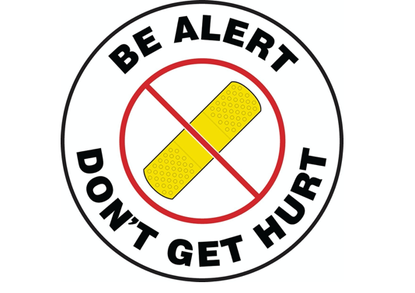
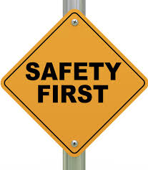

FIRST AID
The purpose of this section is to help managers, coaches and other participants know how to handle common injuries that may occur during Little League play. This information you are receiving is basic and is not intended to be as complete as you might expect in a certified first aid course. It is impossible to cover every injury a player may sustain while engaged in a sporting activity. If you are not sure what to do, always allow parents to make the decision in the best interest of the player!

Prevention
Preventing injuries is crucial in any organized sporting activity. There are many things that you as a manager or coach can do to make your playing fields, practices and games safe for the kids.

> Check your fields before every game! Make sure there are no sharp or dangerous
objects (i.e. glass, metal, plastic, snakes, holes, sticks or rocks) on the ground near
the playing fields or where people may be seated to watch the game.

> Try to anticipate any object that may cause injury and remove it, such as a bat or ball bag, equipment, chairs, etc.

> Warm up before every game to ensure muscles are warm and stretched. This can be very helpful in preventing unnecessary and painful injuries.

> Try to control "horseplay". Kids can get out of control quickly so limit one-on-one contact and get kids in the habit of calling for catches, i.e. “I’ve got it.”

> Take your First Aid Kit to all practices and games; including pre-season clinics.

> There is a CCLL complex First Aid Kit in the Office.

> Make sure every player knows the rules and understands how they can prevent an injury, i.e. no headfirst sliding.

> If weather is stormy, especially if lightning, get off the field. It's tempting to try to finish a game, but it can be very dangerous.

> Know where the closest phone is located. Cell phone reception is poor in some
areas of the CCLL complex. Identify an area within the complex to receive good
reception before the need arises. Land line phone service is available, in an emergency, on the CCLL complex at the snack bar and in the office.

Call Immediately for
EMERGENCY ASSISTANCE
9-1-1

> Be familiar with the medical conditions listed on the application and medical waiver for each player on your team. Identify which players may have bee sting or other allergies, seizure disorders, asthma, etc.

> Rattlesnakes are a danger in the hills around our complex. Please help keep our children safe by having your team’s parents aware of this and NEVER allowing children to go off the complex and into the brush/hill areas.

> Make sure each player has plenty of liquids to drink. Some teams rotate the responsibility of filling the entire team’s water bottles with their snack day. Ask your team parent to organize this.

It is very helpful if you are familiar with your First Aid Kit prior to needing it. Team First Aid Kit supplies include:

a. Plastic bandages
b. Gauze pads
c. Antiseptic wipes
d. Triple antibiotic ointment
e. Tape
f. Cold packs
g. Gloves

Keep player Applications with Medical Waivers with your team’s First Aid Kit.
Make sure you bring the kit to each game and practice.

Decision Making

Injuries to players can range from almost insignificant to very serious. Knowing how to assess the situation and what to do once you have assessed the situation is extremely important.

A. It is always the best choice to have a parent of the injured player make the
decision.

B. If you as the manager or coach feel that the parent is being conservative and that
the player is hurt more seriously, please encourage the parent to seek further
medical care.

C. If no parent is available, the coach or manager should make the decision in the
best interest of the player.

D. Notify the parent immediately of injury and where their child has been transported
for treatment.

9-1-1: When to Call or Not to Call
It is difficult for some people to know when to call 9-1-1 and when not to. The suggestions given here are by no means meant to be the law, but instead are meant to be used as a guide to help those at the field make the best decision they can with the level of expertise they have.
Always call 9-1-1 for:
> For any life-threatening injury.
> Any player who has no pulse and/or is not breathing.
> Any player with a head or neck injury that includes a loss of consciousness (passing out, fainting, etc.)
> Any wound or broken bone that has excessive bleeding.
> Any player with respiratory difficulties, i.e. asthma without relief from inhaler, allergic reaction, etc.
> Any injury that looks "bad", i.e. protruding bone, or significant eye injury such as a direct blow to an eye.

The purpose of this education is not to teach people CPR. There may be EMT'S, nurses, MD's, etc. in the audience who are able to take over the care of a seriously injured player before an ambulance arrives. You should defer care to them. Do not attempt to perform advanced care if you are not qualified.

All minor injuries should be treated at the field by the manager or coach. If a parent feels the player needs further care, they can transport their child to receive medical care by car. For life threatening injuries, a “9-1-1” phone call is best to allow experts to treat and transport the injured person so as not to injure the victim any further.

NOTE: If a parent feels that a minor injury should be transported by ambulance, you should not intervene in that decision. It is ultimately the parents' choice.

If parents are not at the field at the time of a minor injury, please make sure to notify them that their child was hurt while playing and complete the Incident Report form.

Obviously, if their child has a serious injury, you would notify them after you have initiated a 9-1-1 call.

What to Do if a Player is Hurt
> Remain calm and take charge of the situation. If needed, have an adult go to the snack bar area and either use the office phone to call 9-1-1. If 9-1-1 is called, send another adult out to the front gate to direct EMS workers to the injured person.
> You need to direct all players to one area (such as the dugout) while obtaining necessary help from any adults present. For example one parent to call 9-1-1; another to direct EMS; and maybe another to comfort the injured player.
> Your initial assessment of the injury is very important. Investigate an injury by asking the victim questions to inquire what has occurred and what body part(s) are injured. A victim should move his/her own limbs, if possible, and breathe deeply (1-2 times),to assess the injuries. For the initial assessment, refer to the decision flow chart on page 30.
> If the player is unable to move or get up, the manager or coach should go to them immediately and check for injury.

General Guidelines to Follow for Injuries

Head/Neck/Back

> If a player has had a loss of consciousness, do not move them! If they are still
unconscious, call 911 and check for breathing. If the victim is not breathing, and if
you or another person on scene knows CPR, begin treatment immediately until
EMS arrives to assume care.

> If a player lost consciousness but has regained it, assess for any other injuries
starting with the head and working down the body. If parents are present, let
them decide if the player should go to hospital to be seen. For Head/Neck/Back
injuries, suggest hospital visit to the parents.

> Ask questions like "where is your pain?” Have the injured player probe by touching
their own suspected injured areas. Asking victim to slightly move fingers and/or
toes can check severity. Do not move or twist neck for any suspected neck injury.
> Always apply ice to any bumps or bruises.
> Watch for signs of a concussion:
a. Loss of consciousness
b. Nausea/vomiting

c. A change in their normal behavior
d. One pupil dilated larger than the other
e. Headaches that are not relieved with Tylenol, etc.
Remember any player with a possible neck or back injury should never be moved or handled unless you are trained in spine immobilization!

Facial/Soft Tissue
Any injury to the face from a ball, bat, player collision, etc. should have ice applied immediately. Some of these injuries may also include a cut or tear to the skin. Please remember to:
> Always wear gloves when attending to a bloody wound.
> Apply direct pressure to any bleeding wound. After several minutes, bleeding should stop. Cleanse and apply a clean dressing / band-aid.
> A doctor should see any eye injury that is acquired by a direct blow from a ball or bat.
> Discard any bloody material in a biohazard bag.

Nose Injury
> Wear gloves if bloody.
> Apply pressure and ice to the nose. Pressure should be applied to the nostrils, not the bridge. Head should be tilted forward. Hold pressure for a full 15 minutes without letting go. If bleeding still persists, see a doctor.

Dental Injury
Note: Little League Baseball recommends the use of mouth guards to help prevent dental injuries
> If tooth is loose, leave it alone. Apply ice.
> If bloody, wear gloves when assisting player.
> If tooth is completely out, try to clean it off gently in water. Do not disturb the root area. Then reinsert the tooth into the space it came from. Seek dental care.
> If unable to reinsert it, place it in water or milk and seek dental care. This should be done within 30 minutes of injury to assure best outcome.
Lacerations, Abrasions, Punctures, Bruises
> Wear gloves, if possible, to avoid contact with body fluids.
> Apply pressure to bleeding wound.
> Apply ice to the wound.
> Cover with a dressing.
> Elevate the wounded extremity.
> Contact parents for further decision-making.
> Discard bloody dressing in biohazard bag.

Severe Bleeding
> If you have a wound that is bleeding severely and will not stop, you must apply continuous pressure and get player to immediate medical care by calling 9-1-1.
> Make sure you notify parents if they are not present.
> Always wear protective gloves and discard in biohazard bag.

Suspected Broken Bones
> Apply ice to area.
> Elevate extremity, if able.
> Wear gloves if bone through skin and apply dressing.
> Do not let child drink anything/ they may need to go to surgery if bone is through skin.
> Make a splint to support by using something that is stiff, such as a folded newspaper, magazine, catcher's shin guard or board. Secure splint with an Ace wrap.
> If the extremity below the injury turns blue or cold the player needs immediate medical care. CALL 9-1-1. Transport by ambulance.

Heat Exposure
Have players drink lots of water before, during and after the games and practices to prevent overheating. Heat exposure may produce complaints of weakness, headache, nausea, dizziness, pale or clammy skin, profuse sweating. If player is hot without sweating call 9-1-1. This is potentially a life-threatening condition!

> If overheated, get the player out of the heat immediately. Move player to a cool
area (example: shaded location or an air-conditioned vehicle brought down to a
cool temperature).

> Apply ice or cool wet rags to face, neck, etc.

> Seek medical care if the symptoms persist.

Heat Index Values
> Heat Index below 80 Degrees:
- Heat Index in this range does not impact on a person's ability to be outdoors.
> Heat Index between 80 and 90 Degrees:
- Fatigue is possible with prolonged exposure and/or physical activity.
> Heat Index between 90 and 105 Degrees:
- Heat cramps and heat exhaustion is POSSIBLE with prolonged exposure and/or physical activity.
> Heat Index between 105 and 130 Degrees:
- Heat Exhaustion is probable.
> Heat Index of 130 Degrees or Higher:
Heatstroke/Sunstroke is HIGHLY LIKELY with continued exposure!

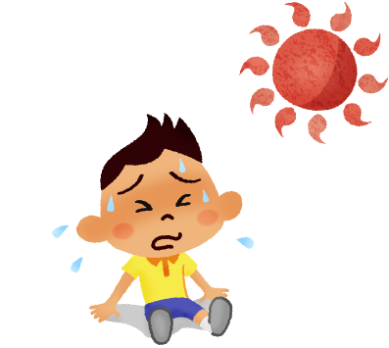

Heat Cramps
Heat Cramps tend to attack the muscles that do the hardest work, especially when hot. A good rule of thumb is to drink 1/2 glass of water every 15 minutes for an hour if you experience heat cramps.

Heat Exhaustion
Heat Exhaustion is a serious disorder that develops when the body loses more fluid than it is taking in.

Symptoms include: sweating profusely, near normal body temperature, clammy skin, pale or flushed complexion, weakness, dizziness, nausea.

First Aid: Move the person to shade or a cool place, have person lie on their back with feet elevated, if conscious, give 1/2 glass of water every 15 minutes, get medical help.

Heat Stroke
Heat Stroke is a medical emergency. Heatstroke occurs when the body's heat regulating system breaks down under stress and sweating stops. Unless the person receives quick treatment, death can occur.

Symptoms include: no sweating or sweating profusely, high body temperature (105 degrees or higher), hot, dry or flushed skin, confused, delirious behavior, loss of consciousness or coma.

First Aid: call 911 immediately for medical help, and then start first aid. Move the person to a cool place, cool the person quickly by giving a cool bath (sponging with cool water) and by fanning, treat for shock, offer a conscious person 1/2 glass of water every 15 minutes.

INJURY DECISION MAKING TREE

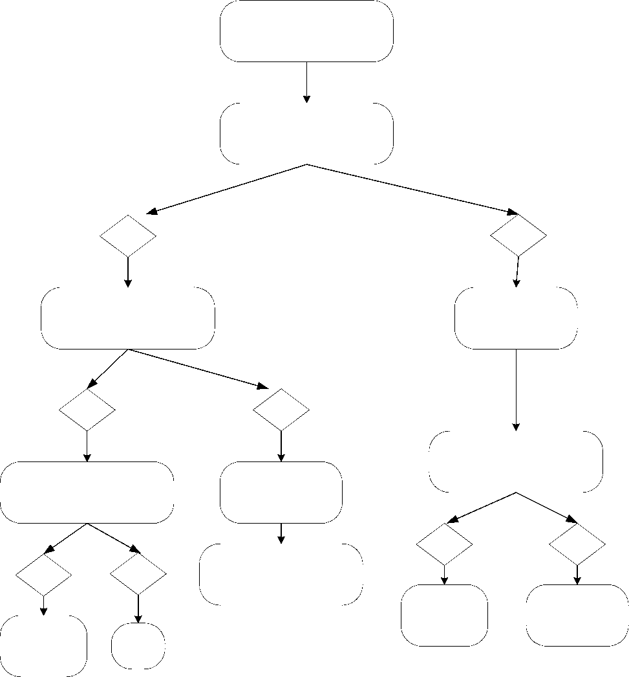
Do Not Move Wait for EMS
Yes
Call 911
Check breathing Check pulse
Still unconscious
Yes
Yes No
CPR
Do Not Move Player
No Let parents decide care
Encourage 911 Call
Ask "What hurts?"
Loss of consciousness
Player is hurt
No
Apply Ice First Aid
Yes
Check for bleeding,
swelling, bruising, etc.
Over areas that are hurt
Ask "What hurts?"
Parents
decide care
No

COMMUNICABLE DISEASE PROCEDURES
While the risk of one athlete infecting another with HIV/AIDS during competition is close to non-existent, there is a remote risk other blood born infectious diseases can be transmitted. Procedures for reducing the potential for transmission of infectious agents should include, but not be limited to the following:
- Bleeding must be stopped, the open wound covered and if there is any excessive amount of blood on the uniform it must be changed before athlete may participate.
- Routine use of gloves or other precautions to prevent skin and mucous membrane exposure when contact with blood or other blood fluids is anticipated.
- Immediately wash hands and other skin surfaces if contaminated (in contact) with blood or other body fluids. Wash hands immediately after removing gloves.
- Clean all blood contaminated surfaces and equipment with a solution made from a proper dilution (1:1) of household bleach and water or other disinfectant before competition resumes (example: 1 gallon of water per 1 gallon of bleach).
- Practice proper disposal procedures to prevent injuries caused by needles, scalpels and other sharp instruments or devices.
- Although saliva has not been implicated in HIV transmission, to minimize the need for emergency mouth-to-mouth resuscitation, mouthpieces, resuscitation bags, or other ventilation devices should be used.
- Athletic trainer/coaches with bleeding or oozing skin should refrain from all direct athletic care until condition resolves.
- Contaminated towels should be disposed of / or disinfected properly.
- Follow acceptable guidelines in the immediate control of bleeding and when handling bloody dressings, mouth guards and other articles containing body fluids.
10. Discard bloody dressing in biohazard bag.

CORONAVIRUS MITIGATION PROTOCOL

As we navigate the Corona virus pandemic, it is highly encouraged that each league and district adhere to the guidelines set forth by their respective state and local government and health officials in terms of public gatherings, organized youth sports, and sporting events when determining how and when to return to Little League activities. Leagues should contact their state and local health authority and other municipalities for guidance prior to resuming any Little League activities.
Little League Baseball
Williamsport, PA

As Canyon Country Little League considers returning to play, we will continue to seek guidance and direction from the following entities:

Center for Disease Control and Prevention: www.cdc.gov/coronavirus

California Department of Public Health: www.cdph.ca.gov

County of Los Angeles Public Health: www.publichealth.lacounty.gov

The CDC provides the following ways to stay safe IF an organization decides to play youth sports after adhering to all the state and local government guidelines.

- Choose outdoor settings as much as possible, particularly for high intensity activities.

- Maintain at least 6 feet of separation and avoid close contact with other people.

- Wear a mask that covers your mouth and nose at all times.

- Limit travel required outside of the local community.

- Wipe off frequently touched surface, equipment, or gear with disinfecting wipes before and after use.

- Wash your hands with soap and water for 20 seconds or use hand sanitizer with at least 60% alcohol before and after using machines.

- Limit how many people you interact with.

Canyon Country Little League will adopt the best practices on organizing, playing, and watching Little League Baseball and Softball during the Corona virus Pandemic as suggested by the Little League Organization (see pages 33 – 38).

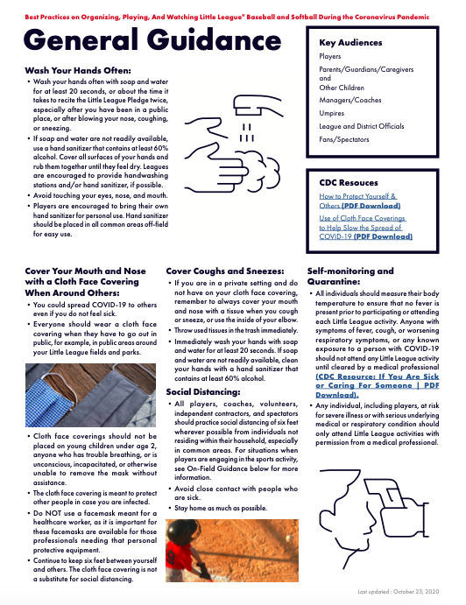

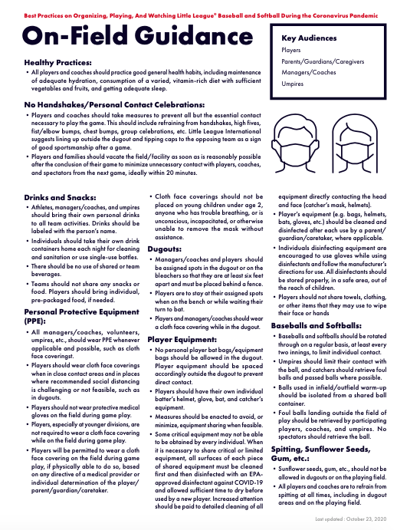

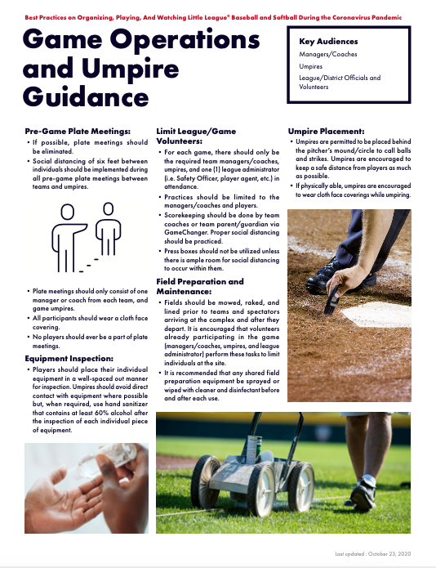

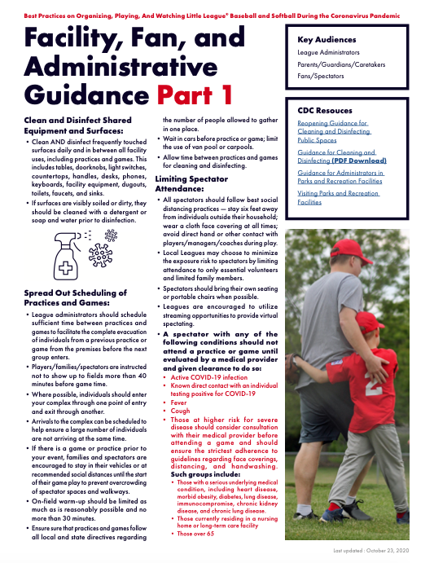

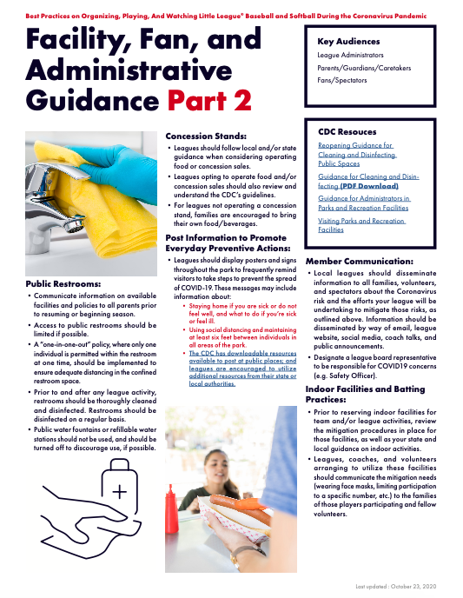

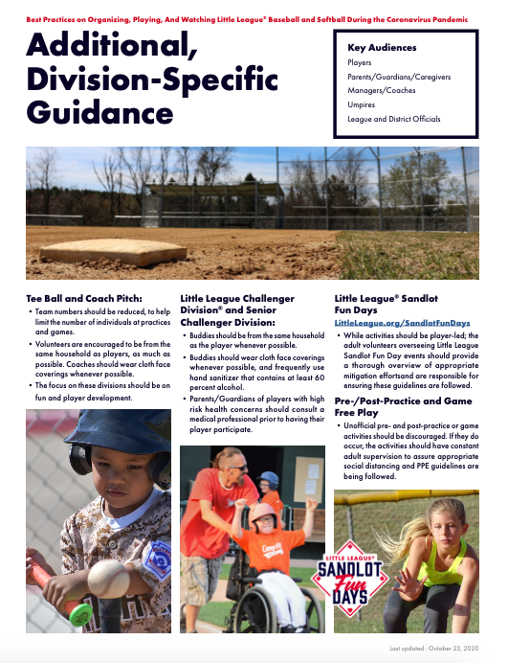

GOOD SAMARITAN LAWS
There are laws to protect you when you help someone in emergency situations. The "Good Samaritan Laws" give legal protection to people who provide emergency care to ill or injured persons. When citizens respond to an emergency and act as a reasonable and prudent person would under the same conditions; Good Samaritan immunity generally prevails. This legal immunity protects you, as a rescuer, from being sued and found financially responsible for the victim’s injury. For example, a reasonable and prudent person would:
>Move a victim only if the victim's life was endangered.
>Ask a conscious victim for permission before giving care.
>Check the victim for life-threatening emergencies before providing future care.
>Summon professional help to the scene by calling 9-1-1.
>Continue to provide care until more highly trained personnel arrive.
Good Samaritan laws were developed to encourage people to help others in emergency situations. They require that the “Good Samaritan” use common sense and a reasonable level of skill, not to exceed the scope of the individual's training in emergency situations. They assume each person would do his or her best to save a life or prevent further injury.
People are rarely sued for helping in an emergency. However, the existence of Good Samaritan laws does not mean that someone cannot sue. In rare cases, courts have ruled that these laws do not apply in cases when an individual rescuer's response was grossly or willfully negligent or reckless or when the rescuer abandoned the victim after initiating care.

INCIDENT REPORTS
The manager or coach is to complete an Incident Report every time a player is injured while participating in any CCLL event.
> Look the form over well and fill them in as completely as possible. Over time you can forget the details of an incident and the report will be the only document that can trigger your memory.
> Of special attention should be the area where you describe what happened. This should be written objectively as if you are giving data only. It should never be accusatory, biased, or blaming.
> The parent contact area also needs to be filled in completely. Use quotations if necessary stating parents’ wishes, such as: "I do not want you to call an ambulance" or "I don't think he needs any treatment" and document the name of the parent who made the decision.
> If you as a manager or coach feel a child should be seen by a doctor and verbalized this to the parent who did not agree, document that you suggested this to parent and that they declined.
All completed Incident Report forms need to be turned in to the CCLL Office or the Safety Officer as soon as possible.
The Safety Officer should be notified of any incident as soon as possible; not to exceed 48 hours.

Injury Reporting Procedures
Concerning injuries, all managers, coaches, parents, umpires, and volunteers should use the following reporting procedures.

What to Report
Any incident that causes a player, manager, coach, umpire, volunteer or spectator to receive medical treatment and/or first-aid must be reported to the Safety Officer or the designated Director On-Duty. This includes even passive treatments such as the evaluation and diagnosis of an injury that requires no further medical treatment.
IMMEDIATE ATTENTION

A full written report to the CCLL Board of Directors is Mandatory.

The report should be filled out immediately by the umpire in chief of the game in question and the injured player’s manager and/or coaches.

Injury report forms are in the CCLL office
CCLL Office Phone - 661-298-1451

How to Make the Report
CCLL requires a written report for every incident. Initially a phone report will be accepted with a full written report to follow. The following information will be needed:
> The name and phone number of the individual involved.
> Name and phone number of the parent or guardian.
> The date, time, and location of the incident.
> A detailed description of the incident.
> The preliminary estimate of the extent of any injuries.
> The names and statements of any witnesses to the incident.
> The name/phone number of the person reporting the incident.

> Did the Emergency authorities need to be contacted?

LIGHTNING FACTS AND SAFETY PROCEDURES
Consider the following facts:
> The average lightning strike is 6-8 miles long.
> The average thunderstorm is 6-10 miles wide and travels at a rate of 25 miles per hour.
> Once the leading edge of a thunderstorm approaches to within 10 miles, you are at immediate risk due to the possibility of lightning strikes coming from the storm's overhanging anvil cloud (for example, a lightning strike that injured 13 people during a concert occurred while it was sunny and dry).
> On average, thunder can only be heard over distances of 3 to 4 miles, depending on humidity, terrain and other factors. This means that by the time you hear the thunder, you are already in the risk area for lightning strikes.

"Flash-Bang" Method
One way to determine how close a recent lightning strike is to you is called the "flash-bang" method. With the "flash-bang" method, a person counts the number of seconds between the sight of a lightning strike and the sound of thunder that follows it. Halt play and evacuation should be called for when the count between the lightning flash and the sound of its thunder is 15 seconds or less.

Rule of Thumb
The ultimate truth about lightning is that it is unpredictable and cannot be prevented.
Therefore, any manager, coach, or umpire who feelsthreatened by an approaching
storm should stop play and get the kidstosafety. When in doubt, the following rule of
thumb should be applied:

WHEN YOU HEAR IT - CLEAR IT
WHEN YOU SEE IT FLEE IT

Where to Go
No place is completely safe from the threat of lightning, but some places are safer than others. Large enclosed shelters (substantially constructed buildings) are the safest. For a majority of participants, the best area for them to seek shelter is in a fully enclosed metal vehicle with the windows rolled up. If you are stranded in an open area and cannot get to shelter in a car, put your feet together, crouch down, and put your hands over your ears (to try and prevent eardrum damage).

Where not to Go
Avoid high places and open fields, isolated trees, unprotected gazebos, rain or picnic shelters, dugouts, flagpoles, bleachers (wood or metal),metal fences, and water.

First Aid to Lightning Victims
Typically, the lightning victim exhibits similar symptoms as that of someone suffering a heart attack. In addition to calling 911, the rescuer should consider the following:

> The first tenet of emergency care is "make no more casualties". If the victim is in a high-risk area (open field, isolated tree, etc.) the rescuer should determine if movement from that area is necessary. Lightning can and does strike the same place twice. If the rescuer is at risk, and movement of the victim is a viable option, it should be done.

> If the victim is unconscious, assess the victim and begin CPR as indicated.

SNACK BAR SAFETY
> No person under the age of twelve (12) will be allowed behind the counter of the snack bar.
> No person under the age of eighteen (18) will be allowed to handle items such as fryers, BBQ grills, propane or open flame.
> Snack bar workers must be trained in safe food preparation. Training should cover safe use of equipment.
> Cooking equipment will be inspected periodically and repaired or replaced if need be.
> Propane tanks will be turned off at the grill and at the tank after use.
> Food not purchased by CCLL to sell in its snack bar will not be cooked, prepared, or sold in the snack bar.
> Cooking grease will be stored in containers away from open flames.
> Carbon dioxide tanks will be secured with chains so they stand upright and cannot fall over. Report damage to tanks or valves to the supplier and discontinue use.
> Cleaning chemicals must be stored in a locked container.
> A certified fire extinguisher suitable for grease fires must be placed in plain sight, at all times.
> A fully stocked First Aid Kit will be placed in the snack bar.
> Snack bar doors will not be locked or blocked while people are inside.

STORAGE SHEDS AND EQUIPMENT
> All individuals who have either the keys or the combinations to the equipment storage areas have a responsibility to make sure that all equipment is in good repair, properly stored and secured after using it.
> All individuals who are aware of any unsafe equipment or supplies are responsible to report this information to a member of the Little League Board.
> Unsafe equipment is to be destroyed prior to being disposed of to prevent children from retrieving equipment and using it.
> Before using any equipment, please familiarize yourself with the proper use of that equipment (i.e., lights).
> All chemical or organic materials stored in the Little League storage areas will be properly marked and labeled as to their contents.
> Any spilled chemicals or organic material within these storage areas should be cleaned up and disposed of as soon as possible to prevent accidental poisoning.

EMERGENCY EVACUATION PLAN

> In planning for emergencies, there may be a need for all players, managers and/or coaches, umpires, and spectators to evacuate the CCLL Complex.

> The decision to evacuate the complex will be made by the Director on Duty or, in
their absence, any member of the board.

> In the event of a fire, earthquake, or other natural disaster, the decision to
evacuate the complex will be announced to the umpire at each field.

> Managers and coaches should be prepared to assist the players on their teams
with uniting with their parents prior to evacuating the complex, if possible.

> In the event players and families are separated during the evacuation, the
designated point for reunification will be at the bus transit parking lot located at
the intersection of Sierra Highway and Vasquez Canyon Road.

> If the decision is made to evacuate the CCLL Complex, vehicle traffic will be
directed to exit out the North and South Gates and on to Sierra Highway (see
Emergency Evacuation Map on Pg. 44).

FINAL THOUGHTS

> Remember, safety is everybody's job. Prevention is the key to reducing accidents to a minimum. Report all hazardous conditions to the Safety Officer or another Board Member immediately. Do not play on a field that is unsafe or with unsafe equipment. Check your equipment before each game and practice.

> Follow Little League policy regarding on-deck batters for ages 12 and under; during the game, the act of practice swinging a bat for any player that is not the present batter is not allowed by Little League. Players are not allowed to swing a bat during a game in the dugout, outside of the dugout, in the bullpen and/or batting cage. The time for your player to loosen up and practice a swing with a bat during the game is when the batter is up and it is his/her turn to bat in the game line-up; this batter can practice swing with the bat on the field and outside the foul lines and batter’s box.

> Be sure that your players are properly equipped, at all times, especially catchers and batters. Encourage the use of mouth guards and face guards.

> A catcher warming up a pitcher for a game, during a game, or between innings is to be a player on your team. For safety reasons, managers/coaches are not allowed to perform this task.

> Per Little League game and safety rules, managers and coaches are only allowed on the field during game play in the T-Ball Division; all other baseball and softball divisions require the coaches and managers to be in the dugout. Exception: For the team that is batting, their base coaches are allowed to stand in the base coach boxes, except for between innings and umpire approved timeouts. The only exception is for machine pitch or coach-pitch applications, which applies to the baseball Rookie Division. For the Rookie Division, the only coach allowed on the field during the game is the one operating the pitching machine or coach pitching. Managers or coaches on the field during the game can be assessed a time-out. Manager/coaches must be mindful of being assessed time-outs for being on the field; upon the 3rd time-out per pitcher in a game, a team must replace the current pitcher.

> Follow Little League guidelines on how often a player can pitch. Managers and coaches should keep an accurate pitch count on their pitchers…a child's arm is a terrible thing to injure with overuse.

> Players that are performing the base coaching duty must wear a helmet.

> Always warm-up all your players before a practice or a game.

> Whenever possible, make sure that someone at your practice or game has a cellular phone and reception(especially on those fields where no public phone access is available.)

> Canyon Country Little League provides it coaches, players and umpires with many clinics. Please attend as many of these clinics as possible. Attendance at these clinics is considered when applying for manager positions in regular and post season play. Managers and coaches must attend at least one Skills Clinic and one Safety Clinic every three years. One representative of each team must attend the Skills and Safety Clinic each year.

> Check the Canyon Country Little League Home Page frequently. It has important information about team standings, upcoming events, safety tips and general information. http://www.ccll.org

> Please remember that the players are looking at your behavior and sportsmanship. Set a GOOD EXAMPLE. No manager, coach or parent assistant is allowed to smoke or consume alcoholic beverages in the facility, at practices or at any other gathering where the players are present.

If you have any questions or concerns, contact any CCLL Board Member. Remember everyone can help - if you see anyone acting in an unsafe manner, or potentially unsafe manner, please take the personal initiative to resolve the situation or contact a board member. Thanks again for making Canyon Country Little League a safe place for our children to play ball.

Sincerely,

Marc Botello
Safety Officer
Canyon Country Little League 2021

EMERGENCY PHONE NUMBERS
The nearest phone is located at the CCLL Office and Snack Bar
CCLL Office………………………………………………………...661-298-1451
Fire…………………………………………………………………………..…..9-1-1
Ambulance…………………………………………………………………….9-1-1
Sheriff……………………………………………………………..…661-255-1121
Poison Control Center…………………………………………....800-222-1222
The Gas Company………………………………………….…….800-427-2200
Southern California Edison………………………………….…...800-684-8123
Electrical Shut off - see attached map
Santa Clarita Water Company…………………………….……..661-259-2737
Water Shut off valves - see attached map
Canyon Country Little League Address:
16066 Sierra Highway
Canyon Country, CA 91390
(just North of Vasquez Canyon Road)
CCLL President:
Jorge Diaz………………………………………………………..(818) 636-8341
CCLL Safety Officer:
Marc Botello………………………………………………….…..(661) 388-8917

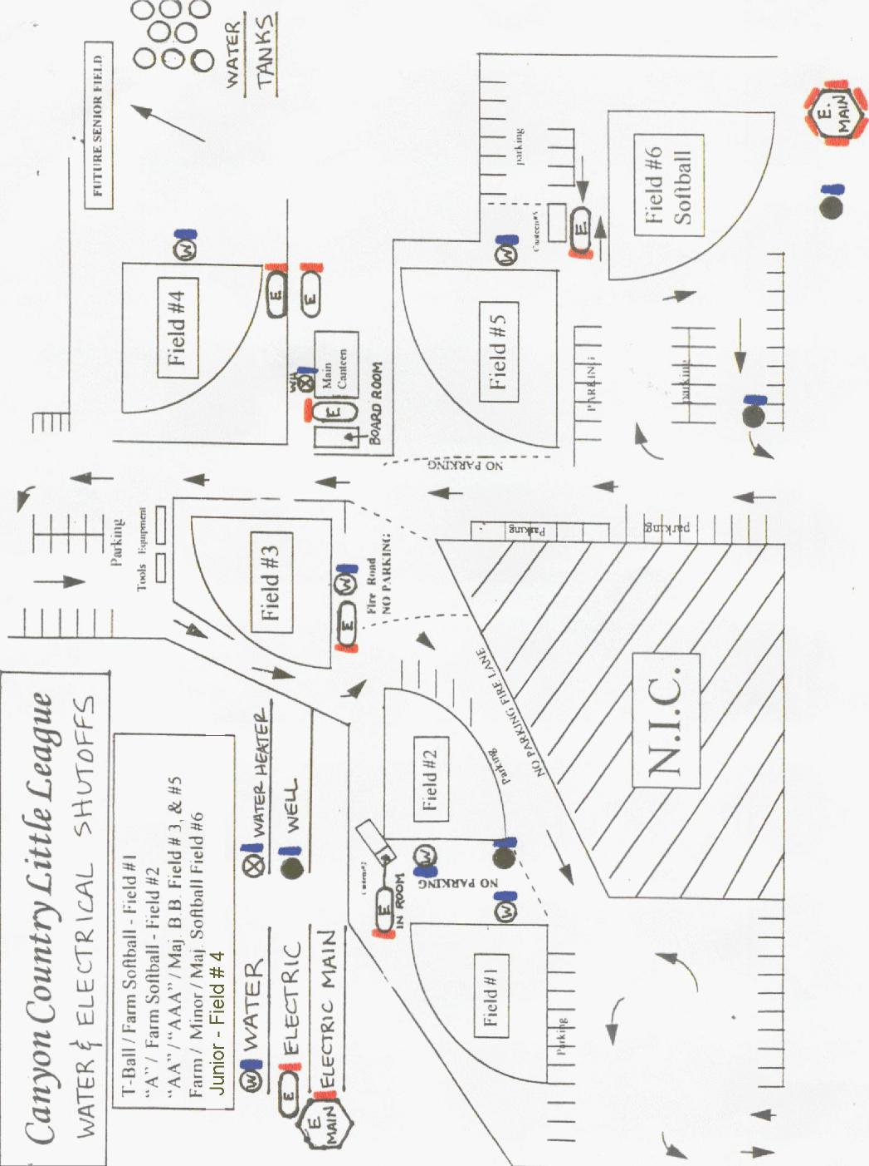
•
1' Elall/ Farm Softball - Field N I
000
00
000 cc
w
3
—4
Yd ON

EMERGENCY EVACUATION - MAP

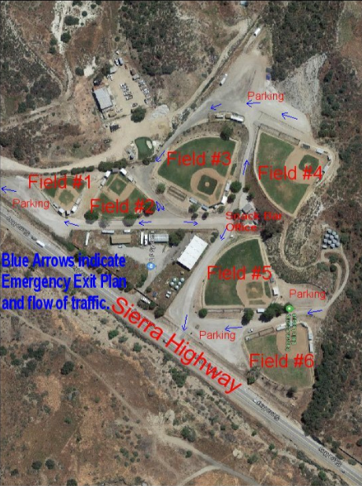

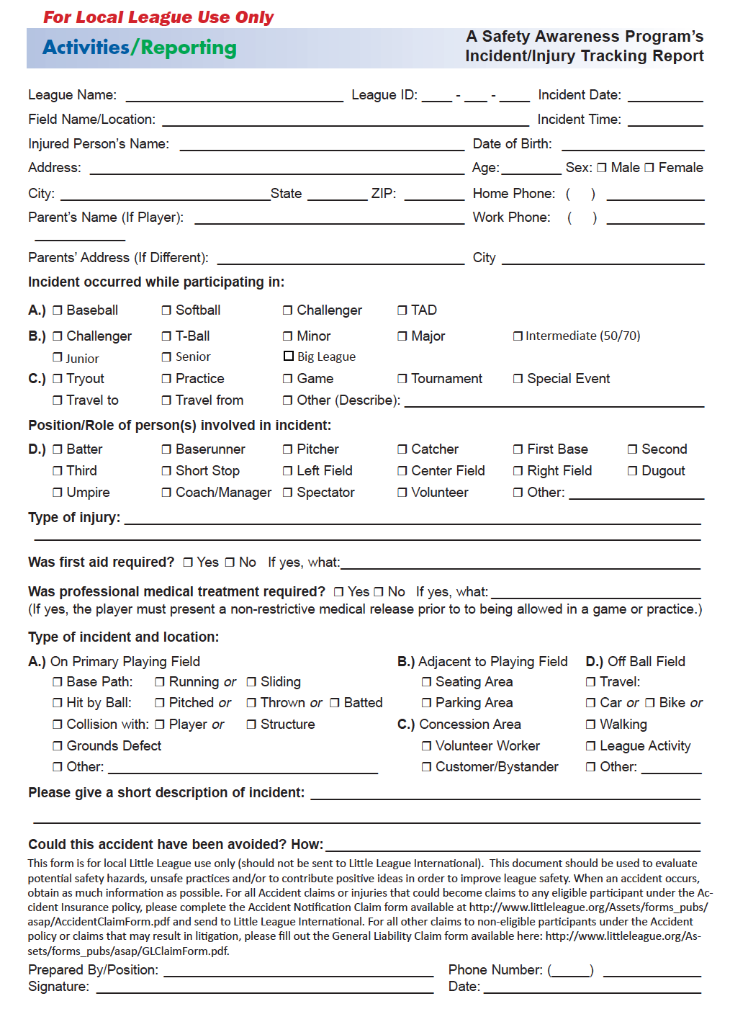
Incident Report Form
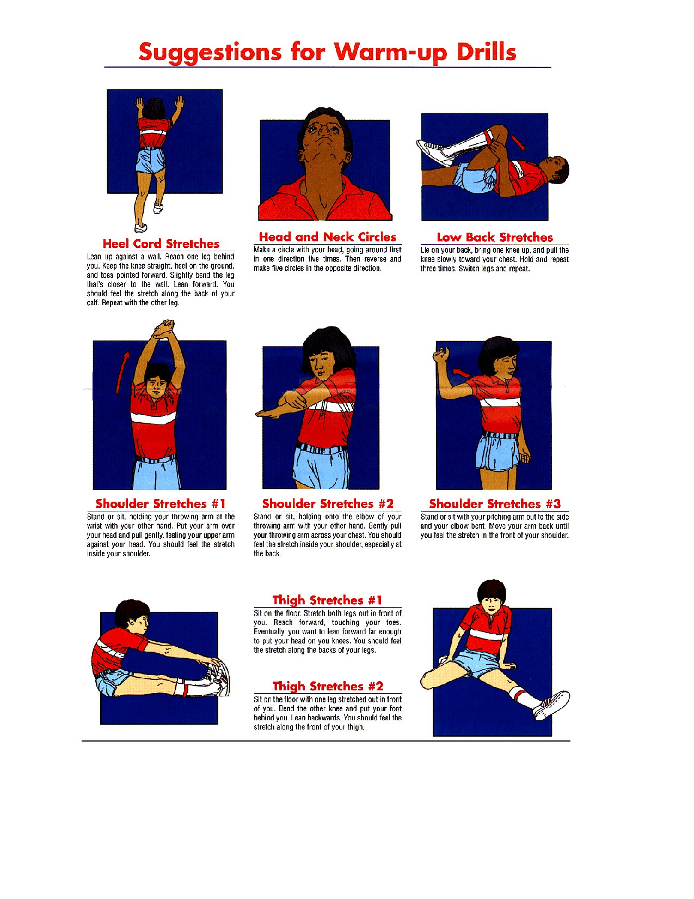

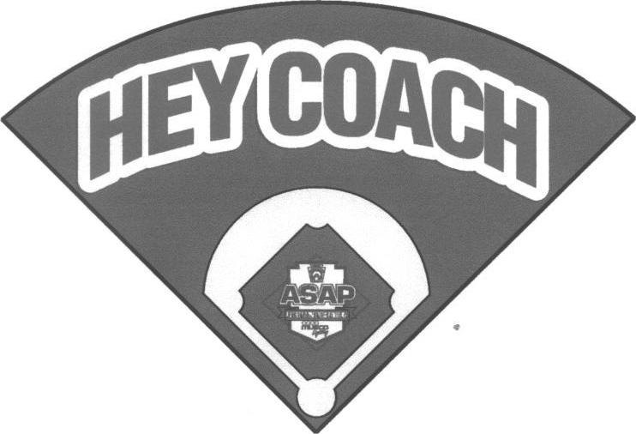
HAVE YOU:
1. Walked field for debris/foreign objects?
2. Inspected helmets, bats, catchers' gear?
3. Made sure a First Aid Kit is available?
4. Checked conditions of fences, backstops,
bases, and warning track?

5. Made sure a working telephone is available?

6. Held a warm-up drill?
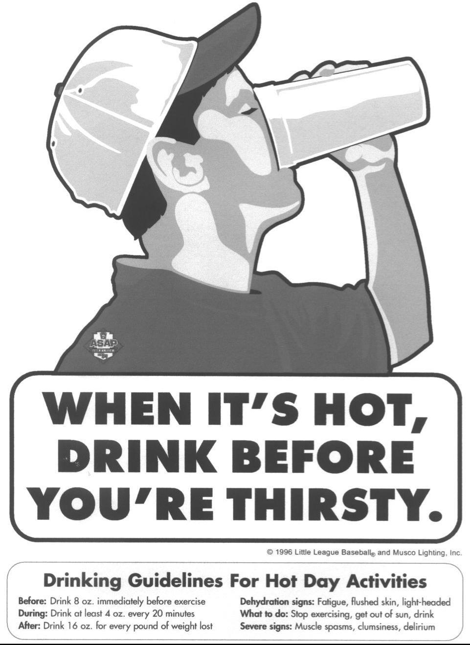

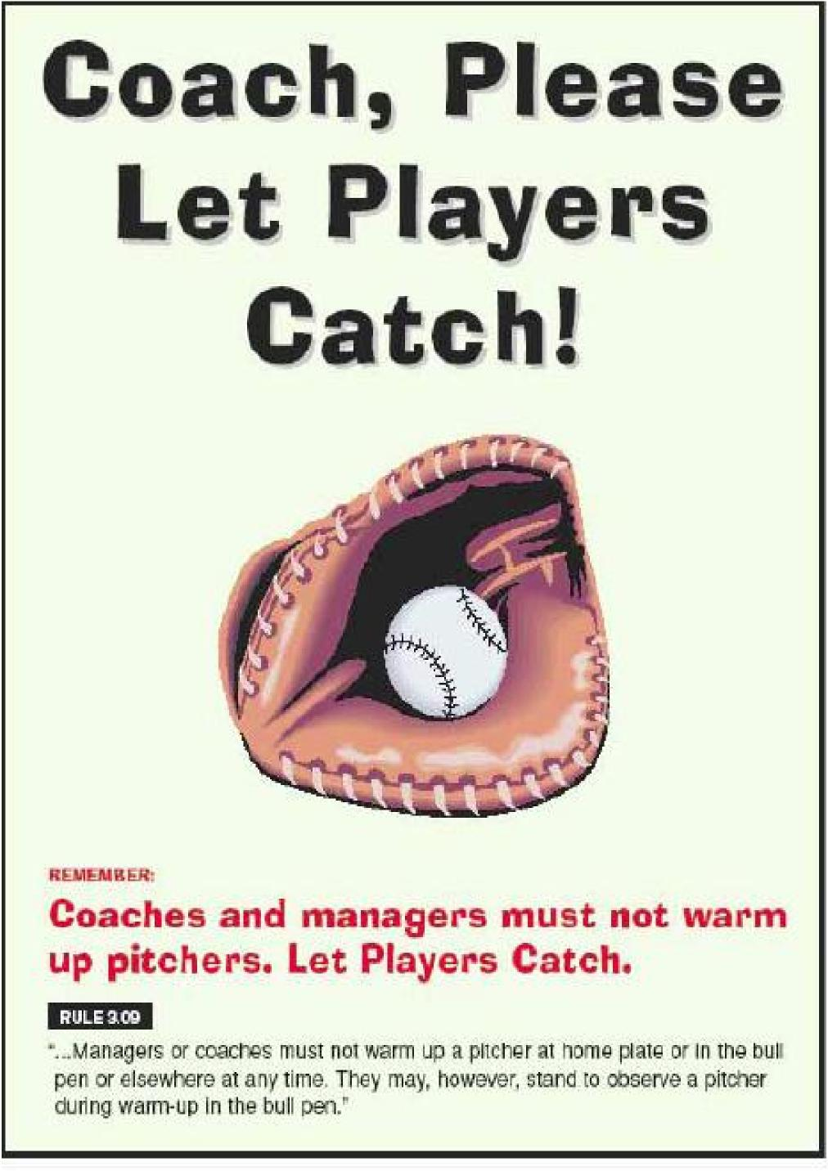

Don't Swing It

..Until You're Up to the Plate&
REM EMBER:

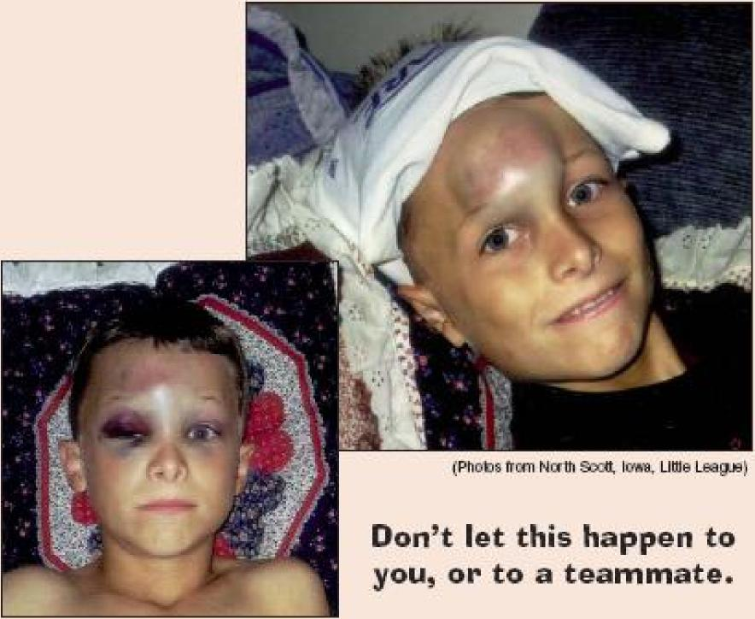
1.Phol:*frcfrr Nutt! Ica v, LIIII6 L6ague!
Don't let this happen to you, or to a teammate.
Don't pick up your bat until you leave
the dugout, to approach the plate.
MULE LOS, Noise
"1. The on-deck position is not permitted in Tee Ball, Minor League or Little League (Majors) Division. 2. Only the first batter of each half-inning will be allowed outside the dugout between the half-innings in Tee Ball, Minor League or Little League (Majors) Division."

CCLL Volunteer Code of Conduct

The following Code of Conduct has been mandated by the Board of Directors of Canyon Country Little League. All coaches and managers will read this Code of Conduct and sign in the space provided below acknowledging that he or she understands and agrees to comply with the Code of Conduct. Tear the signature sheet on the dotted line and mail to the CCLL Safety Officer in the enclosed envelope.
No Board Member, Manager, Coach, Player or Spectator shall:
- At any time, lay a hand upon, push, shove, strike, or threaten to strike an official.
- Be guilty of heaping persona] verbal or physical abuse upon any official for any real or imaginary belief of awrong decision or judgment.
- Be guilty of an objectionable demonstration of dissent at an official's decision by throwing of gloves, helmets, hats, bats, balls, or any other forceful un-sportsmanlike action.
- Be guilty of using unnecessarily rough tactics in the play of a game against the body of an opposing player.
- Be guilty of a physical attack upon any board member, official manager, coach, player or spectator.
- Be guilty of the use of profane, obscene or vulgar language in any manner at any time.
- Appear on the field of play, stands, or anywhere on the CCLL complex while in an intoxicated state at any time intoxicated will be defined as an odor or behavior issue.
- Be guilty of gambling upon any play or outcome of any game with anyone at any time.
- Be guilty of discussing publicly with spectators in a derogatory or abusive manner any play, decision or his/her personal opinion on any players during the game.
- As a manager or coach, be guilty of mingling with or fraternizing with spectators during the course of the game
but shall remain on the player’s bench or on the field during the game.
- Speak disrespectfully to any manager, coach, official or representative of the league.
- Be guilty of tampering or manipulation of any league rosters, schedules, draft positions or selections, official score books, rankings, financial records or procedures.
- Shall challenge an umpire's authority. The umpires shall have the authority and discretion during a game to penalize the offender according to the infraction up to and including removal from the game.
The Board of Directors will review all infractions of the CCLL Code of Conduct.
Depending on the seriousness or frequency, the Board may assess additional disciplinary action up to and including expulsion from the league.
No TOBACCO PRODUCTS while on the CCLL premises

I have read the CCLL Volunteer Code of Conduct and will adhere to all rules and regulations set forth.

Print Name of Manager:_______________________________________ Team Name and Division:________________

Signature of Manager:________________________________________________ Date: _______________________

Assistant Coach Name:________________________________________________

Assistant Coach Signature:____________________________________________ Date: _________________________

Assistant Coach Name:________________________________________________

Assistant Coach Signature:____________________________________________ Date: __________________________

Youth Sports Parent Code of Conduct
Preamble
The essential elements of character building and ethics in sports are embodied in the concept of sportsmanship and six core principles: trustworthiness, respect, responsibility, fairness, caring, and good citizenship. The highest potential of sports is achieved when competition reflects these "six pillars of character.'
I therefore agree:
1. I will not force my child to participate in sports.
2. I will remember that children participate to have fun and that the game is for
youth, not adults.
- I will inform the coach of any physical disability: or ailment that may affect the safety of my child or the safety of others.
- I will learn the rules of the game and the policies of the league.
- I (and my guests) will be a positive role model for my child and encourage sportsmanship by showing respect and courtesy, and by demonstrating positive support for all players, coaches, officials and spectators at every game, practice or sporting event.
- I (and my guests) will not engage in any kind of unsportsmanlike conduct with any official, coach, player, or parent such as booing and taunting, refusing to shake hands, or using profane language or gestures.
- I will not encourage any behaviors or practices that would endanger the health and well-being of the athletes.
- I will teach my child to play by the rules and to resolve conflicts without resorting to hostility or violence.
- I will demand that my child treat other players, coaches, officials and spectators with respect regardless of race, creed color, sex or ability.
- I will teach my child that doing one's best is more important than winning, so that my child will never feel defeated by the outcome of a game or his/her performance.
- I will praise my child for competing fairly and tying hard, 9rdmake 17 child feel like a winner every time.
- I will never ridicule or yell at my child or other participants for making a mistake or losing a competition
- I will emphasize skill development and practices and how they benefit my child over winning_ I will also de-emphasize games and competition in the lower age groups.
- I will promote the emotional and physical well-being of the athletes ahead of any personal desire I may have for my child to win.
- I will respect the officials and their authority during games and will never question, discuss, or confront coaches at the game field, and will take time to speak with coaches at an agreed upon time and place.
- I will demand a sports environment for my child that is free from drugs, tobacco, and alcohol, and I will refrain from their use at all sports events.
- I will refrain from coaching my child or other players (luting games and practices, unless I am one of the official coaches of the team.

CLAIM FORM INSTRUCTIONS
For claims occurring after January 1, 2005
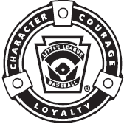
WARNING—It is important that parents/guardians and players note that: Protective equipment cannot prevent all injuries a player might receive while participating in baseball/softball
To expedite league personnel's reporting of injuries, we have prepared guidelines to use as a checklist in completing reports. It will save time -- and speed your payment of claims.
The AIG Accident Master Policy acquired through Little League contains an "Excess Coverage Provision" whereby all personal and/or group insurance shall be used first.
To help explain insurance coverage to parents/guardians refer to What Parents Should Know an the internet that should be reproduced on your league's letterhead and distributed to parents/guardians of all participants at registration time.
H injuries occur, initially it is necessary to determine whether claimant's parents/guardians or the claimant has other insurance such as group, employer, Blue Cross and Blue Shield, etc., which pays benefits. (This information should be obtained at the time of registration prior to tryouts.) If such coverage is provided, the claim must be filed first with the primary company under which the parent/guardian or claimant is insured.
When filing a claim, all medical costs should be fully itemized and forwarded to Headquarters. If no other insurance is in effect, a letter from the parent's/guardian's or claimant's employer explaining the lack of group or employer insurance should accompany the claim form.
The AIG Accident Policy is acquired by leagues, not parents, and provides comprehensive coverage at an affordable cost. Accident coverage is underwritten by National Union Fire Insurance Company of Pittsburgh, Pa., with its principal place of business in New York, NY. This is a brief description of the coverage available under the policy. The policy will contain limitations, exclusions, and termination provisions.
With your league's cooperation, insurance rates have increased only three times since 1965. This rate stability would not have been possible without your help in stressing safety programs at the local level. The ASAP manual, League Safety Officer Program Kit, is recommended for use by your Safety Officer. In 2000 the State of Virginia was the first state to have its accident insurance rates reduced by high participation in ASAP and reduction in injuries. In 2002, seven more states have had their accident insurance rates reduced, as well. They are Alaska, California, Delaware, Idaho, Montana, Washington, Wisconsin.
TREATMENT OF DENTAL INJURIES
Deferred Dental Treatment for claims or injuries occurring in 2002 and beyond: If the insured incurs injury to sound, natural teeth and necessary treatment requires that dental treatment for that injury must be postponed to a date more than 52 weeks after the date of the injury due to, but not limited to, the physiological changes occurring to an insured who is a growing child, we will pay the lesser of the maximum benefit of $1,500.00 or the reasonable expense incurred for the deferred dental treatment. Reasonable expenses incurred for deferred dental treatment are only covered if they are incurred on or before the insured's 23rd birthday. Reasonable Expenses incurred for deferred root canal therapy are only covered if they are incurred within 104 weeks after the date the Injury occurs.

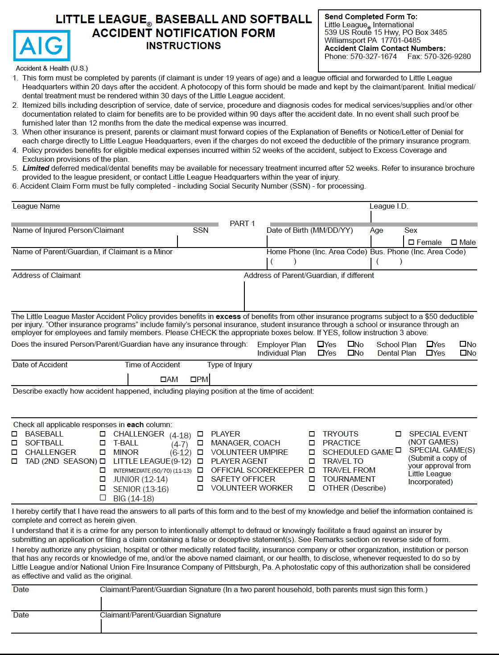

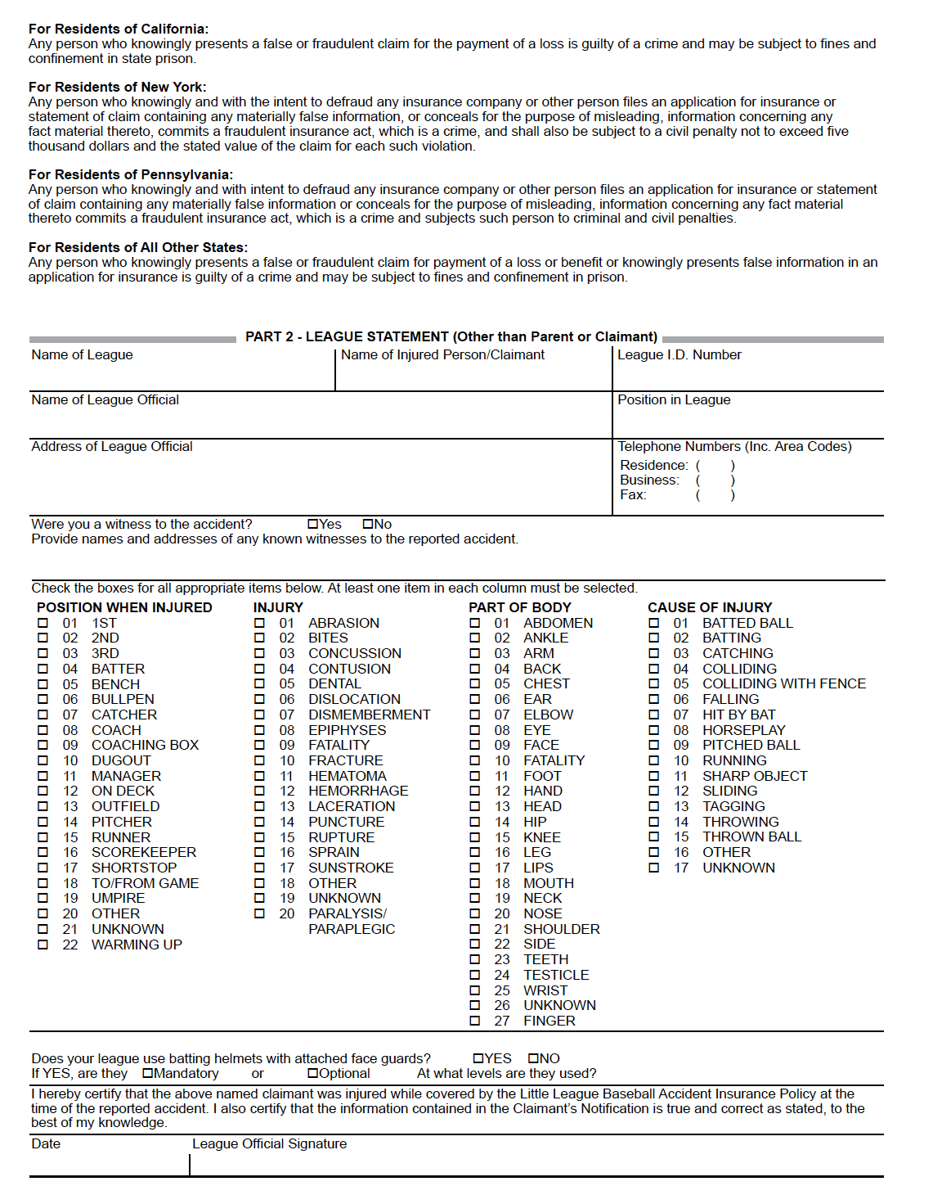
CHECKLIST' FOR PREPARING CLAIM FORM
- Print or type all information.
- Complete all portions of the claim form before mailing to our office.
- Be sure to include league name and league ID number.
PART I - CLAIMANT, OR PARENT(S) GUARDIAN(S), IF CLAIMANT ISA MINOR
- The adult claimant or parent(s) (guardians) must sign this section, if the claimant is a minor.
- Give the name and address of the injured person, along with the name and address of the parent(s) guardian(s), if claimant is a minor.
- Fill out all sections, including check marks in the appropriate boxes for all categories. Do not leave any section blank. This will cause a delay in processing your claim and a copy of the claim form will be returned to you for completion.
- It is mandatory to forward information on other insurance. Without that information there will be a delay in processing your claim. If no insurance, written verification from each parent ( spouse ) employer must be submitted.
- Be certain all necessary papers are attached to the claim form. (See instruction 3.) Only itemized bills are acceptable.
- On dental claims, it is necessary to submit charges to the major medical and dental insurance company of the claimant, or parent(s) guardian(s) if claimant is a minor. "Accident-related treatment to whole, sound, natural teeth as a direct and independent result of an accident" must be stated on the form and bills. Please forward a copy of the insurance company's response to Little League Headquarters. Include the claimant's name, league ID, and year of the injury on the form.
PART II - LEAGUE STATEMENT
- This section must be filled out, signed and dated by the league official.
- Fill out all sections, including check marks in the appropriate boxes for all categories. Do not leave any section blank. This will cause a delay in processing your claim and a copy of the claim form will be returned to you for completion.
IMPORTANT: Notification of a claim should be filed with Little League International within 20 days of the incident for the current season.

CONCUSSION FACTS and INFORMATION
Canyon Country Little League

A Fact Sheet for YOUTH SPORTS COACHES
One of the main jobs of a youth sports coach is keeping athletes safe. This sheet has information to help you protect athletes from concussion or other serious brain injury, learn how to spot a concussion, and know what to do if a concussion occurs.

WHAT IS A CONCUSSION?
A concussion is a type of traumatic brain injury—or TBI— caused by a bump, blow, or jolt to the head or by a hit to the body that causes the head and brain to move quickly back and forth. This fast movement can cause the brain to bounce around or twist in the skull, creating chemical changes in the brain and sometimes stretching and damaging the brain cells.

HOW CAN I HELP KEEP ATHLETES SAFE?
Sports are a great way for children and teens to stay healthy and can help them do well in school. As a youth sports coach, your actions create the culture for safety and can help lower an athlete’s chance of getting a concussion or other serious injury. Aggressive and/or unsportsmanlike behavior among athletes can increase their chances of getting a concussion or other serious injury. Here are some ways you can help keep your athletes safe:

Talk with athletes about the importance of reporting a concussion:
• Talk with athletes about any concerns they might have about reporting their concussion symptoms. Make sure to tell them that safety comes first and you expect them to tell you and their parent(s) if they think they have a concussion.

Create a culture of safety at games and practices:
• Teach athletes ways to lower the chances of getting a concussion.
• Enforce the rules of the sport for fair play, safety, and sportsmanship.
• Ensure athletes avoid unsafe actions such as:
› Striking another athlete in the head;
› Using their head or helmet to contact another athlete;
› Making illegal contacts or checking, tackling, or colliding with an unprotected opponent;
and/or
› Trying to injure or put another athlete at risk for injury.
• Tell athletes that you expect good sportsmanship at all times, both on and off the playing field.

Keep up-to-date on concussion information:
• Review your state, league, and/or organization’s concussion guidelines and protocols.
• Take a training course on concussion. CDC offers concussion training at no cost at
www.cdc.gov/headsup.

• Download CDC’s HEADS UP app or a list of concussion signs and symptoms that you can keep
on hand. Check out the equipment and sports facilities:
• Make sure all athletes wear a helmet that fits well and is in good condition when appropriate for
the sport or activity. There is no “concussion-proof” helmet, so it is important to enforce safety rules
that protect athletes from hits to the head and when a helmet falls off during a play.
• Work with the game or event administrator to remove tripping hazards and ensure that equipment,
such as goalposts, have padding that is in good condition.

Keep emergency contact information handy:
• Make sure all athletes wear a helmet that fits well and is in good condition when appropriate for the
sport or activity. There is no “concussion-proof” helmet, so it is important to enforce safety rules that
protect athletes from hits to the head and when a helmet falls off during a play.
• Work with the game or event administrator to remove tripping hazards and ensure that equipment,
such as goalposts, have padding that is in good condition.

HOW CAN I SPOT A POSSIBLE CONCUSSION?
Athletes who show or report one or more of the signs and symptoms listed below—or simply say they just “don’t feel right” after a bump, blow, or jolt to the head or body—may have a concussion or other serious brain injury.

SIGNS OBSERVED BY COACHES OR PARENTS:
• Appears dazed or stunned.
• Forgets an instruction, is confused about an assign mentor position, or is unsure of the game, score, or opponent
• Moves clumsily.
• Answers questions slowly.
• Loses consciousness (even briefly).
• Shows mood, behavior, or personality changes.
• Can’t recall events prior to or after a hit or fall.

SYMPTOMS REPORTED BY ATHLETES:
• Headache or “pressure” in head.
• Nausea or vomiting.
• Balance problems or dizziness, or double or blurry vision.
• Bothered by light or noise.
• Feeling sluggish, hazy, foggy, or groggy.
• Confusion, or concentration or memory problems.
• Just not “feeling right”, or “feeling down”.
NOTE: Concussion signs and symptoms often show up soon after the injury, but it can be hard to tell how serious the concussion is at first. Some symptoms may not be noticed or may not show up for hours or days.

WHAT ARE SOME MORE SERIOUS DANGER SIGNS TO LOOK FOR?
In rare cases, a dangerous collection of blood (hematoma) may form on the brain after a bump, blow, or jolt to the head or body and can squeeze the brain against the skull. Call 9-1-1 or ensure an athlete is taken to the emergency department right away if, after a bump, blow, or jolt to the head or body, he or she has one or more of these danger
signs:
• One pupil larger than the other.
• Drowsiness or inability to wake up.
• A headache that gets worse and does not go away.
• Slurred speech, weakness, numbness, or decreased coordination.
• Repeated vomiting or nausea, convulsions or seizures (shaking or twitching).
• Unusual behavior, increased confusion, restlessness, or agitation.
• Loss of consciousness (passed out/knocked out). Even a brief loss of consciousness should be taken seriously.

CONCUSSIONS AFFECT EACH ATHLETE DIFFERENTLY.
While most athletes with a concussion feel better within a couple of weeks, some will have symptoms for months or longer. Talk with an athlete’s parents if you notice their concussion symptoms come back after they return to play.

WHAT SHOULD I DO IF I THINK AN ATHLETE HAS A POSSIBLE CONCUSSION?
As a coach, if you think an athlete may have a concussion, you REMOVE THE ATHLETE FROM PLAY. When in doubt, sit them out!

KEEP AN ATHLETE WITH A POSSIBLE CONCUSSION OUT OF PLAY ON THE SAME DAY OF THE INJURY AND UNTIL CLEARED BY A HEALTH CARE PROVIDER.
Do not try to judge the severity of the injury yourself. Only a health care provider should assess an athlete for a possible concussion. After you remove an athlete with a possible concussion from practice or play, the decision about return to practice or play is a medical decision that should be made by a health care provider. As a coach, recording the following information can help a health care provider in assessing the athlete after the injury:
• Cause of the injury and force of the hit or blow to the head or body.
• Any loss of consciousness (passed out/knocked out) and if so, for how long.
• Any memory loss right after the injury.
• Any seizures right after the injury.
• Number of previous concussions (if any).

INFORM THE ATHLETE’S PARENT(S) ABOUT THE POSSIBLE CONCUSSION.
Let them know about the possible concussion and give them the HEADS UP fact sheet for parents. This fact sheet can help parents watch the athlete for concussion signs or symptoms that may show up or get worse once the athlete is at home or returns to school.

ASK FOR WRITTEN INSTRUCTIONS FROM THE ATHLETE’S HEALTH CARE PROVIDER ON RETURN TO PLAY.
These instructions should include information about when they can return to play and what steps you should take to help them safely return to play.

JOIN THE CONVERSATION AT www.facebook.com/CDCHEADSUP

WHY SHOULD I REMOVE AN ATHLETE WITH A POSSIBLE CONCUSSION FROM PLAY?
The brain needs time to heal after a concussion. An athlete who continues to play with concussion has a greater chance of getting another concussion. A repeat concussion that occurs while the brain is still healing from the first injury can be very serious and can affect an athlete for a lifetime. It can even be fatal.

SOME ATHLETES MAY NOT REPORT A CONCUSSION BECAUSE THEY DON’T THINK A CONCUSSION IS SERIOUS.
They may also worry about:
• Losing their position on the team or during the game.
• Jeopardizing their future sports career.
• Looking weak.
• Letting their teammates or the team down.
• What their coach or teammates might think of them.

WHAT STEPS CAN I TAKE TO HELP AN ATHLETE RETURN TO PLAY?
An athlete’s return to school and sports should be a gradual process that is approved and carefully managed and monitored by a health care provider. When available, be sure to also work closely with your team’s certified athletic trainer.
Below are five gradual steps that you, along with a health care provider, should follow to help safely return an athlete to play. Remember, this is a gradual process. These steps should not be completed in one day, but instead over days, weeks, or months.
BASELINE:
Athlete is back to their regular school activities, is no longer experiencing symptoms from the injury when doing normal activities, and has a green light from their health care provider to begin the return to play process. An athlete should only move to the next step if they do not have any new symptoms at the current step.
STEP 1:
Begin with light aerobic exercise only to increase an athlete’s heart rate. This means about 5 to 10 minutes on an exercise bike, walking, or light jogging. No weightlifting at this point.
STEP 2:
Continue with activities to increase an athlete’s heart rate with body or head movement. This includes moderate jogging, brief running, moderate-intensity stationary biking, moderate-intensity weightlifting (less time and/or less weight than a typical routine).
STEP 3:
Add heavy non-contact physical activity, such as sprinting/running, high-intensity stationary biking, regular weightlifting routine, non-contact sport-specific drills (in 3 planes of movement).
STEP 4:
An athlete may return to practice and full contact (if appropriate for the sport) in controlled practice.
STEP 5:
An athlete may return to competition.

REMEMBER:
It is important for you and the athlete’s parent(s) to watch for concussion symptoms after each day’s return to play progression activity. If an athlete’s concussion symptoms come back, or he or she gets new symptoms when becoming more active at any step, this is a sign that the athlete is pushing him- or herself too hard. The athlete should stop these activities, and the athlete’s health care provider should be contacted. After the okay from the athlete’s health care provider, the athlete can begin at the previous step.

1. Kerr ZY, Register-Mihalik JK, Marshall SW, Evenson KR, Mihalik JP, Guskiewicz KM (2014). Disclosure and non-disclosure of concussion and concussion symptoms in athletes: Review and application of the socio-ecological framework. Brain Inj. 2014;28(8):1009-21.
2. Register-Mihalik JK, Guskiewicz KM, McLeod TC, Linnan LA, Mueller FO, Marshall SW. (2013a). Knowledge, attitude, and concussion- reporting behaviors among high school athletes: A preliminary study. J Athl Train, July 12, 2013.
3. Chrisman, S. P., Quitiquit, C., Rivara, F. P. (2013). Qualitative Study of Barriers to Concussive Symptom Reporting in High School Athletics. J Adolesc Health. March, 2013, 52(3): 330-335.

Content Source: CDC’s HEADS UP campaign. Customizable HEADS UP fact sheets were made possible through a grant to the CDC Foundation from the National Operating Committee on Standards for Athletic Equipment (NOCSAE).
JOIN THE CONVERSATION AT
www.facebook.com/CDCHEADSUP

TO LEARN MORE GO TO
cdc.gov/HEADSUP

