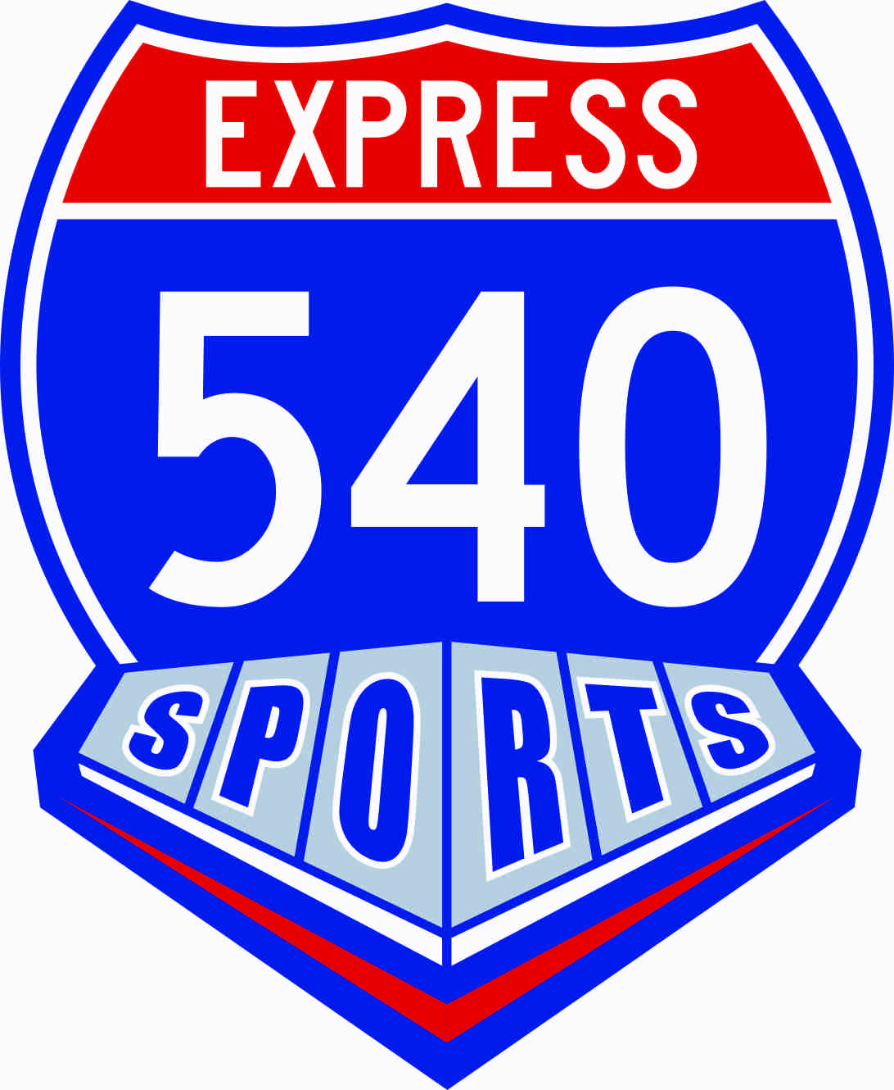

March 1, 2018

540 Express Sports is a non-profit organization that is dedicated to provide our area children with opportunities to participate in recreational sports such as softball, baseball, football and cheerleading to enhance leadership, sportsmanship and teamwork skills. It serves hundreds of families with children’s recreational sport’s needs.

As we strive to improve our youth sports programs, we plan to hold the 13th Annual 540 Express Sports “Swinging for Sports” Golf Challenge on Monday, May 14th, at 9 am at 12 Oaks Golf Course. We anticipate full participation with 100-120 players. In addition, we will have Hot Buffet Breakfast and BBQ lunch. Come early and practice with the pro’s with unlimited range balls. Proceeds for this event will benefit all 540 Express Sports sports programs.

We would like to invite you to be a part of this worthwhile event by doing one or all of the following:

1. Organize a team(s) to participate in the tournament (see enclosed flyer).

2. Become one of our four-level sponsors.

Corporate WORLD SERIES
Champion Sponsor
$1000.00
4 Free Play Spots
Banner and Tee Box Marker
Top Tournament Recognition

NATIONAL LEAGUE AMERICAN LEAGUE DIVISIONAL
Champion Sponsor Champion Sponsor Champion Sponsor
$500.00 $300.00 $150.00
2 Free Play Spots 1 Free Play Spot Tee or Green Sign
Premier Tee Sign Premier Green Sign Placement
Placement Placement

Advertise your business on either a hole or tee on the golf course. A sign will be posted on either a hole or tee with your name showing that your business supports our cause. Additionally, brochures will be distributed to all players listing those sponsors by sponsor level. As always, we encourage all participants to became patrons of our sponsors.

3. Donate an item to be given as a door prize.

As many of our participants are avid sports fans, we hope to provide sports and dining treasures that no one can resist. If your organization directly lends itself to these items (green fees, game tickets, sports equipment or clothing, autographed items, shooting rounds, restaurant or equipment certificates, etc.), we would be most appreciative for its donation to this worthy cause. You may also contribute by funding the purchase of these items. “Goody Bag” items are also appreciated to make this a fun and memorable event for our participants.

If you choose to participate in our tournament or you should you have any questions, please contact me at the address or numbers listed above. All donations are tax-deductible. Thank you in advance for your generous support of our efforts to improve our youth sports program for our 540 Express Sports children.

Sincerely,

Jeff Scott
919-306-7012

“Leadership, Sportsmanship and Teamwork through Athletics”

