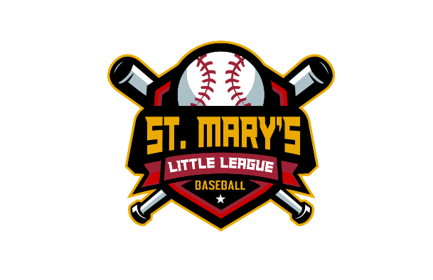
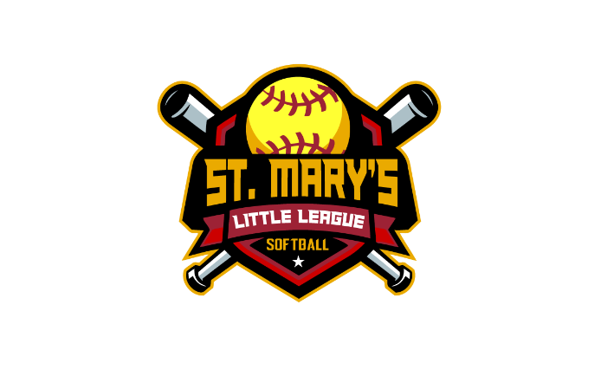
St. Mary’s Little League
PO Box 1641
California, MD 20619

St Mary’s Little League Coaches, Parents/Guardians, and Players,

St Mary’s Little League (SMLL) board of directors with the support of St Mary’s Parks and Recreation have developed the following return to play procedures and guidelines. In accordance with Maryland’s Interim Guidance for Limited Outdoor Youth Sports, SMLL submits the below plan for youth baseball and softball skill-building drills and team-based practices.

Prior to Arrival to Park/Baseball Field
- All coaches, parents, and players shall read and sign the SMLL Covid-19 Release of Liability, Waiver of Claims, Assumption of Risks and Indemnity Agreement.
- These requirements will be shared prior to the event with all players, coaches, parents/guardians, and spectators prior to their arrival at the park/baseball field.
- Must conduct daily symptom assessments by coaches and players (self-evaluation). Anyone experiencing symptoms must stay home.
- Athletes are strongly recommended to travel to the park/baseball field alone or with a member of their immediate household.

Arrival to Park/Baseball Field
- Any league equipment and common spaces will be wiped down by coaches prior to each practice.
- Coaches must have a face covering available (pocket) for such situations (giving first aide) where you can not keep six-feet of social separation.
- All participants, spectators, and coaches must adhere to six-foot physical distancing at all times while at the park/baseball field.
- No congregating in parking lot, or in bleacher area.
- Personal belongings and equipment will only be used by the individual owner or operator including, but not limited to water bottles, gloves, bats, hats, and other on- and off-field gear.

Skill-Building Drills and Team-Based Practice at the Park/Baseball Field
- When reporting to the field, Coaches and players must adhere to physical six-foot distancing at all times. No congregating in the dugout.
- All skill-building drills/practicing of skills will be set-up to maintain a minimum of 6 feet or more of separation/distance between all players and coaches.
- For each practice/skills session, coaches will divide players into groups (no more than 8 players and 2 coaches per group) and establish rotating shifts of 2-3 groups. Each group will be in a different location within the park.
  - 90 foot diamond fields, (2) groups a total of 16 players are allowed
  - 60 Foot diamond fields, (1) group with a total of 8 players are allowed
  - Batting cages are an extension of your assigned baseball field.
- Rotation of groups should not cross and social distancing shall be maintained.
- No team water coolers or shared drinking stations will be allowed.
- At no time will any player and/or coach touch any other player or coach. The “No Touch Rule” will be enforced – players will be refrained from high fives, handshake lines, huddles, and other physical contact with teammates, coaches, and fans.
- No spitting or eating seeds, gum, other similar products.

During Games (when approved by St Mary’s P&Rs)
- All guidelines for Arrival and Practices will remain in effect with the additions of:
  - Prior to competitive tournaments, event owners must alert the local health department of the event.
  - Lineups should be entered online or by spoken word and recorded by officials/umpires without exchanging any physical documents with coaches or players.
  - The home plate umpires will call balls and strikes from behind the pitching mound.
  - Bleachers are closed. Parents and fans will bring their own chairs and set up along the fence, keeping six-feet of physical separation between other families.
  - During batting, both the hitter and catcher will wear a face covering.
  - While players and coaches are in the dugout, face coverings will be worn by all players and coaches. Additionally, dugout size dependent, players will be allowed to sit with families outside the field along the fence.
  - No touch rule – players and coaches will refrain from high fives, handshake lines, and other physical contact with teammates, opposing players, coaches, umpires, and fans. A “tip the cap” can be used following the game in lieu of the handshake line.
  - At no time will there be more than 35-total on a ballfield consisting of players, coaches, and umpires for a game.
    - Team 1: (3) coaches, (12) players
    - Team 3: (3) coaches, (12) players
    - Umpire: (2)

VR / / St Mary’s Little League

