R EQUIPMENT INFORMATION
PLAYER EQUIPMENT (SUBJECT TO CHANGE)
Team Uniform & Hat: Provided by Niceville Valparaiso Little League. Team uniforms & hats will be distributed to the team during the first week of practice.
Baseball Pants: Baseball pants are required will be provided by the league.

Belt & Socks: Baseball socks and belts are required (depending on division) and are provided by the league.
Baseball Bat: Bats are required and all players should have their own as it ensures a more enjoyable season to be comfortable with using the same one. It is essential that you select a baseball bat that fits your player's skill level, height, weight, and hitting strength. Use the following links for tips when buying the your players’ bat Selecting the Right Baseball Bat and selecting the right Softball Bat.

ALL NVLL BATS MUST CONFORM TO THE USA BASEBALL BAT STANDARD SPECIFICATIONS as to what bats are approved by Little League for use in their various divisions. It must have the USA Baseball Stamp per below. Any other bats are illegal and may cause a team to forfeit a game and suspend a team manager.
Little League Bat Information Page
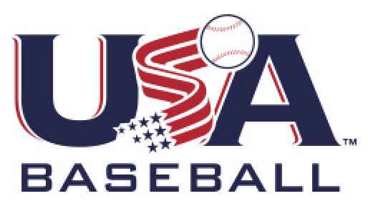
Bat Sizing is always a challenge as well as if your child is beginning with baseball. Go for a lighter bat to maintain bat speed, which is the top priority in hitting. If they cannot hold the bat for 20 seconds without the arm starting to shake it is too heavy. The goal is to not fight the equipment and typical the higher the drop weight number the easier for the player to swing. And bats have a wide range of prices. What does it mean to your players batting average - Zero. You make the same contact no matter how expensive the bat.
Glove: Baseball gloves are required at all practices and games. Avoid buying an oversized glove. Beginners should stick to a smaller glove for additional control. It does take time to break in your new glove. No matter what you do, most will agree that the most effective way to break in a baseball glove is by using it. Most gloves have the pre-measured size stamped inside where the pocket is. Below are general sizes:
Tee-Ball 9-10
Infield 10 - 11.75
Pitcher 11.5 - 12.25
Outfield 11.5 - 12.25

Cleats: Baseball cleats are required and is arguably an important baseball item to buy your child. If you want your child to truly learn and enjoy any sport as well as avoid injury, you will go out of your way to purchase them appropriate shoes. Cleats with metal spikes are not permitted. Shoes with molded cleats are permissible. PLEASE NO SOCCER CLEATS. Parents/players can select the color of their choosing. Please make sure they properly fit to ensure a comfortable two plus hours on the field. The Juniors/Seniors level does allow for metal cleats or spikes in these divisions but are not required so it's the players choice.
Helmet: The league does not provide helmets. It is required that each player purchase their own helmet. Altering the helmet in any form, including painting or adding decals (by anyone other than the manufacturer or authorized dealer) may void the warranty. Face guards are permitted, provided they were fitted to the helmet by the manufacturer and contain all of the original fasteners. No alterations are allowed.
Catcher Gear: One set of catcher’s gear is provided to each team by NVLL. Players may provide their own gear. Catchers must wear approved long or short model chest protectors. All catchers must wear chest protectors with the neck collar, throat guard, shin guards and catcher's helmet, all of which must meet Little League specifications and standards. All catchers must wear a mask, “dangling” type throat protector and catcher's helmet during infield/outfield practice, pitcher warm-up and games.
Batting Gloves: Batting gloves are optional and a personal preference of the player.
Athletic Supporters: All male players playing divisions higher than Tee Ball must wear an Athletic Supporter or compression shorts under their baseball pants for their protection per Little League. The catcher (males) must wear an athletic supporter, metal, fiber or plastic type cup.

Equipment Bag: Baseball equipment bags are an optional item but are very nice to have and some only costs $20. The player can put all his baseball gear & water in the bag and hang it on the dugout fence. This item can be used for future seasons.
Long Sleeve Under Jersey Shirt: Long sleeve shirts are optional and parents’ choice. These keep the player warm for any of those cold spring weather games and there will be a few.

Baseballs: Baseballs are provided by Niceville Valparaiso Little League. These balls shall weigh not less than five (5) nor more than five and one-fourth (5¼) ounces, and measure not less than nine (9) nor more than nine and one-fourth (9¼) inches in circumference for Majors division and lower. Tee Balls will say Little League Tee Ball on them.

