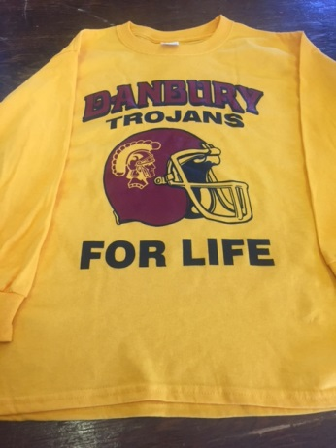
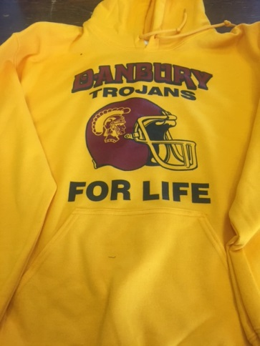
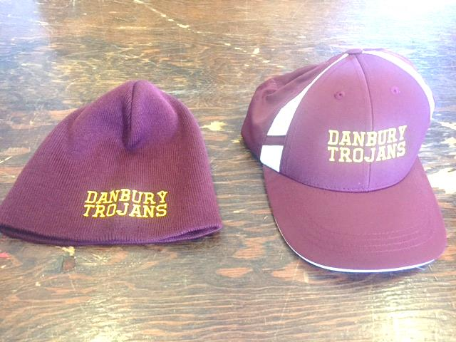
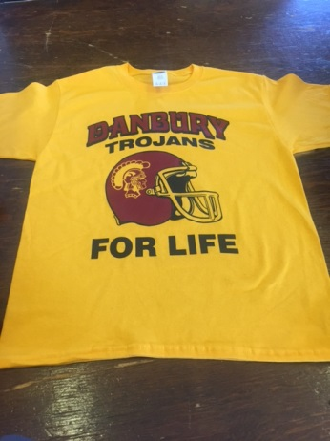
DANBURY TROJAN FOOTBALL WEAR -2017

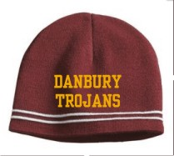
ALL HATS ARE $15.00 only

$12.00 Short sleeve
3XL and above $15

$25.00 Sweatshirts
3XL and above $30
$15.00 Long Sleeve
3XL and above $20

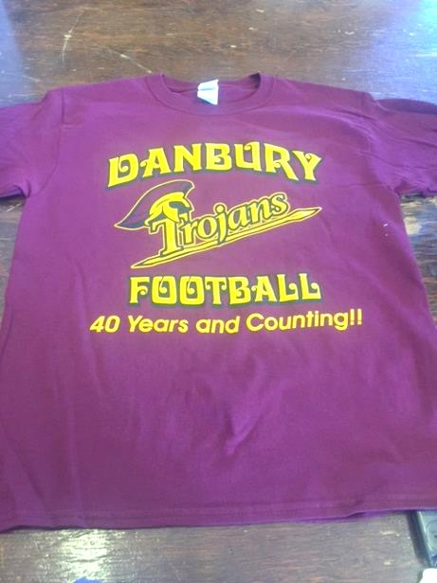
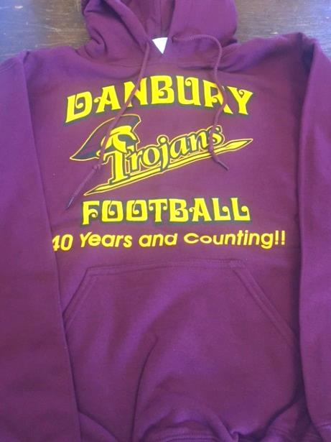
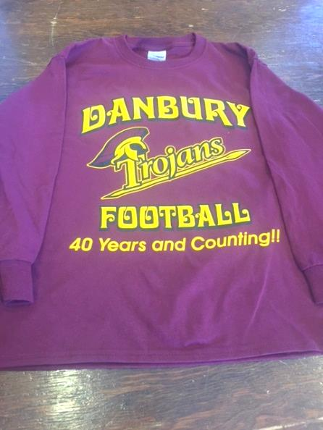

A

$25.00 Sweatshirts
3XL and above $30

$15.00 Long Sleeve
3XL and above $20

$12.00 Short sleeve
3XL and above $15

