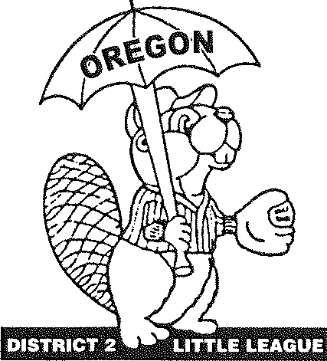
OREGON DISTRICT #2 LITTLE LEAGUE
Vern Loftis, District Administrator, 503-260-3261 455 Bridge St, Fairview, OR 97024 vern.loftis@gmail.com

Congratulations and Welcome!!!
To the 2026 Oregon State Tournament Major Baseball

Oregon District #2 & Clackamas Little League welcome you, your coaching staff, the All-Stars and their fans to Oregon State's LL Major Baseball Tournament and wish you good luck and lots of fun while in Clackamas. Enclosed please find information that will help make your stay with us an enjoyable one.
Tournament Director: Cory Tobias Cell: 503-442-1932
E-mail: coreytobias8@gmail.com

Umpire in Chief: Brad Parker Cell: 971-998-4451
E-mail: bparkerblue2548@gmail.com

Clackamas Little League
President: JessicaKloberdanz
Cell: 503-758-5243
E-mail: president@clackamaslittleleague.org

Managers: There will be a mandatory manager/coach meeting at TBA at the tournament location. Riverside Park in Clackamas Little League is located at 17298 SE Water Ave in Clackamas, OR. A map of the location is enclosed. Please bring your copy of the approved affidavit to this meeting. We will verify affidavits after the meeting and return them to managers upon completion. Clackamas LL is hosting a welcome ceremony Saturday, after the last game @5:45 PM?. See attached schedule.

District Administrators/Tournament Directors: As soon as you have a district champion, please e-mail your coaching staff contact and roster information to coreytobias8@gmail.com.

Please let me know if there is anything my staff or I can do for you. We look forward to making this an event your players will remember for a lifetime.

Little Leagues Serving the Youth of Multnomah and Clackamas Counties

Clackamas * East County * Mt. Hood * Mountain View * Southeast * Taborvilla

Welcome Ceremony
State 9-11 Baseball Tournament
Clackamas Little League
TBA

2026 Oregon State Little League
Major Baseball
Hosted by Clackamas Little League
Riverside Park - 17298 SE Water Ave
A
B

2026 Oregon Little League Baseball Oregon District #2 Little League Tournament Protocol & Schedule
Please review the following agenda for all state tournament games:
- Report to the score booth 45 minutes before game start time with your line-up each game. Please have three copies prepared, one for the official book, one for the opposing team and one to keep. The first scheduled game you'll need to bring your team's phonetic player roster for the announcer, in addition to the line-up.
- If you have a league or district representative travelling with you, please advise the tournament director at this time, so we can introduce and thank that person during the opening ceremony.
- We'll flip for Home/Visitor at this time and announce to spectators which side their team will be on. The teams will then report to their dugouts.
- 25 minutes before game start time both teams need to be in their dugout. The tournament director will ask the visiting team to take their 7 minutes of infield. Then the home team will have 7 minutes of infield.
- We'll have a brief welcome and introduction of players at each game. We ask that the manager come to the plate to announce his/her players because you know how to pronounce their names. This also gives the announcer an opportunity to hear each name correctly. Visiting team will line up between 1st base and pitcher's mound, home team between 3rd base and pitcher's mound.
- After games where a team has been eliminated, tournament officials ask for a few moments with your team to present pins.
- At the conclusion of the championship game, the State Runners-up will be called onto the field for their presentation. Then the State Champs will be called out for their presentation. Spectators must remain in the stands until invited to come onto the field of play. This is the player's time to shine in the spotlight. Parents will be given the opportunity to take pictures on the field after the presentations.
- Managers of tournament teams are responsible for their fan’s behavior as well as their players. If there is a problem, we expect you to address it. You set the tone of behavior among the players and their parents. Set the example for young players to follow. Please teach them to respect their fellow competitors - win or lose.
- No artificial noise-makers/cowbells/kazoos are allowed at District 2 tournament games, but cheering great plays regardless of who makes them is always welcomed.

Good Luck to all. "Let's play ball !!!"

PHONETIC SPELLING ROSTER

Tournament Level: Major Baseball STATE
District:
League:
NAME PHONETIC SPELLING
President:
Manager:
Coach:
Coach:

Uniform# | Players | Phonetic Spelling
Example:ITom Berringer tom bear-in-jer
Please complete this form for the announcer at your tournament site.
Turn in to the Tournament Director at your first game.

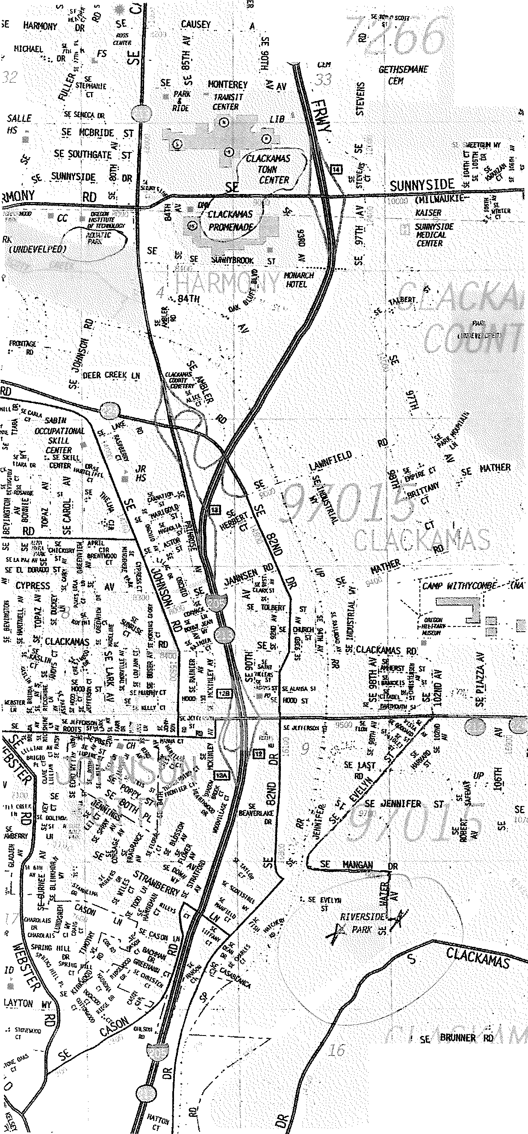
AV
t
.:r
,, ,,,
.H£MilllIAL
d!i.lW
'BAR/JENS
C£H
TOP O SCOTT
GOLF
COURSE
C•
'"'

Directions to Clackamas LL
Riverside Park

From I-205, Exit at Hwy. 212/224 heading east toward Damascus & Estacada. Turn South on Evelyn St. Keep going, straight through Jennifer St. The road makes a sharp left turn and becomes Mangan Dr. At the end of Mangan Dr., turn right onto Water Ave. At the bottom of the hill will be the parking lot and ball fields.
Beware! I-205 can be nasty during rush hour and the Sunnyside Rd. interchange is often packed with traffic from Clackamas Towne Center.
If you're coming in on Hwy. 26 and plan to take the back roads, Hwy. 212 is the best bet. Head west on Hwy 212 at the Compton Rd. exit half way between Sandy and Gresham.
Drive Safely!!!

Sightseeing in Clackamas Riverside Park not only offers ball fields, but a lovely park facility too. Clackamas River access is the park's other function.
Clackamas Towne Center & the Clackamas Promenade offers a shopper's paradise.
Clackamas Aquatic Park is just west of the Towne Center, on Sunnyside Rd. just west of 82nd Ave.
Take some time to enjoy the sights.

Lodging & Attractions

Hotels for Tournament:

Monarch Hotel & Conference Center: 503-652-1515 Across Sunnyside Rd from Clackamas Towne Center Pool, shopping, close to freeway

Hampton Inn: 503-655-7900
9040 South East Adams, Clackamas, OR 97015 Nearest to the field, close to freeway

Attractions during the Tournament:

Mount Talbert Nature Park
Tree-covered 4-mile trail network ranging from paved, ADA-accessible routes to steep footpaths.
Clackamas, OR

North Clackamas Aquatic Park Water Park
Wave pool, water slides & other attractions featured at an aquatic center with a rock wall too.

End of the Oregon Trail Historical Place
Interpretive center with costumed guides & interactive exhibits showcasing life in the mid-1800s.

