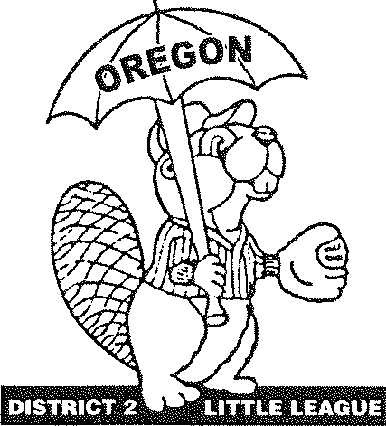
OREGON DISTRICT #2 LITTLE LEAGUE
Vern Loftis, District Administrator, 503-260-3261 455 Bridge St, Fairview, OR 97024 vern.loftis@gmail.com

Congratulations and Welcome!!!
To the 2026 Oregon State Tournament Junior / Senior Softball

Oregon District #2 & Hood River Little League welcome you, your coaching staff, the All-Stars, and their fans to Oregon State's Junior / Senior Softball Tournament and wish you good luck and lots of fun while in Hood River, Oregon. Enclosed please find information to help make your stay with us enjoyable.

Tournament Director: Ron Brown Cell: 503-349-4583
E-mail: Ron@refconinc.com

Umpire in Chief: Seth Hunt
Cell: 503-334-7316
E-mail: sethhunt@msn.com

Hood River Valley Little League President: Eric Foster
Cell: 541-490-4084
E-mail: hrvlittleleague@gmail.com
Hood River Valley Little League - VP Softball - Jeremy Belcher
Cell: 541-380-1455
E-mail: jeremybelcher7@gmail.com

Managers: There will be a mandatory manager/coach meeting at 6:00 pm on Friday, July 10th, at the tournament location. Hood River Little League is located at 1500 Nix Dr.,d River, Oregon 97031. A map of the location is enclosed. Please bring your copy of the approved affidavit to this meeting. We will verify affidavits after the meeting and return them to the managers upon completion. Hood River LL is hosting an opening ceremony on Friday, July 10th, after the Manager meeting @7:00pm. See attached schedule.

District Administrators/Tournament Directors: As soon as you have a district champion, please e-mail your coaching staff contact and roster information to Ron@refconinc.com

Please let me know if there is anything my staff or I can do for you. We look forward to making this an event your players will remember for a lifetime.

Little Leagues Serving the Youth of Multnomah, Clackamas and Hood River Counties

Clackamas * East County * Mt. Hood * Mountain View * Southeast * Taborvilla *Hood River

Welcome Ceremony
Junior / Senior Softball Tournament
Hood River Little League
Friday, July 10th, 6:00pm

Note: Please bring any pins to trade during the ceremony and after

6:00pm:
Mandatory Manager/Coach Meeting W/Tournament Staff

7:00pm:
Line up w teams and coaches w/ District banners behind 3rd base dugout

7:10pm:
- Welcome
- Introductions of teams (team pictures)
- Group picture
- Little League pledge
- Parent pledge

7:30:
- Pizza Party: Pizza & Drinks (For players and managers/coaches)

8:00:
- Event End

2026 Oregon Junior/Senior League Softball Oregon District #2 Little League Tournament Protocol & Schedule
Please review the following agenda for all state tournament games:
- Report to the score booth 45 minutes before the game start time with your line-up for each game. Please have three copies prepared, one for the official book, one for the opposing team, and one to keep. For the first scheduled game, you'll need to bring your team's phonetic player roster for the announcer, in addition to the line-up.
- If you have a league or district representative traveling with you, please advise the tournament director at this time, so we can introduce and thank that person during the opening ceremony.
- We'll flip for Home/Visitor at this time and announce to spectators which side their team will be on. The teams will then report to their dugouts.
- 25 minutes before the game starts, both teams need to be in their dugout. The tournament director will ask the visiting team to take their 7 minutes of infield. Then the home team will have 7 minutes of infield.
- We'll have a brief welcome and introduction of players at each game. We ask that the manager come to the plate to announce his/her players because you know how to pronounce their names. This also gives the announcer an opportunity to hear each name correctly. The visiting team will line up between 1st base and the pitcher's mound, the home team between 3rd base and the pitcher's mound.
- After games where a team has been eliminated, tournament officials ask for a few moments with your team to present pins.
- At the conclusion of the championship game, the State Runners-up will be called onto the field for their presentation. Then the State Champs will be called out for their presentation. Spectators must remain in the stands until invited to come onto the field of play. This is the player's time to shine in the spotlight. Parents will be given the opportunity to take pictures on the field after the presentations.
- Managers of tournament teams are responsible for their fans' behavior as well as their players. If there is a problem, we expect you to address it. You set the tone of behavior among the players and their parents. Set the example for young players to follow. Please teach them to respect their fellow competitors - win or lose.
- No artificial noise-makers are allowed at District 2 tournament games, but cheering great plays regardless of who makes them is always welcomed.

Good Luck to all. "Let's play ball !!!"
PHONETIC SPELLING ROSTER

Tournament Level: Junior Softball STATE
District:
League:
NAME PHONETIC SPELLING
President:
Manager:
Coach:
Coach:

Uniform# | Players | Phonetic Spelling
Example:ITom Berringer tom bear-in-jer
Please complete this form for the announcer at your tournament site.
Turn in to the Tournament Director at your first game.

PHONETIC SPELLING ROSTER

Tournament Level: Senior Softball STATE
District:
League:
NAME PHONETIC SPELLING
President:
Manager:
Coach:
Coach:

Uniform# | Players | Phonetic Spelling
Example:ITom Berringer tom bear-in-jer
Please complete this form for the announcer at your tournament site.
Turn in to the Tournament Director at your first game

Hood River Area Hotels

Best Western Plus Hood River Inn
1108 E. Marina Way
Hood River, Oregon 97031
541-386-2200

Holiday Inn Express and Suites
2625 Cascade Ave
Hood River, Oregon 97031
541-308-1000

Sunset Motel
2300 Cascade Ave
Hood River, Oregon 97031
541-386-6322

Westcliff Lodge
4070 Westcliff Drive
Hood River, Oregon 97031
541-386-2992

Hampton Inn and Suites
1 Nichols Parkway
Hood River, Oregon 97031
541-436-1000

The Dalles Area Hotels (26-28 miles from field)

Cousins Country Inn
2114 W 6th St.
The Dalles, Oregon 97058
541-298-5161

Holiday Inn Express and Suites IHG
2920 W 6th St.
The Dalles, Oregon 97058

Fairfield by Marriott Inn and Suites
2014 W. 7th St.
The Dalles, Oregon 97058
541-769-0753

Comfort Inn Columbia Gorge
351 Lone Pine Dr.
The Dalles, Oregon 97058
541-298-2800

White Salmon Hotels (15 minutes from field)

Inn of the White Salmon
172 W Jewett Blvd
White Salmon, WA 98672
509-493-2335

The Society Hotel
210 Cedar S
Cook, WA 98605
(509) 774-4437

Camping / RV

Tucker Park -
2440 Dee Hwy

Lost Lake Resort and Campground
9000 Lost Lake Rd

Memaloos State Park Campground

Viento State Park

Toll Bridge Park
7360 Toll Bridge Rd

Gorge Base Camp
65271 WA-14 White Salmon, WA 98672
509-310-7504

Things to do

Hood River Aquatic Center

WAAAM Museum

Frog Beach - Hood River Water Front - Close to waterfront restaurants.

Hood River Water Front Park- swimming and playground. Restaurants across the street

Hood River Fruit Loop - Fruit, ciders, beer, pastries, ice cream

Kingsley Reservoir - Swimming and Trout Fishing - 12 miles 28 minute drive

Lost Lake Resort - paddle boat rentals, fishing, gift shop, camping. 24 miles 45 minute drive

Mosier Tunnels Hike - Start at the Mark O. Hatfield Trailhead

Indian Creek Golf

Hood River Golf

Multnomah Falls

Bonneville Dam Fish Hatchery

Wet Planet white water rafting

Skamania Lodge Adventures

Zollers Outdoor Odysseys - white water rafting

Restaurants - Some of our local favorites with many others to choose from.

Full Sail Brewing
Divots Restaurant
Crush Cider
Sixth Street Bistro
Ixtapa
Bette’s Restaurant
Hood River Taqueria
Solstice Pizza
Riverside Grill
Egg River
Mesquitery
Apple Valley BBQ
Ferment Brewing
Pfriem Brewing
Kickstand
Freshies Bagel Co.
Pietro's Pizza
Everybody’s
Mike’s Ice cream
Everybody’s Brewing
Kickstand
Thai House

Coffee Shops
Kickstand Coffee
Dog River Coffee
Doppio Coffee
Ground Coffee
Stoked Rosters
Pine Street Bakery

Coffee Drive Thru
Country Coffee
Dutch Bros
Moby Coffee
Starbucks

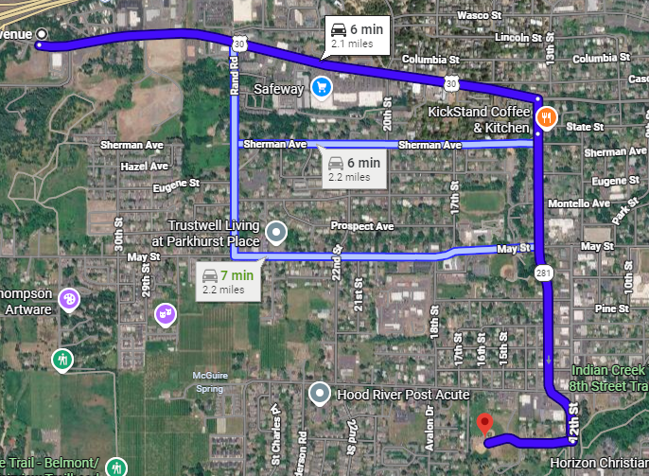
Directions Eastbound I-84 at Exit 62

Head east on I-84 E
Take exit 62 for US-30 toward W Hood River/Westcliff Drive
Turn right onto US-30 E
Turn right onto 13th St.
Keep left to continue on OR-281 S/13th St
Turn right onto Nix Dr

1500 Nix Dr (through the gate at the dead end rd)
Hood River, OR 97031

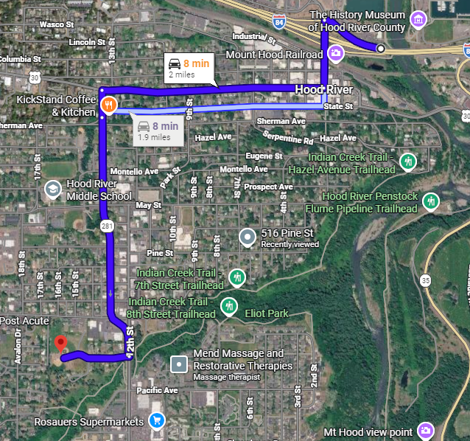
Directions West bound at Exit 63
Head toward N 2nd
Turn left onto N 2nd StTurn right onto Oak St
Turn left onto 13th St.
Keep left to continue on OR-281 S/13th St
Turn right onto Nix Dr

1500 Nix Dr (through the gate at the dead end rd)
Hood River, OR 97031

