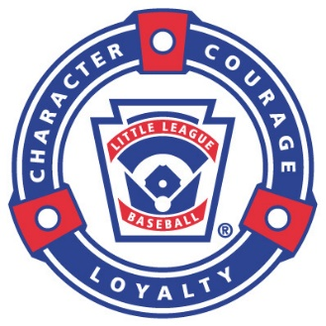
2022

7th Annual Portland Umpire Outreach Clinic

- Have you ever been called out of the stands to help umpire a game?
- Have you ever made a safe and out at the same time?
- Are you the new “UIC” for your local league?
- Do you need to just shake off the cobwebs for the upcoming season?
- Are you looking for a source to fine-tune your umpiring skills?
- Do you want to work-with and learn-from the best of the best?

If you answered yes to any of these questions, this is the event for you!!!

Oregon District 2 & Oregon District 4 Little League are hosting a
Western Region Accredited Umpire Mechanics Clinic

Featuring:
- Instructors from Western Region Headquarters teaching at the event.
- In depth personalized instruction in plate mechanics with cage work.
- Detailed instruction on field mechanics, positioning, timing and communication.
- An opportunity to ask questions of Regional and World Series umpires.
- The chance to meet a variety of other umpires and make new contacts.
- Each student receives a shirt and a hat.
- Breakfast and lunch provided on Saturday and Breakfast on Sunday.

When:

Friday, March 18 | 6 pm to 8 pm
Saturday, March 19 | 8 am to 5 pm
Sunday, March 20 | 8 am to 2 pm

Where:
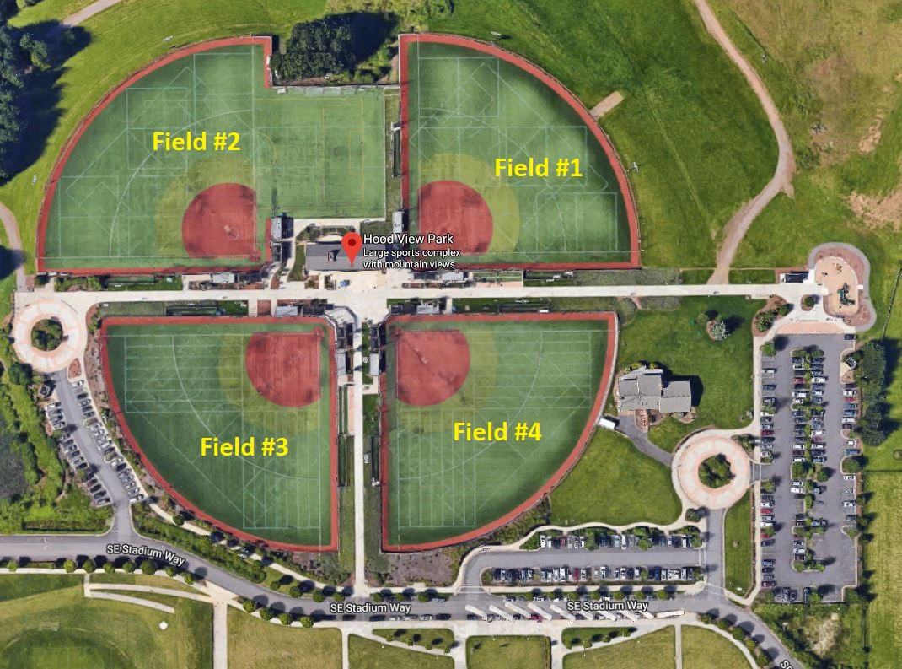
A.C. Nelson High School
(A.K.A. Hood View)
16223 SE Stadium Way,
Happy Valley, OR 97015

*Advanced registration is REQUIRED*

Early registration (prior to March 1, 2022) per student is $100
Registration after March 1, 2022 is $115.00
To register, complete the attached Registration Form

AGENDA

Date | Time | Event
Friday, March 18 | 5:00 pm to 5:50 pm | Check In/Registration (A.C. Nelson Aux Gym)
Introductions & Training- | 6:00 pm to 8:00 pm | A.C. Nelson Aux Gym
Saturday, March 19 | 8:00 am to 8:30 am | Breakfast is Provided
Mechanics Instruction- | 8:30 am to 5:00 pm | Field 2 (Lunch is Provided)
Sunday, March 20 | 8:00 am to 8:30 am | Breakfast is Provided
Mechanics Instruction - | 8:30 am to 1:30 pm | Field 2
Graduation | 1:30 pm to 2:00 pm | Field 2
 |  | ~Subject to change~

NOTES

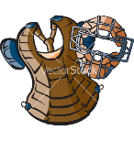
Equipment: Bring any equipment you might want or need to survive a pitching machine throwing baseballs at you (all males MUST have a cup to work plate mechanics)

Clothing: Yes, this is the Pacific Northwest, so plan for cold, wet weather. Dressing in layers is highly recommended.

Registration: Information to follow

Covid-19: Per the state of Oregon, Masks are to be worn while indoors. As of 11/28/2021 masks are not required outdoors but they are suggested. (Subject to change)

Disclaimer: The events and venues are subject to change. You will be notified via email of any such changes.

Lodging: Information to follow

For clinic questions, contact:
Brad Parker at 971-998-4451 or bparkerblue2548@gmail.com

