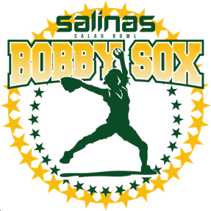 Salinas Salad Bowl Bobby Sox
Girls Fast-Pitch Softball
2021
**FALL SEASON**
Register online now at: www.Salinasbobbysox.com
Opening Day is September 11, 2021 and Season ends November 13, 2021

ALL GAMES WILL BE PLAYED SATURDAYS AT THE
SALINAS BOBBY SOX FIELDS AT GAVILAN VIEW MIDDLE SCHOOL

For ages 4 – 18 years old

NO TRY OUTS! ALL GIRLS PLAY!
A FUN AND COMPETITIVE WAY FOR GIRLS TO LEARN THE FIVE SHIPS:
SPORTSMANSHIP, LEADERSHIP, FRIENDSHIP, CITIZENSHIP AND SCHOLARSHIP

THE BEST IN GIRLS SOFTBALL!!

IN PERSON REGISTRATION DATES:

Ryli’s & Papa’s Pizzeria 530-730pm Salinas Bobby Sox Fields 10am-1:00pm
931 W. Alisal 18250 Van Buren Ave (behind GVMS)
WEDNESDAY, AUGUST 4, 2021 SATURDAY, AUGUST 7, 2021
WEDNESDAY, AUGUST 11, 2021 SATURDAY, AUGUST 14, 2021
WEDNESDAY, AUGUST 18, 2021 SATURDAY, AUGUST 21, 2021

Pizza Factory 530-730pm, 926 South Main Street
MONDAY, AUGUST 9, 2021 MONDAY, AUGUST 16, 2021

***MUST PROVIDE A COPY OF BIRTH CERTIFICATE AT REGISTRATION***

Registration Fees:
6U – 18U (All Divisions)
If played in Spring 2021: $55.00
If not registered in Spring 2021: $95.00
Family Discount: $10.00 off 2nd, 3rd, 4th, etc. sibling to register
*Uniform jersey and visor included in registration fees*
**No refunds after August 21, 2021**

Any registration after 8/21/21 will be charged a $30.00 late fee

Salinas Salad Bowl Bobby Sox
P.O. Box 6822, Salinas, CA 93912
(831)784-4464
Visit us on FACEBOOK: Salinas Bobby-Sox
Register online at: www.SalinasBobbySox.com

