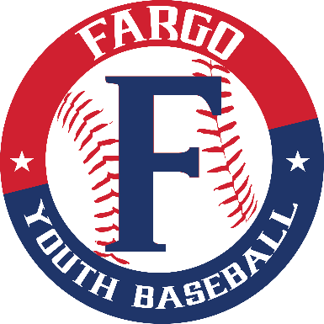
sD
1892 17th Ave. S, Fargo, ND 58103
701-232-9225
info@fargoyouthbaseball.com
Fargo Youth Baseball

Fargo Youth Baseball Summer Internship

Overview:
The summer intern will be involved in various tasks that will assist Fargo Youth Baseball during the 2023 summer baseball season. Interns will focus on tournament and league operations while also learning turf management and concessions. The summer intern will provide customer service and oversee tournament preparation, grounds, concessions, and other duties as assigned. This is a paid internship with up to 30-40 hours of work per week.

Start/Completion Date: May 1st – August 1st

Duties and Responsibilities:
Specific duties include, but may not be limited to:
- Tournament operations
- Manage employees and volunteers
- Maintaining playing surfaces
- Organize and handle all aspects of running a concession stand
- League Management
- Maintaining Indoor Facility
- Tasks and projects assigned by the Fargo Youth Baseball Board of Directors and its staff
Qualifications:
- Currently pursuing a Bachelor Sport Management/Administration, Turf Management, Business, or a related field.
- Proficiency in MS Word, Excel and PowerPoint.
- Strong communication and time management skills.
- Knowledge in the sport of baseball.
- Preferred experience in maintaining a baseball field and knowing how to grill.
- Committed.
- Fun and Energetic personality.
Additional Information:
- These roles will be located in our Fargo Youth Baseball office and at our baseball complex.
- Interns will work from Monday – Thursday and some weekends.
- Interns will be paid $1,000 per month. Time off will be communicated by Fargo Youth Baseball.
- Housing will be the responsibility of the intern.
- Send cover letter and resume to Scott at scott@fargoyouthbaseball.com
About Fargo Youth Baseball:
Fargo Youth Baseball is a community-based organization that brings the diamond sport of baseball to families in our town. A chartered member of Little League International and Babe Ruth International, the league operates as a 501c(3) non-profit, operated by volunteers from the community in which we live. The league offers opportunities for children to learn our great pastime and provides enhanced playing opportunities for more advanced players.

