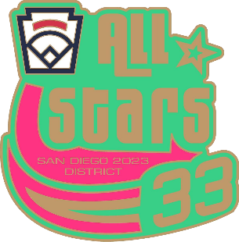
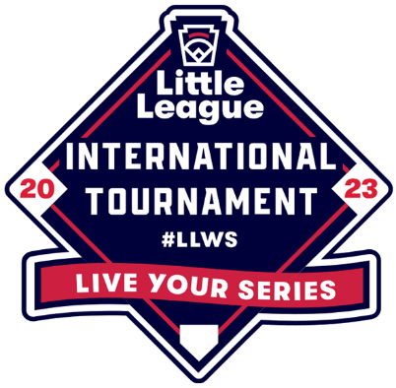
All-Star Saturday
June 17th, 2023

Skill Events Rules
Order of all events will be by seeding order unless indicated differently

Around the Horn (1st event; both fields)

3rd

1st

Path of Thrown Ball
Path of Fielder

- Each team will provide eight players for this event.
- This event will be a timed event based on the total time required to complete a full rotation of all players.
- Players will throw the ball “around the horn”. To begin players will be positioned at home, 1st base, 2nd base, 3rd base and remaining players at the home plate end of the 3rd base dugout.
- Players lined up by dugout will be positioned in order by jersey number; lowest to highest. Lowest jersey number at home, highest jersey number as last player in line at 3rd base dugout.
- A ball will be placed on home plate—time will start when the player positioned at home picks up the ball.
- Rotation will be as follows:
- Player picks up ball from home, touches home plate and throws to 1st base.
- Player at 1st base catches or retrieves ball, touches 1st base and throws ball to 2nd base.
- Player at 2nd base catches or retrieves ball, touches 2nd base and throws ball to 3rd base.
- Player at 3rd base catches or retrieves ball, touches 3rd base and throws ball to Home.
- Each time ball is thrown without touching the base, a 10 second penalty will be added to team’s time.
- Rotation continues “Around the Horn.”
- After each player throws the ball they will rotate to the base to which the ball was thrown and be ready to receive a throw and continue the rotation, except for the player at 3rd base. After the throw, the player at 3rd will rotate to the end of the line at the 3rd base dugout.
- After each throw from home to 1st base the next person in line will rotate to home.
- Once the player who threw the first ball at home plate returns and catches the throw from third to home the event will be finished.
- The top three teams will earn points: 1st place: 6 points, 2nd place: 4 points, and 3rd place: 2 points.
- Shortest total time including potential penalties will win event.

Last Man Standing (2nd event; takes place simultaneously with next event) (Majors field)
- Each Team will provide one player for this event; players must have a team hat and fielder’s glove.
- Players will field the ball from the shortstop position and make a throw to first base. First baseman will be a college-age player.
- Each player will have a ball hit to them from a District 33 volunteer assigned to the event.
- Each player must field the ball cleanly and then make a throw to first base in an attempt to retire a runner (No runner will be used).
- If a player misplays the ball, makes a throw which is missed by the first baseman or pulls the first baseman off the bag, they will turn their hat backwards to indicate an error.
- An umpire will be positioned to judge if an out was recorded.
- A player is eliminated if they commit a second error.
- All players have the opportunity to record an out in every round. If they make the play they will continue without penalty.
- Event will continue until the “Last Man Standing” wins the competition.
- The top three players will earn points for their team: 1st place: 3 points, 2nd place: 2 points, and 3rd place: 1 point.

Closest to the Screen (2nd event; takes place simultaneously with previous event) (Minors Field)
- Objective is to throw the ball from center field accurately to a screen positioned at home plate.
- Each team will put each of their remaining players in this event.
- Players will release the ball from behind a line in center field. Line will be drawn at 165 feet from home plate. Players will have 5’ to complete their throwing motion. A line will be drawn at 170 feet.
- Each player will have two individual throws. Players who score will rotate to back of line after two throws.
- Scoring:
- Screen hit on the fly = 2 points
- Screen hit on a single bounce = 1 point
- Screen missed, multiple bounces or stepping outside lines of throwing area = 0 points
- Ties will be broken using rounds of one additional throw per player. Additional rounds will continue until a winner is determined. Keep your players at the event until event is completed.
- The top three players will earn points for their team: 1st place: 3 points, 2nd place: 2 points, and 3rd place: 1 point

Home Run Derby (last event; Majors Field)
- Each team will be represented by three players, one batter, a catcher in full protective gear, and a player positioned in the outfield to shag balls.
- Team can choose either a rostered adult or player to pitch. Pitcher will be pitching from behind a protective screen at 46’.
- Event will consist of one round. Each batter will receive eight pitches in the round. In the event of a tie additional rounds will be added to determine a winner. Batters will receive five pitches in all additional rounds.
- Batting order for second round will be in same order as first round. Batting order for additional rounds after the second round will be determined by coin flip.
- District 33 International tournament baseballs will be used for event.
- The top three home run hitters will earn points for their team: 1st place: 3 points, 2nd place: 2 points, and 3rd place: 1 point.

Awards Ceremony
At the conclusion of the Home Run Derby all Leagues return to Majors field for the awards ceremony.

Tie Breaker
In order to break a tie, each league will receive points equal to the number of events they have placed in. If the tie still has not been resolved, additional points will be assigned based on first place finish in events as follows: Around the Horn (4 points), Home Run Derby (3 points), Last Man Standing (2 points), and Closest to the Screen (1 point).

