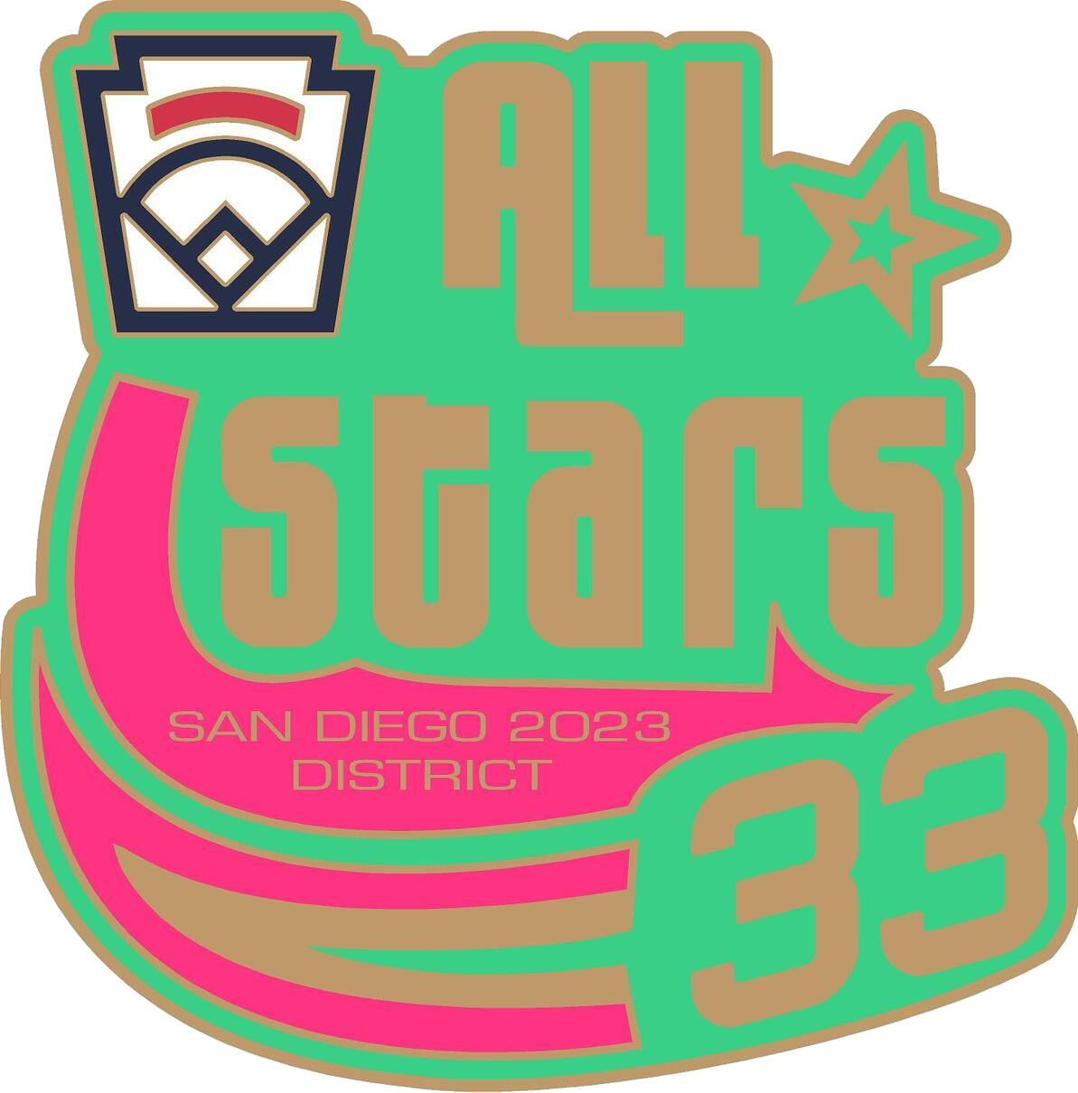
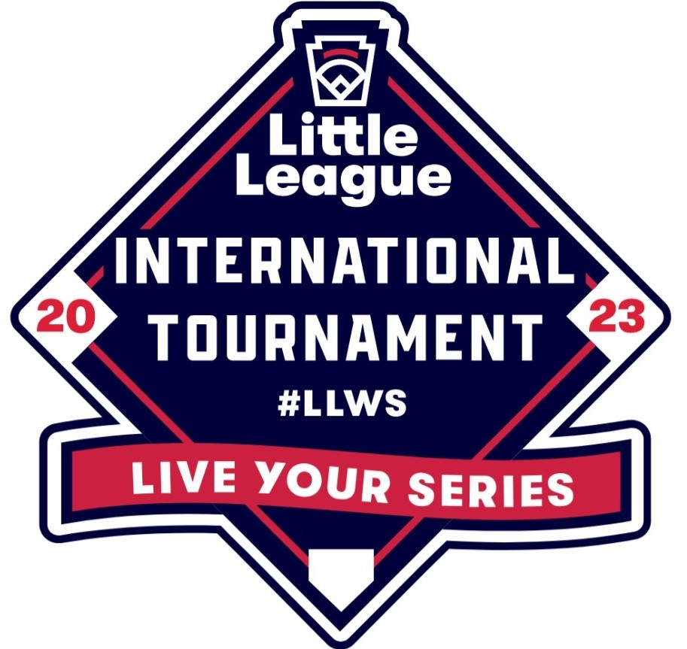
All-Star Saturday
June 17th, 2023

League Name: Division:

Manager’s Name:
Event  * Players may only compete in a single event! | Players (First and Last)  *If you have < 11 leave the last one blank
Home Run Derby (one player*) | 1.
Last Man Standing (one player*) | 1.
Around the Horn (eight players*)
Closest to the Net (all remaining players*)

