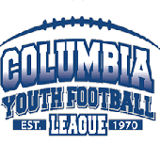

July 7th, 2021 Agenda

Call to Order
Attendance taken
President’s Report
VP Report
Treasurer’s Report
Secretary’s Report
Football Director’s Report
Cheer Director’s Report

Old/New Business
Summer Camps/Training Camp Week
Registration Update
5th/6th Grade Teams
Fall Schedule
Fundraising
Parades
Marketing (signs/radio/TV/etc)
Riddell Grant and Dick’s Sponsorship
Helmet/Shoulder Pad Purchase
Field Equipment (Pylons, Yard Markers, First Down Sticks, etc)
Sponsors (banners, scoreboards, etc)
Alumni/Veterans Weekend
The Ryan McCarthy Award
End of the Year Party/banquet

