Grassroots Recertification

Recertification for the officiating year 2022 is now OPEN.

Step 1:
Recertifying Referees must log into your CSRP eRefreee account, scroll to "Clinic Administration" and from the list select register for Grassroots Recertification Clinic (GR22). After enrolling in the clinic, you will receive a confirmation email with links to detailed instructions. Payment will be made in the US Soccer Learning Center.

Step2:
All recertification work will be done online at your own pace at the U.S. Soccer Learning Center. All CSRP Referees should already have a profile at the Learning Center, so try logging in before signing up for a new account.

After logging in at the US Soccer Learning Center, scroll down and click Referee Program. Then, hover over courses (a red box will appear) then click on available courses. After the new page loads, on the left side of the screen click on Grassroots Recertifying Referee. Then, on the right, click Go To Course List and continue.

Select the course: 2022 GRASSROOTS RECERTIFICATION ONLINE 3508

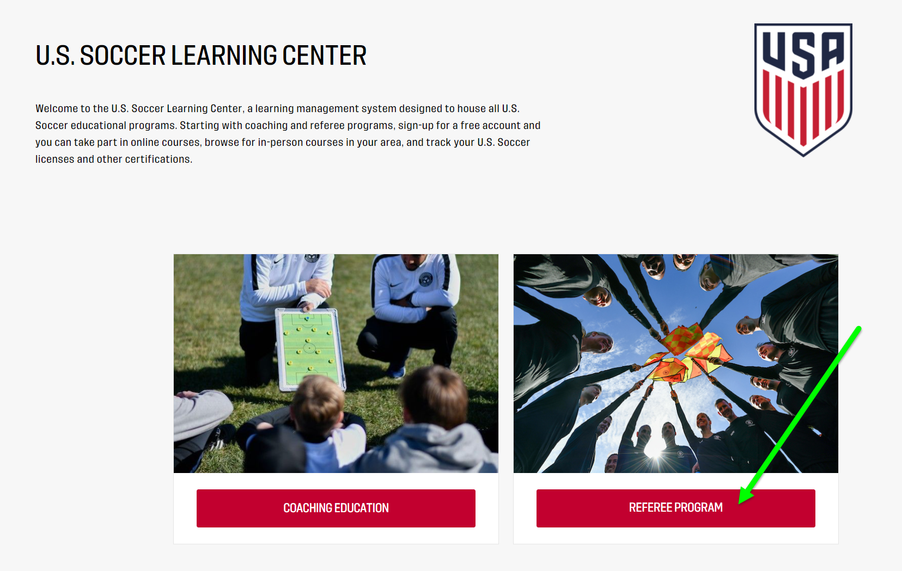
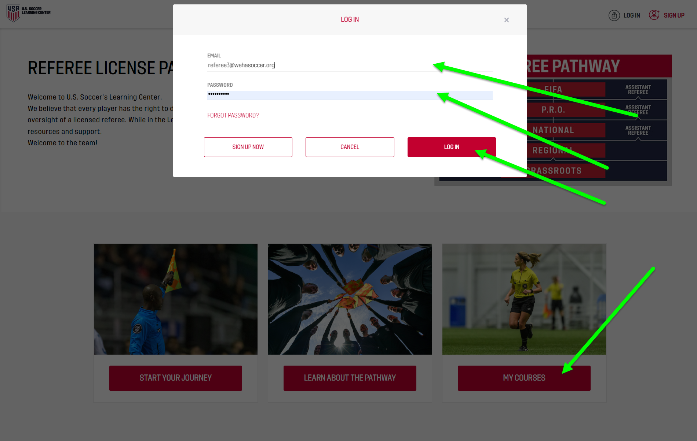

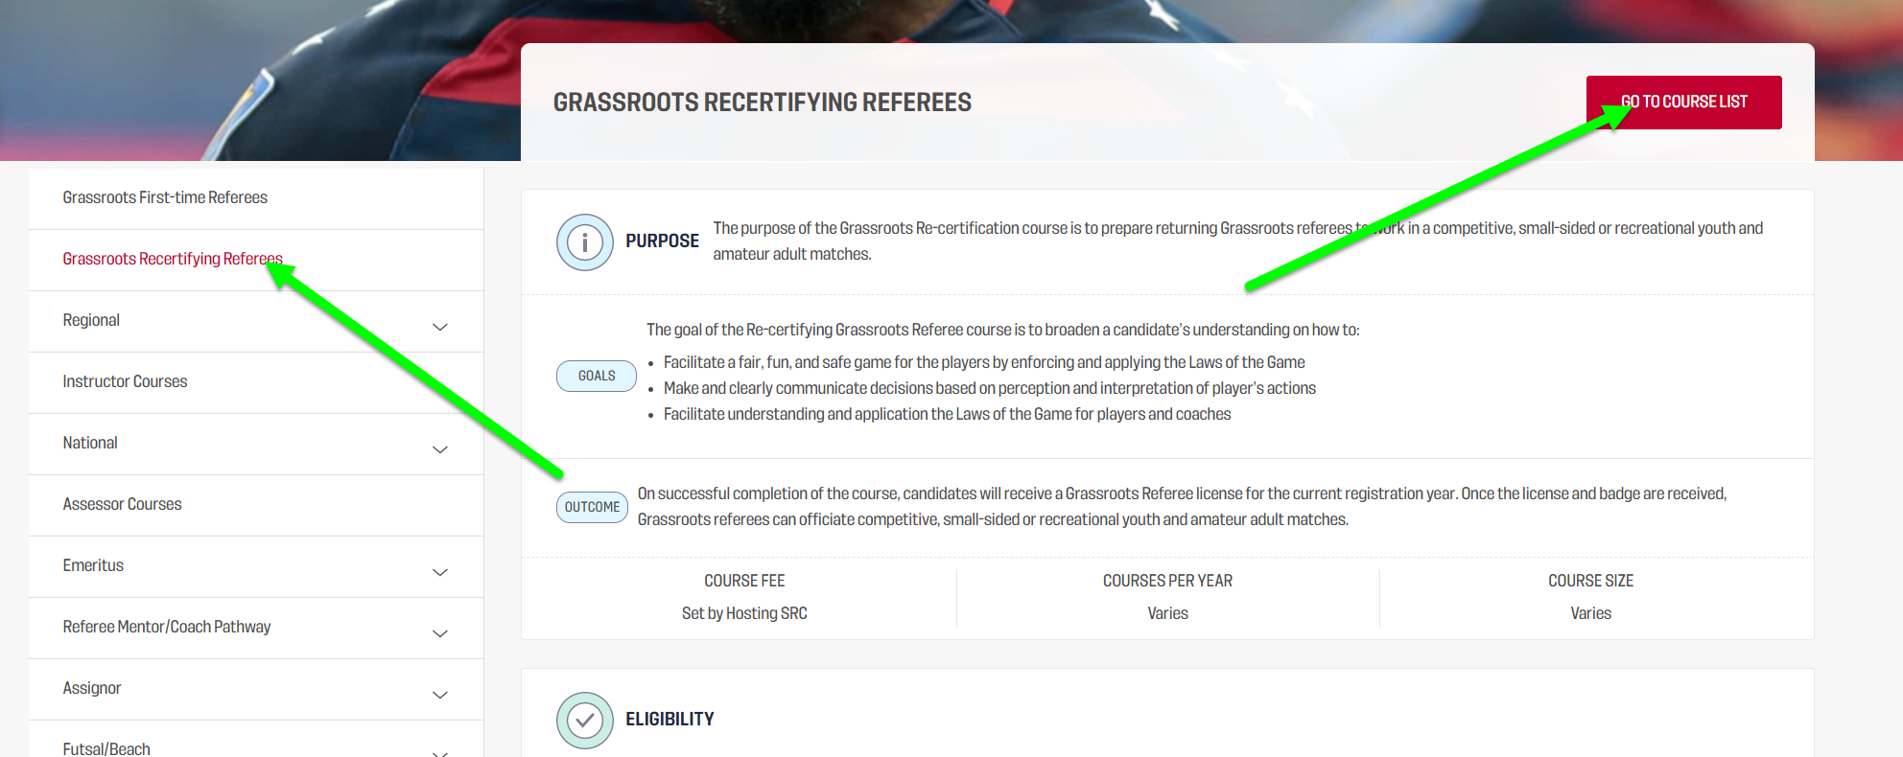

Select: 2022 GRASSROOTS RECERTIFICATION ONLINE 3508

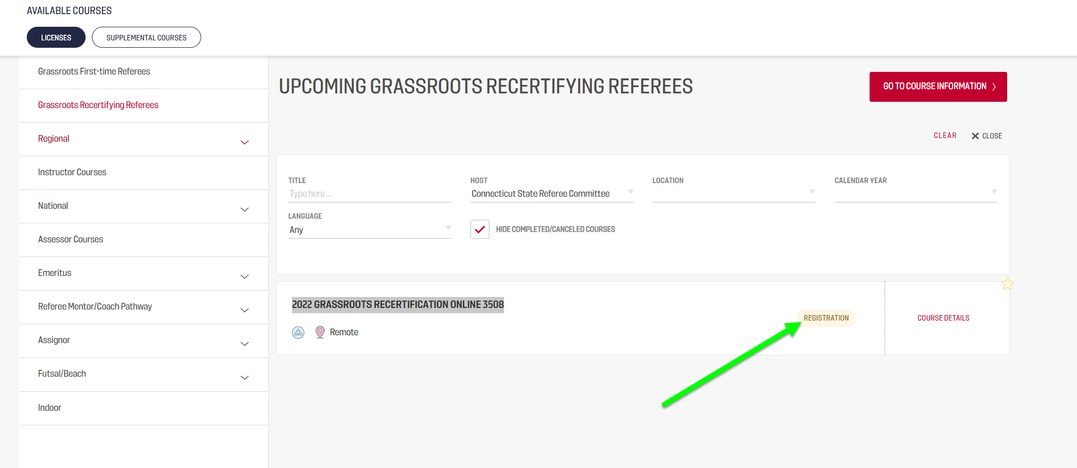

------------------------------------------------------------------------------------------------------------------------------------------
NEW REFEREE / Grassroots Training is now OPEN

Step 1:
Please create a profile on the CSRP Referee Clinics Page. We encourage for all referees to use their own email address, not parents.

New Referees must log into CTREFEREE.NET scroll to "Clinic Administration" and register for New Grassroots Recertification Clinic (GR21). Payment will be made at the Learning Center. After enrolling in the clinic, you will receive a confirmation email with links to detailed instructions.
CSRP website: Connecticut State Referee Program - CSRP (ctreferee.net)

In addition to the coursework at the Learning Center, New Grassroots Referees are required to attend an in-person session with a USSF/CSRP Instructor.

Step 2:
Create an account in US Soccer Learning Center. We encourage for all referees to use their own email address, not parents.

Register for this course: 2022 NEW GRASSROOTS CERTIFICATION - NEW REFEREES #3902

Select referee program.

Log into site after selecting my courses.

You want to select Grassroots First-time Referee and then go to course list.

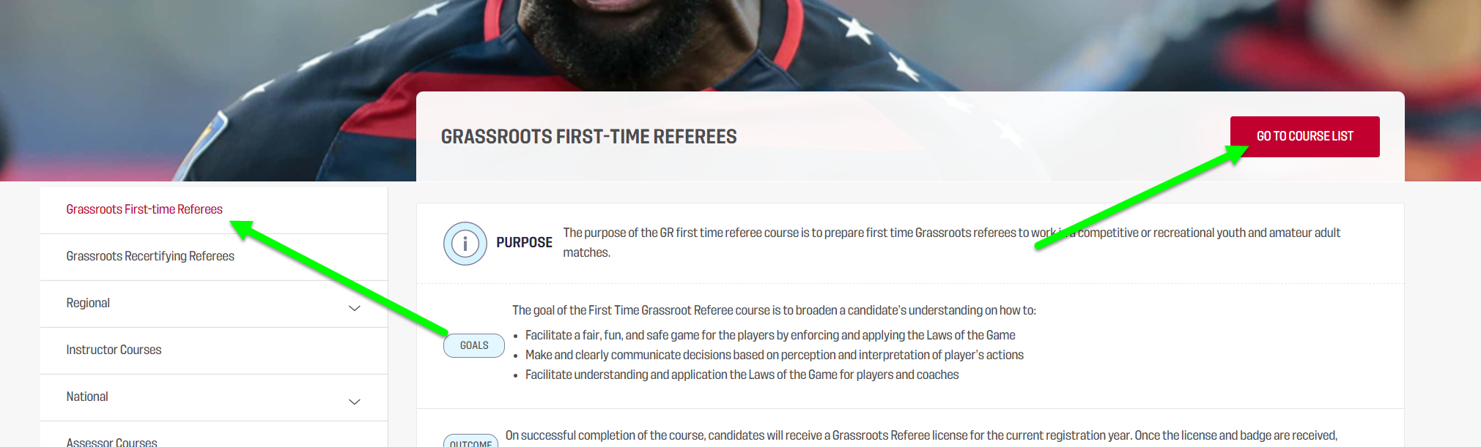

Register for 2022 NEW GRASSROOTS CERTIFICATION - NEW REFEREES #3902 course.

