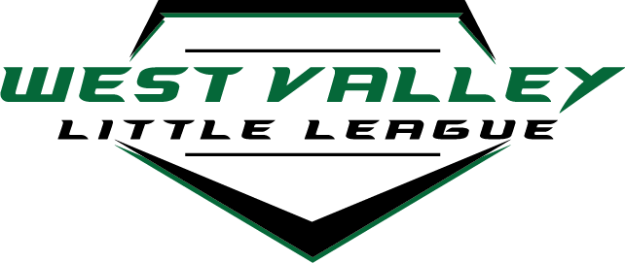
Equipment list for parents to bring:
- gloves
- rakes
- hula hoes
- edgers
- weed eaters
- blowers……

Families planning on playing AA and A (Rookie)

Eagle Christian
Walk outfield to make sure all large holes are field with dirt. Need to seed filled in holes.

FIELD 2 (West field)
- Spike Drag
- Drag
- Level pitching mound rubber
- Needs new home plate
- Clean out dugouts
- Clean out storage bin….figure out what inventory is needed. Chalk, string line, etc.
- Make sure bases are OK…may need to order new base tops.
- 3 drags on field…move 1 to field 1
FIELD 1 (east field)
- Spike drag
- Drag
- Clean out dugouts
- Clean out storage box
- Make sure bases are ok

Guerber Park
- Spike Drag
- Drag
- Edge infield (inside mainly, back arc is ok)
- Clean storage bins out
- Build mound up
  - City has dirt…need a couple bags of clay
- New rope for the drag mat
- City has ok’d a larger storage bin so we can store a couple rakes to rake out home plate and pitchers mound
- If games are going to be played there, we will need a batters box template and chalk.

Families planning on playing AAA and Majors
Duck Alley
- Entrance Road crew
  - Clean up limbs and haul to SW corner of property to burn
- Edge Crew
  - Infield
  - Warning track
- Clean out sheds
- Clean out dugouts
- Pick up trash
- Fix fences
- Fix bullpens
- Spike Drag and Drag fields
- Batting cage clean up

Families planning on playing Juniors/Seniors …Field Day will be at a later date! Those fields will be:

Eagle Middle School
- Spike drag
- Drag
- Mound is good other than raking
- There are 2x L-screens….bring back orange one to Duck Alley
(There is a drag mat in the 3rd base dugout….make sure it works)
Hunters Creek
- Spike drag
- Drag

