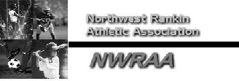

Northwest Rankin Athletic Association
P.O. Box 5176
Brandon, MS 39047

Dear Sponsor,

The Northwest Rankin Athletic Association is appreciative of your support and your sponsorship of our football team for 2025. Our Association is a non-profit organization, which provides recreational activities for the youth of our area. We cannot provide these activities without the generous support of businesses like you. Our Association has been approved by the IRS as a 501(C)(3) corporation. The Federal I. D. number is #57-0884066.

Your team sponsorship donation provides uniforms, equipment, footballs, etc. Without this generous support we would not be able to offer the quality football program that the kids in our area enjoy today.

Again, thank you for your support of the Northwest Rankin Athletic Association.

Sincerely,

Bo Lewis
2025 NWRAA Football Commissioner

Team Sponsor for 2025 with 4 x 6 sign at fields - $350.00

Name of Sponsor ___________________________________________

Name of Coach ___________________________________________

Sponsor Address ___________________________________________

Contact Person ___________________________________________

Email Address ___________________________________________

