TAYLOR SOUTH BROWNSTOWN LITTLE LEAGUE
^{2026 REFUND POLICY}

- Refunds (less any credit card fees) are available upon request based on the below schedule:
  - Full refunds are available upon request, if request is received prior to March 6, 2026
  - Refunds are not available after the March 7, 2026 deadline as uniforms will be ordered.

To submit a refund request, send email to TAYLORSOUTHBROWNSTOWNLITTLELEAGUE@GMAIL.COM
and include “Refund Request” in the subject line:

Please be sure to include the following information:
• Player’s Name
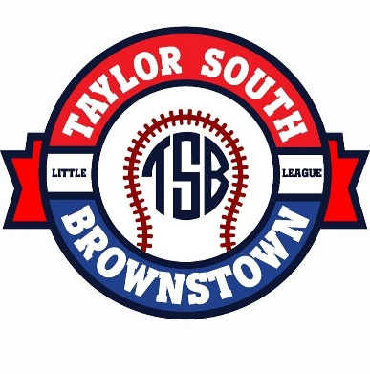
• Parent/Guardian Name
• Parent Phone Number
• Reason for Refund

Signature: ____________________________________
Date: ________________________________________

*Taylor South Brownstown Little League is not responsible for any Government issued mandates.

