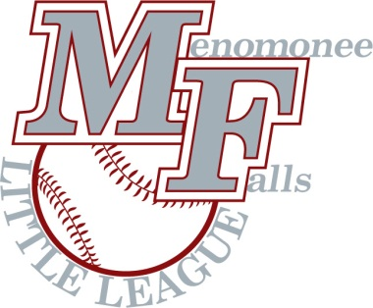
2021 Season

Happy New Year!

Menomonee Falls Little League is grateful for your generous sponsorship of our organization. We are hopeful you will continue sponsoring the young athletes within our community for the 2021 season.

Menomonee Falls Little League is a nonprofit t-ball, baseball, and softball organization focused on building confidence, promoting teamwork, and developing sportsmanship. Our organization is committed to providing young athletes with a safe and clean environment, strong coaching, and age-appropriate levels of competition.

With your generous support, Menomonee Falls Little League is able to achieve the organizational goals outlined above along with keeping registration fees reasonable for over 800 families throughout the community.

Please consider sponsoring the Menomonee Falls Little League for the 2021 season. The sponsorship levels available are outlined below:

Gold Team Sponsor: $750 donation
- One (1) 3 ft. x 5 ft. Multi-Colored Banner with logo displayed at the MFLL Complex
- Plus, all Silver Team Sponsor benefits

Silver Team Sponsor: $450 donation
- Sponsor’s name on Player Hats
- Team Plaque
- Recognition and Link on MFLL website

Grand Slam Banner: $500 donation
- 3ft X 5ft multi colored banner with logo
- Placed along field #2 facing Mill Rd.
- Highest visibility location!

Home Run Banner: $350 donation
- 3ft X 5ft multi colored banner with logo
- Placed inside The Complex
- Multiple banners acceptable!

To facilitate planning and team assignments, please to visit our website (fallslittleleague.org) to register as a sponsor or complete the enclosed pledge form with funds by March 1st, 2021.

For organizations wishing to have a broader impact, Menomonee Falls Little League also offers Custom Sponsorships such as Field Naming Rights, Dugout, Scoreboards & Bleacher sponsors & MORE! If interested, please contact Katie Gardner at 414-688-8917 or email sponsor@fallslittleleague.org.

Your sponsorship is very much appreciated and valued by all of those involved with Menomonee Falls Little League. We welcome any comments or questions you have regarding the details of your sponsorship. Thank you in advance for your support of the Menomonee Falls Little League.

Menomonee Falls Little League
Sponsorship Coordinators:
Tim Wallinger: 414-218-2563
Katie Gardner: 414-688-8917
EMAIL: sponsor@fallslittleleague.org

Menomonee Falls Little League
Sponsorship Form

2021 Season
The information below will be listed in our Team Sponsor section of the website
Sponsor Name:
Contact: Title:
Address:
City: | State: Zip:
Phone No: | Fax No:
Email: | Web Address:
Mailing Address: (if different than above)
Name to Appear on Team Hats:

Level of Sponsorship: Circle One: Bill Me / Payment Enclosed

- Gold Team Sponsor - $750 Donation (Banner + Name on Hats)
- Silver Team Sponsor - $450 Donation (Name on Hats)
- Grand Slam Banner (3 ft. X 5 ft.) High visibility, displayed at Complex - $500 Donation
- Home Run Banner (3 ft. X 5 ft.) Banner displayed inside Complex - $350 Donation

For Custom Sponsorships such as Naming Rights for Fields, Dugouts, Scoreboards & Bleacher sponsors please reach out to a Sponsorship Coordinator

GOLD & SILVER TEAM SPONSORS - Please indicate your Team Sponsor preference: (Check only one)

- We have no preference, assign us as needed
__ We wish to sponsor: _____________________________________

(Child OR Coach name - only one name please)

Please provide a message to the league families to be included on our website

Please mail this completed form with payment to: MFLL
PO Box 253 Menomonee Falls, WI 53052

If selecting the “Bill Me” option, email the form to: sponsor@fallslittleleague.org
Please contact Tim Wallinger or Katie Gardner, if you have any questions or would like to discuss other sponsorship options.
Thank you for supporting the Menomonee Falls Little League!

