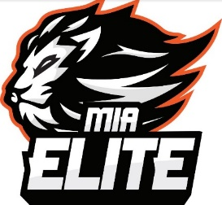

Recreational Team Sponsorship

TEAM NAME (to be sponsored): ____________________________________________
SPONSOR NAME (TO BE DISPLAYED):_________________________________________
ADDRESS: ______________________________________________________________
CONTACT NAME: ________________________________________________________
CONTACT NUMBER: ______________________________________________________
SPONSOR WEBSITE (TO BE DISPLAYED) _______________________________________
SPONSOR SOCIAL MEDIA (TO BE TAGGED IN POSTS): ____________________________

$300 – Spring or Fall Season

Company recognized and tagged on all social media posts and platforms. Acknowledgement during closing ceremonies. Sponsors will receive a personalized team jersey with sponsor name for display.
Please make payments to: MIA ELITE FOOTBALL

For questions and inquiries, please contact: miaeliteflag@gmail.com or 786-322-1468

