VIKINGS YOUTH FOOTBALL & FLAG CAMP

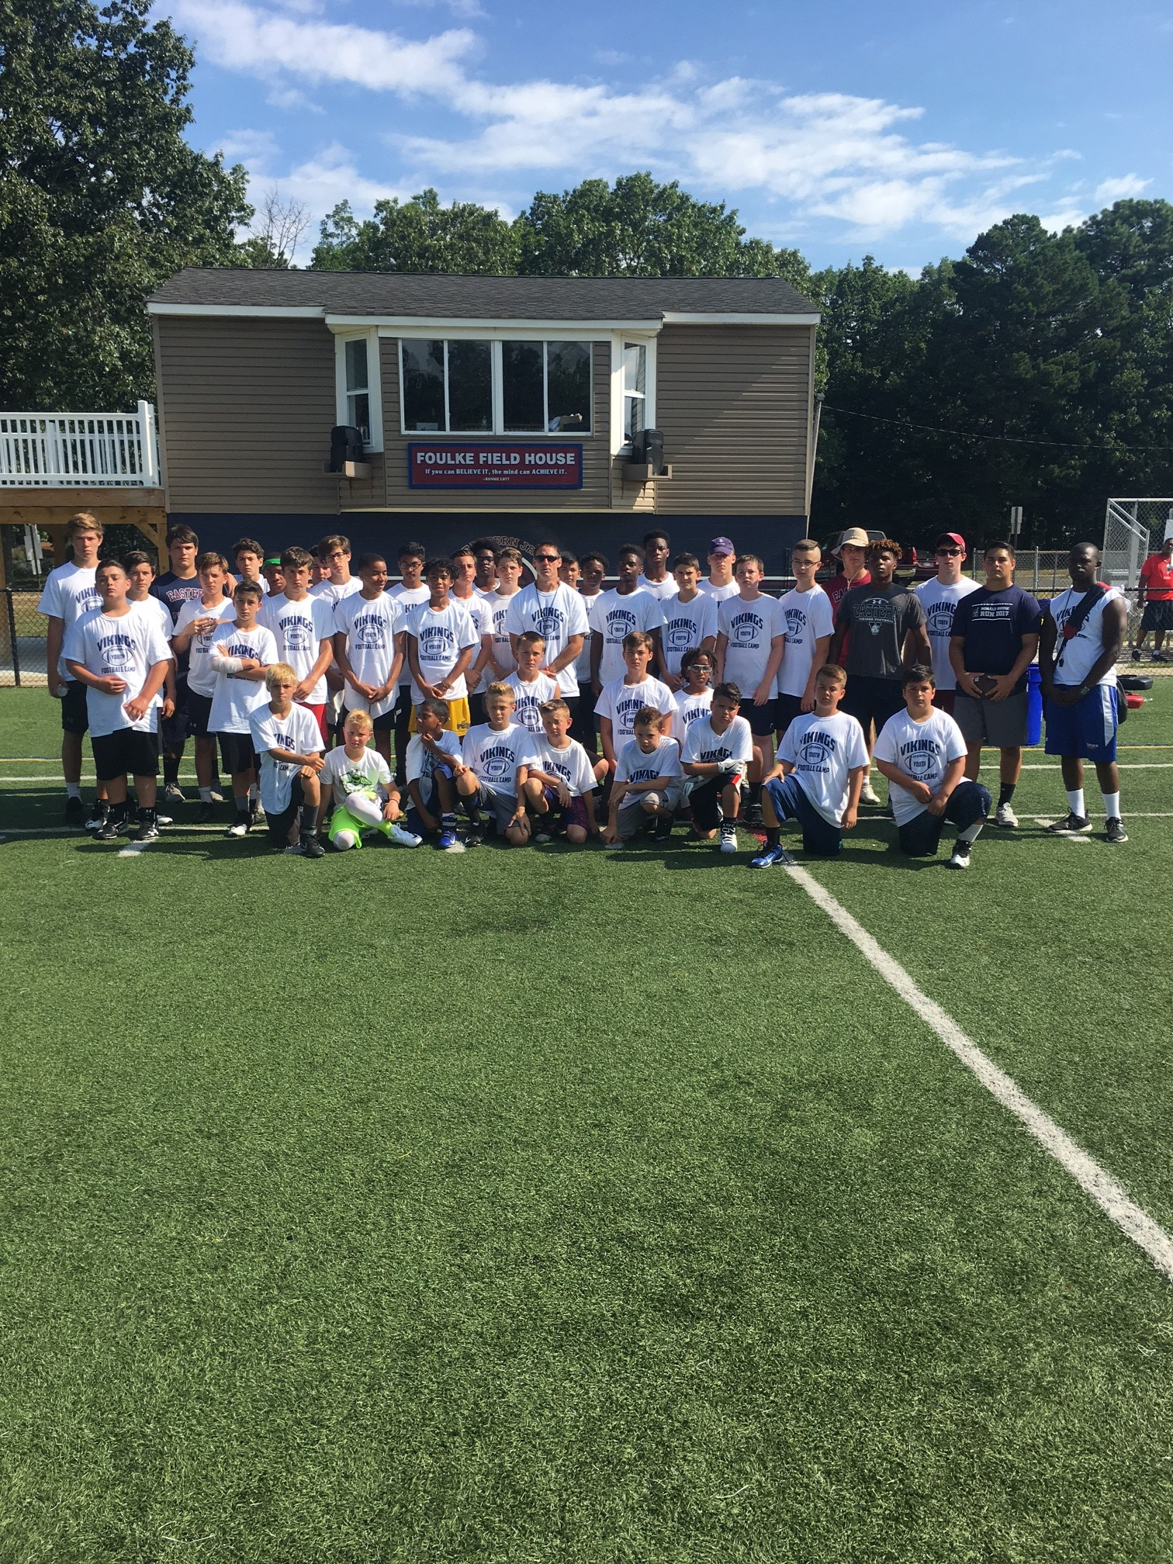

**For players in grades 3rd through 9th,**

**Incoming Eastern H.S. Freshman Orientation Camp**

***$135.00 per/player***

***$60.00 for sibling***

***CAMP DIRECTOR: John Doherty. Eastern High School Head Football Coach***

**2019 Camp Dates**

**15th- through July 19th**

9:00 am – 12:00 pm daily

Voorhees Vikings Youth Field @

Giangiulio Sports Complex, 1000 Victor Blvd, Voorhees NJ 08043

2019 Special Guest Coach: Albert Young- Former University of Iowa and Minnesota Viking RB

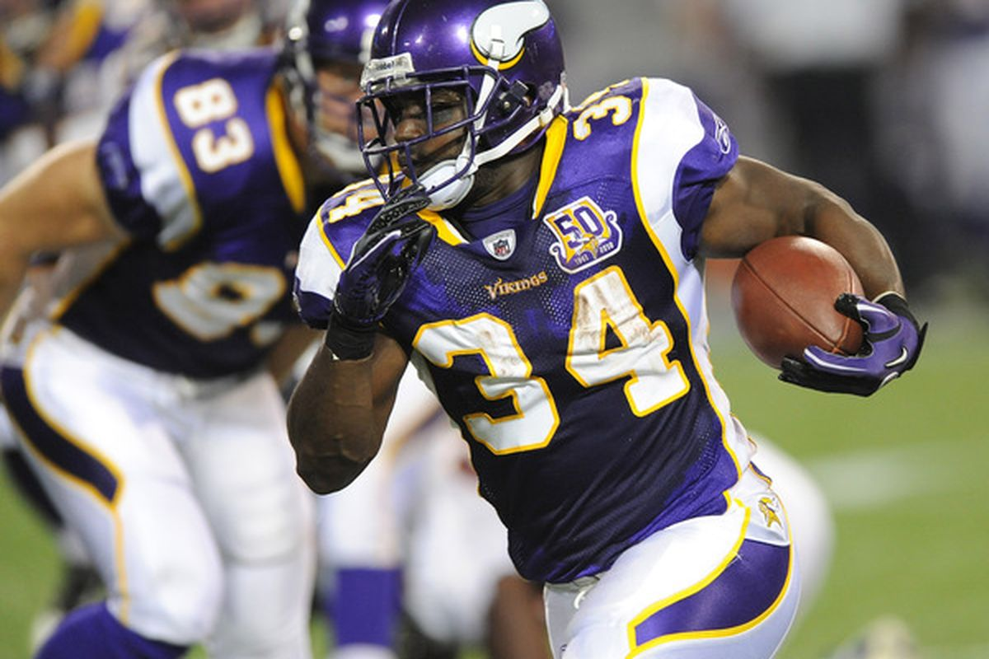

*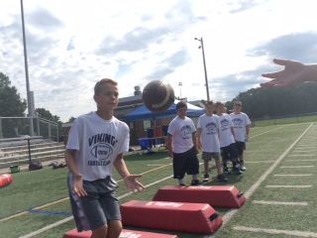

#### *POSITION SPECIFIC SKILLS:*

#### *QUARTERBACK:*

#### Footwork, 3 Step drops, 5 Step drops, Ball handling, Accuracy, Throwing on the run, Throwing from the shotgun, Running from the shotgun, Game management, Mental preparation, and Leadership training.

#### *WIDE RECEIVER:*

#### Stance and Starts, Footwork, Ball Drills, Route running, catching in traffic, Blocking technique

#### *RUNNING BACKS:*

#### Stance and Starts, Cutting, Vision Drills, Footwork, Ball Security, breaking tackles, Receiving and Route running from the backfield, Blocking technique

#### *OFFENSIVE LINEMEN:*

#### Stance and Starts, Footwork, Hand position, Pass Sets, Zone Blocking, Blocking technique, Combination blocks

#### *DEFENSIVE BACKS:*

#### Stance, Footwork, Backpedaling, Zone technique, Man-to-Man technique, Tackling technique, Ball Drills

#### *LINEBACKERS:*

#### Stance, Footwork, Tackling Technique, Zone Pass Drops, Man-to-Man Technique, Eye Discipline (read & react) Pass Rushing technique

#### *DEFENSIVE LINEMEN:*

#### Stance, Get-Off, Footwork, Tackling Technique, Man Technique, Getting-Off Blocks, Pass Rushing Technique

Some of our former camp Coaches

Shabaz Ahmed- Temple University

Irvin Charles- Penn State University

Matt Barnett- Wagoner University

Stefonne Moore-Green- Bucknell U

Alec Vignola-Albrite University.

Phil Costa-Maryland/Dallas Cowboys

Jonathan Grimes- Houston Texans

Francis Brown-Temple University

John Santini-Widener University

Rich Fisher-LSU

ZahirGoyins-EastStrousburg University

Ryan Jennings-Kutztown University

Jakwail Bailey- Old Dominion University

***VIKINGS YOUTH FOOTBALL CAMP GOALS:***

**The Vikings Football Camp aims to provide a fun, exciting, competitive football environment. The athletes that attend our camp will be challenged both physically and mentally to improve as football players each day. Players will complete the camp prepared to help their respective teams achieve the ultimate goal of winning a championship in the fall.**

**Learn Position-Specific Skills from college football players, as well as Eastern Staff and current players. There will also be speed and agility training, as well as character development teachings each day.**

***FOOTBALL CAMP DAILY REMINDERS:***

**All players must bring the following to camp daily:**

**\*Cleats, fluids, sun block, snack**

**DAILY 7-ON-7 COMPETITION**

**GRADES 3RD – 9TH PUNT, PASS, & KICK**

**NFL COMBINE DRILL TESTING**

**(40 YD DASH, PRO SHUFFLE)**

**AWARD CERTIFICATES FOR EACH CAMPER**

**SPECIAL AWARDS FOR EXCELLENT CAMP AND CHARACTER SKILLS DURING CAMP**

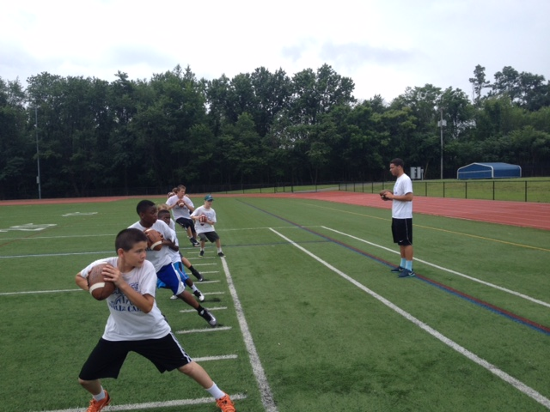

**WAIVER AND RELEASE**

In consideration of the acceptance of this application, we the below signed, our heirs, consenters, administrators to be legally bound to the terms and conditions hereafter set forth. We hereby give our consent and approval to the participation of the applicant in the program conducted by the Vikings Football Skills Camp and certifies that he/she is physically fit to take part in all activities. Further, we do hereby waive, release and forever discharge said organization, its staff, officers, agents, representatives, employees and their successors and agents from any and all claim for damages concerning or ensuing from an accident, injury to person or loss of personal property occurring during this stated camp, his/her participation in activities arising from his/her traveling to or from camp.

WE ALSO AUTHORIZE THE DIRECTOR OF THE VIKINGS YOUTH FOOTBALL SKILLS CAMP TO ACT FOR US ACCORDING TO HIS BEST JUDGMENT IN ANY EMERGENCY REQUIRING MEDICAL ATTENTION

___________________________

PARENT/GUARDIAN NAME \(PLEASE PRINT)

________________________

PARENT/GUARDIAN SIGNATURE

**SEND COMPLETED REGISTRATION WITH CHECK PAYABLE TO:**

***VIKINGS YOUTH FOOTBALL CAMP***

***2 OXFORD CT***

***VOORHEES NJ 08043***

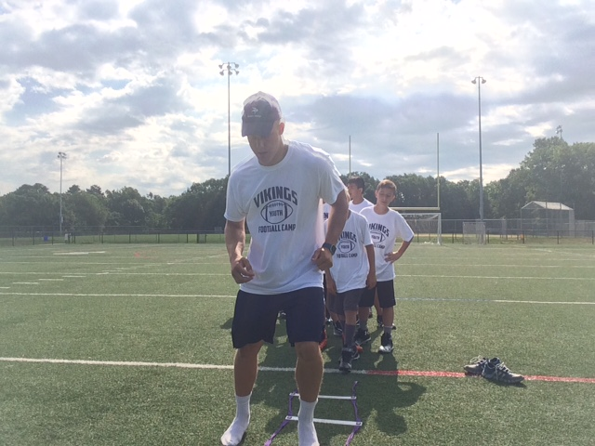

For more registration info email me at johndoherty2@verizon.net

# REGISTRATION FORM – 2019

PLEASE COMPLETE BOTH SIDES FULLY

# CAMP DATES: CAMP PRICE: $135.00/player

JULY 15– JULY 19th, 2019 *\**

**________________________ _________________________**

*REGISTRANT’S NAME Grade Entering this September/Age*

**________________________**  **________________________**

*OFFENSIVE POSITION DEFENSIVE POSITION*

__________________________________________________

*ADDRESS*

___________________________________________________

*CITY, STATE, ZIP*

____________________________________________________

*EMAIL ADDRESS (VERY IMPORTANT – ALL COMMUNICATION IS DONE VIA EMAIL)*

____________________ _______________________

*PHONE NUMBER CELL PHONE NUMBER*

**T-SHIRT SIZE** (CIRCLE ONE):

Youth: M L XL

Adult: S M L XL

**CAMPER HEALTH HISTORY**

______________________ ___________________

*REGISTRANT’S NAME* *DATE OF BIRTH*

________________________ ______________________

*EMERGENCY CONTACT NAME*  *EMERGENCY CONTACT PHONE*

*DOES CAMPER TAKE MEDICATION?* □ YES □ NO

*EXPLAIN:* _____________________________________________

_______________________________________________________

*ARE THERE ANY PHYSICAL OR EMOTIONAL CONDITIONS THAT MIGHT AFFECT CAMPERS ABILITIES OR PERFORMANCE?* □YES □NO

*EXPLAIN:* _____________________________________________

_______________________________________________________

*HAS THE CAMPER BEEN IMMUNIZED?* □YES □NO

*ALL PARTICIPANTS MUST SUBMIT IMMUNIZATION RECORD PRIOR TO CAMP BEGINNING