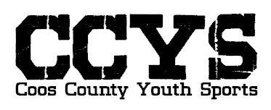
CCYS Awards Ceremony Schedule and Dates
Date: November 19th (Saturday)
Event Location: Our CCYS Old Bangor School Fields, North Bend
K/1st Grade Teams start at 11:00-12:30
2nd/3rd Grade Teams start at 12:30-2:00 pm
4th/5th/6Th Grade Teams start at 2:00-3:30 pm
7th -12th Grade Teams start at 4:00 pm

*Players can dress casually or be in uniform. This event is rain or shine. Please Park Respectfully*

Bring your Gazebos, chairs, BBQs etc. and get comfortable. Potluck, Pizza, Chips, drinks, snacks, cupcakes etc are always a hit if you would like to bring something.
Pictures and Awards will be given to your coach at this event. Each team will go up onto the new stage, one team at a time and receive their end of season awards and picture packet. If you cannot make it to this event due to your health and or families etc, coaches will turn your stuff back in before leaving the ceremony and CCYS will set up a couple informal pick up dates later in the weeks to come (we cannot mail them). Follow our Facebook page for easy access to those dates when we have them set. If a coach cannot attend, the coaches assistant or Coach Kevin and Coach Ali will present to the team. Awards will not be handed out before this event.
We will have tables set up for your soccer players to sign soccer balls, picture frames etc. as gifts to your coaches and sponsors. Also, we will have a donation box for anyone who would like to donate any amount towards our CCYS Pepsi Field. Comments, cards for your coaches can be put in our secure “Comment/Donation” box anytime. Please try and hand deliver any Coaches gifts if possible.
Courtesy Reminder: No smoking/vaping or drugs and NO Dogs or other Pets allowed. Do not come if you’re sick. Anyone who breaks these rules will be asked to leave immediately.
Your player worked very hard this season, and this will be a fun time for them. We look forward to seeing you!!!
Contact Information: call or Text 541-217-9195

