EMW Baseball and Softball Community,
On behalf of our Board we would like to thank all the families that have already registered for our upcoming season and we look forward to many more registrations. Don’t forget registration closes next Tuesday March 16th to avoid any late fees. All registrations end on March 29th.
Our Board has seen a number of changes since last season. We will communicate updates via our website emwbaseball.org and you can email us at info@emwbaseball.org with any questions or concerns you may have. We ask that you be patient with the registration process. With last season being cancelled, our new board inherited decisions made last season and we are working out all the details to ensure registration is successful for everyone. Please review the below frequently asked questions to assist our families this upcoming season.
*Please note due to COVID these could change prior to the season so check our website for updates as the season approaches.
What equipment will be required for players/parents to purchase?
All players will need to purchase their own glove/mitt.
We highly recommend the purchase of players' own helmets. However, a small number of helmets will be available to loan out to players in need on a first come first serve basis. Please note these will not be brand new helmets.
Bats will be provided to each team as in the past, shared and disinfected between use this season. Players may purchase their own bats but they must be USA Bat Approved with the following stamp for baseball and softball respectfully:
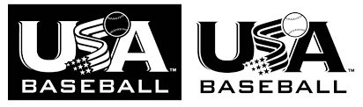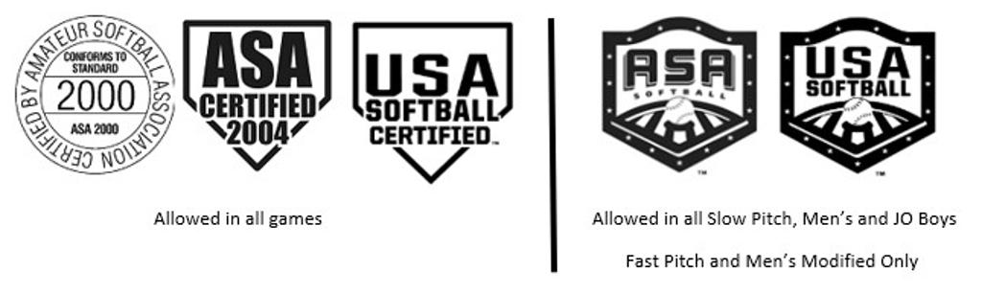
Catchers equipment will be provided by the league and the coaches will determine what players catch during the season or clean and disinfect appropriately to allow more players the opportunity. More information will be provided to the coaches as we get closer to the season.
Dick’s Sporting Goods EMW Discount Day will be held at the Orchard Park location Friday, April 16th through Monday, April 19th at which time you can save 20% off your total purchase. Coupons will be provided on the website and via a separate email.

Do masks need to be worn?
Players may but are not required to wear masks while on the field. Off the field all are asked to wear a mask when not able to be 6ft apart such as in or around dugouts.

How many days a week is the commitment for T-Ball, Baseball, or Softball?
Each coach will determine the number of practices a week for their individual team. We recommend you anticipate at least one or two practices per week specially to start the season and one or two games per week. No games or practices will take place on Wednesdays, Saturday afternoon/evenings, or Sundays for any House Team as these days are secured for EMW Travel Teams.

How are refunds working from last season if not already received?
Most people were given a refund if they did not participate in House last season. There are some that need a credit but the registration system is giving us trouble having it in there so that it applies to this season. We are handling it on a case by case basis as we do have a print out of those affected. If you have a travel player, they do not get a refund or credits for last season.
How does the fundraiser work?
This year we have taken our fundraiser digital. Each family is charged a one-time mandatory $50.00 per family fundraiser fee. It is up to the family if you choose to sell the Delta Sonic tickets or keep them for your own family. If you sell them, money collected is kept by the family and the fundraiser was not a cost to your family. Tickets will be distributed at first practice.
Will the concession stand be open?
Yes, we plan to open the stand. We are exploring new plans for end of game team treats/snack which would avoid congestion at the stand and the use of tokens.
Are you still in need of coaches, volunteers and umpires?
Yes, we are always looking for help in all the above areas. Please sign up on the website for coaching and umpires. If you wish to assist in any other area please email us at info@emwbaseball.org listing what you would like to assist with and someone will reach out to you. A coach’s night will be provided once registration closes. Umpires will be provided a clinic prior to the start of the season.

How can my business sponsor a team or the league?
Please email us at info@emwbaseball.org to express your interest in sponsorship and our sponsorship coordinator will contact you.

Jeff Mochrie EMW President (Director of Baseball)
Sarah Larson EMW Vice President (Director of Softball)

