2023
2023

“Teaching the skills of field hockey…
Growing the love of the game.”

CENTRAL PENN
FIELD HOCKEY
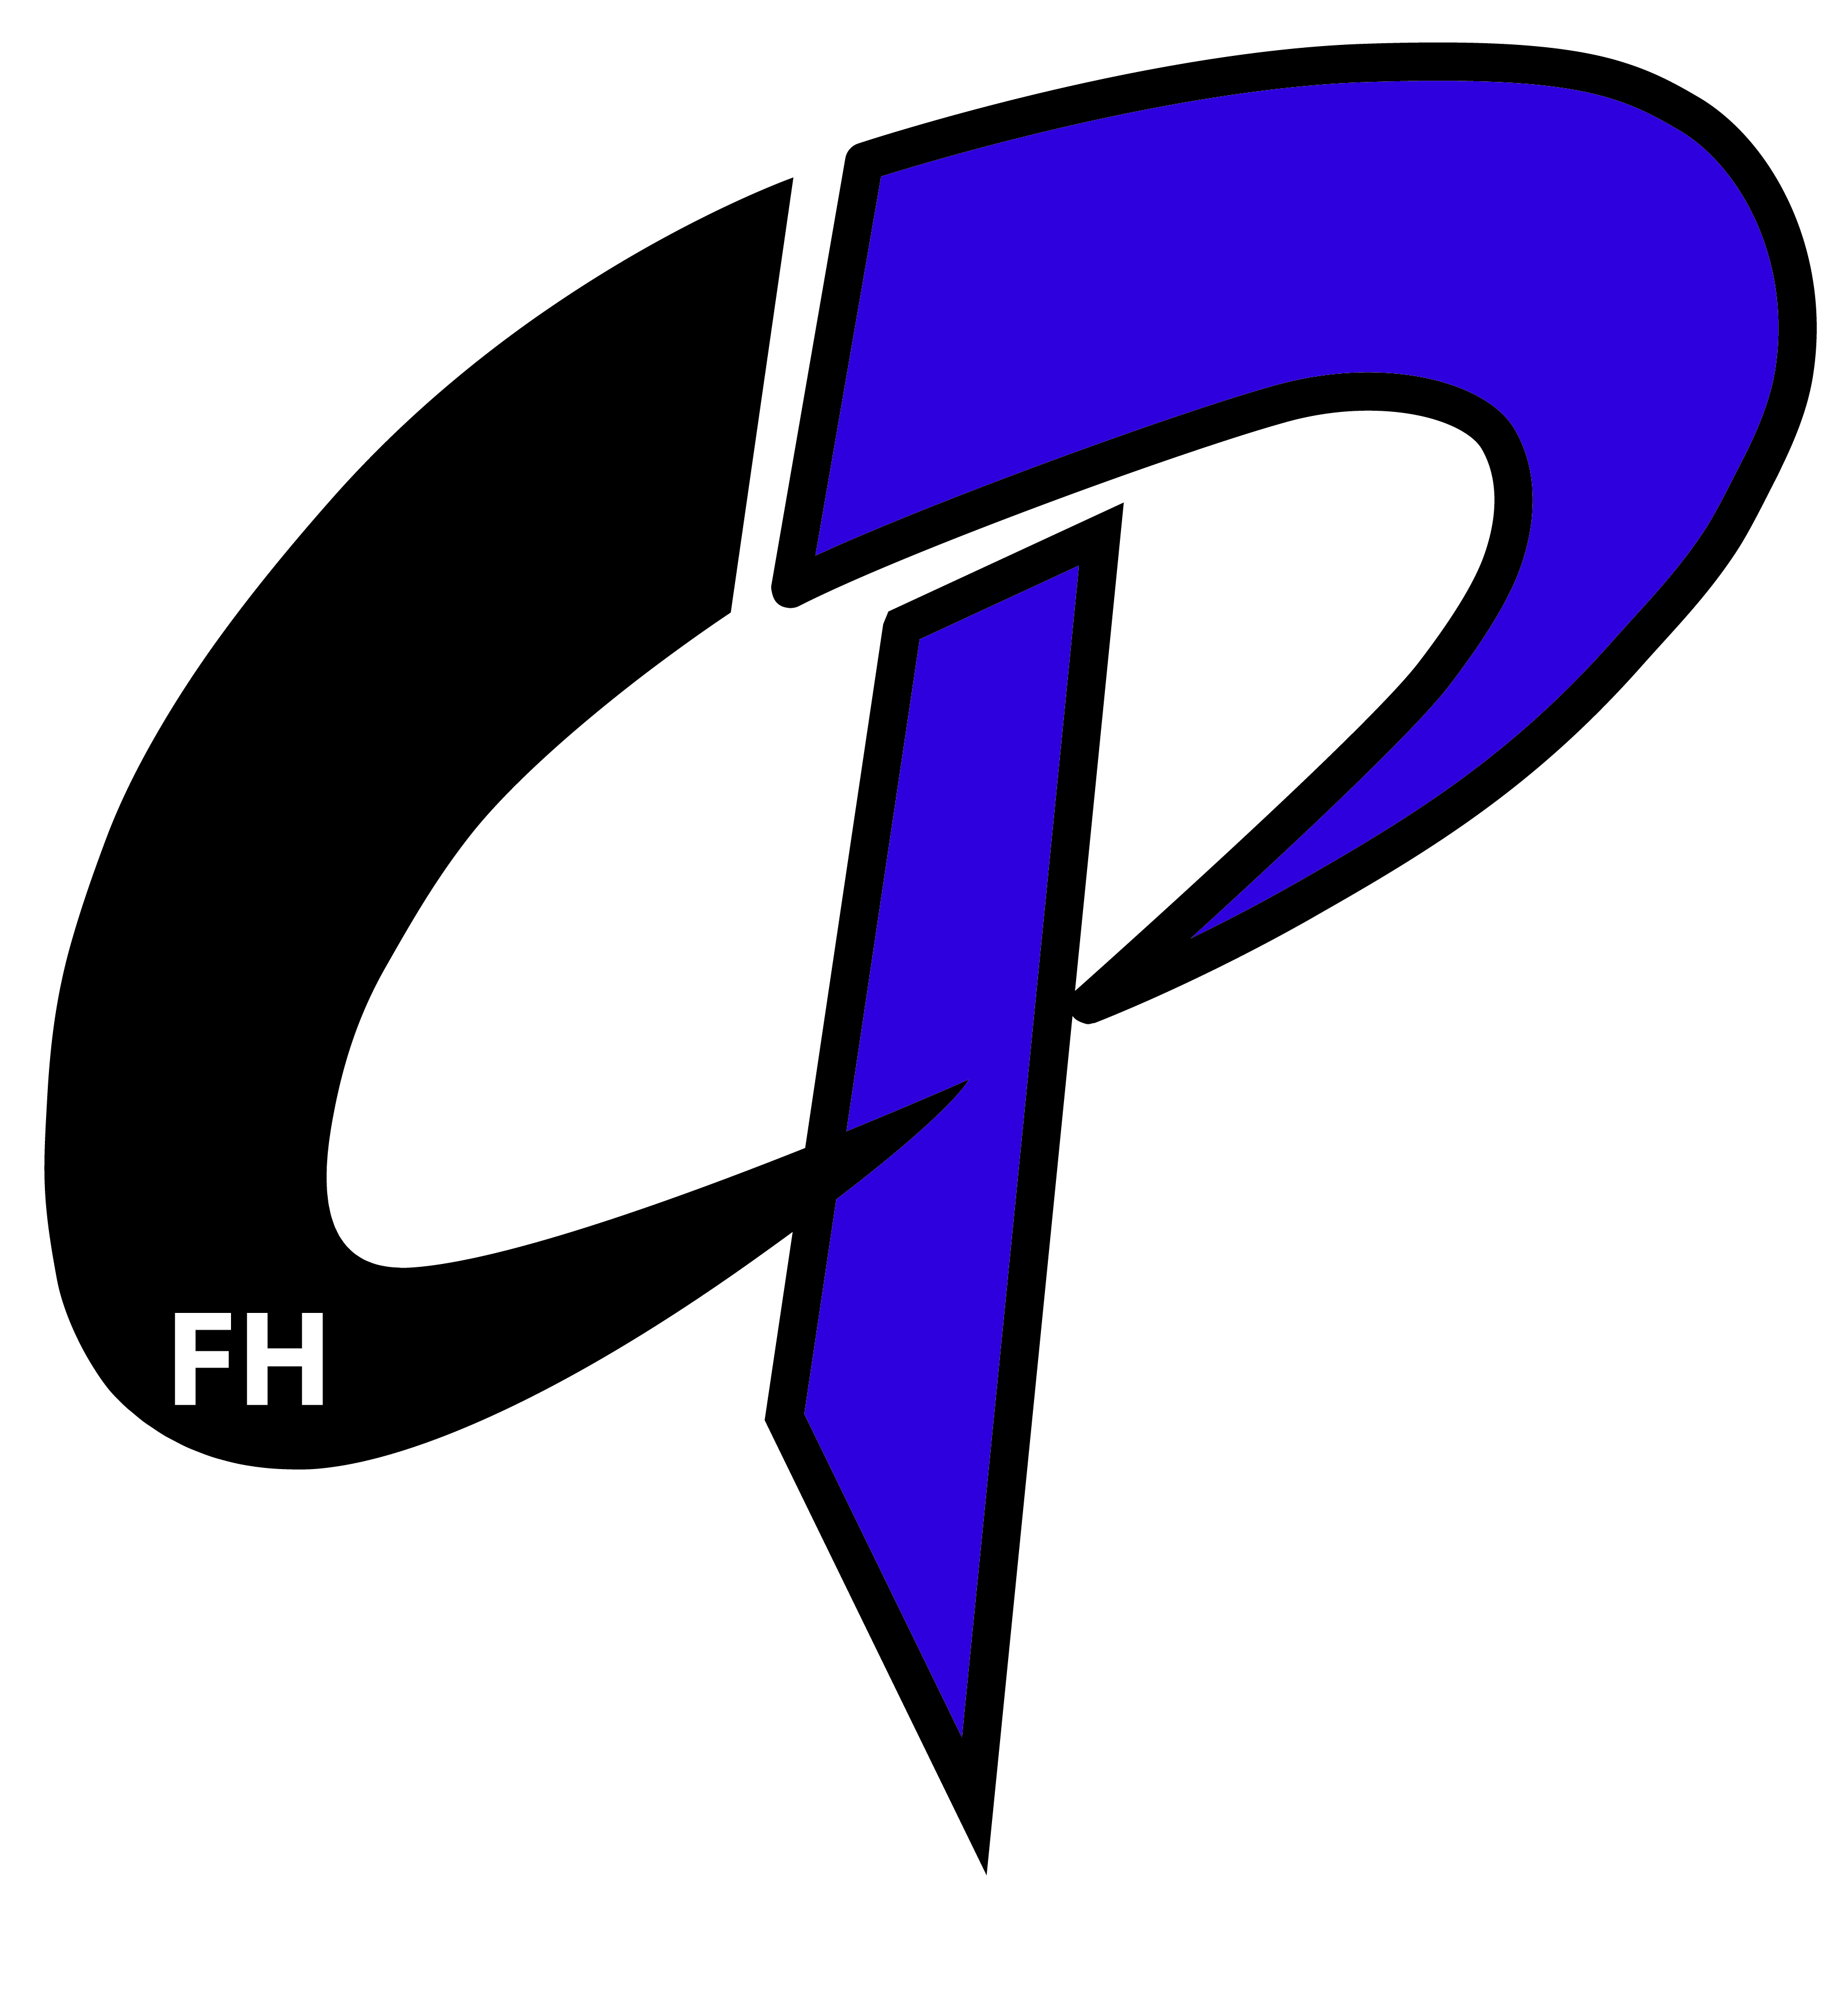
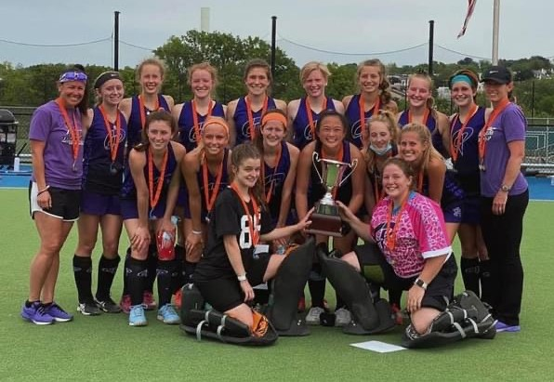
Central Penn Field Hockey is an elite field hockey club that that allows athletes to learn the sport of field hockey, develop a love of the game, and provide players the opportunities to perform in elite level competition to be recruited to play beyond high school. Our athletes are working hard to accomplish their dreams and we hope we can provide them with the best opportunities that will allow them to reach for the stars! We would like to extend an opportunity for your business to become a sponsor for our CPFH program. Your sponsorship will help cover various aspects of our program such as training opportunities, team building and leadership programing events, equipment, traveling expenses, player t-shirts, college bus ride tour, and any other expenses beyond our operating budget that helps keep the cost to our athletes and families affordable yet provide the opportunities to develop their future.

If you are able to become a sponsor, please complete the form below. Thank you for your consideration and support!

Sincerely,
Central Penn Field Hockey
--------------------------------------------------------------------------------------------------------------------------------------------------
Please mail this form and payment to: CPFH, 26 S Alydar Blvd, Dillsburg PA 17019
Make checks payable to CPFH (Central Penn Field Hockey)
Email Company Logo and artwork to centralpennfieldhockey@gmail.com

Sponsor Level | Donation | Recognition
ORCHID | $100 | -Featured Business on all our Social Media Venues and on the CPFH Website for the 2023 Spring/Summer & Fall Seasons
VIOLET | $250 | -Company Logo in Small/Violet Sponsor size on a (3ft X 8ft) sponsorship banner (artwork of your choice) to be hung at Messiah University for U19, U16 and U14 PA State Regional Club Championships in May 2023.  -Featured Business on all our Social Media Venues  -Business Name/Company Logo listed on our website for the 2023 Spring/Summer & Fall Seasons
BLACK | $500 | -Company Logo in Medium/Black Sponsor size on a (3ft X 8ft) sponsorship banner (artwork of your choice) to be hung at Messiah University for U19, U16 and U14 PA State Regional Club Championships in May 2023.  -Featured Business on all our Social Media Venues  -Business Name/Company Logo listed on our website for the 2023 Spring/Summer & Fall Seasons  -Company Logo Displayed on our 2023 Summer Collegiate Bus Tour T-shirts
PURPLE | $1000 | -Company Logo in Large/Purple Sponsor size on a (3ft X 8ft) sponsorship banner (artwork of your choice) to be hung at Messiah University for U19, U16 and U14 PA State Regional Club Championships in May 2023.  -Featured Business on all our Social Media Venues  -Business Name/Company Logo listed on our website for the 2023 Spring/Summer & Fall Seasons  -Company Logo Displayed on CP 2023 Summer Collegiate Bus Tour T-shirts  -Company Logo Displayed on 2023 Central Penn Mini Sticks Summer Camp T-shirts  -Company Logo on CPFH National Club Championship T-shirts
Sponsor Le
Company Name: ____________________________________________________________________
Contact Name: ______________________________________________________________________
Email Address: __________________________________ Phone No: _________________________

ALL SPONSORSHIPS MUST BE RECEIVED BY 4/14/23 FOR ACKNOWLEDGMENT ON OUR BANNER for The PA State Regional Club Championships

