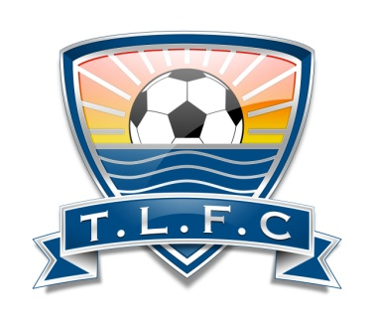

ACTION INDOOR SPORTS & TRI-LAKE FC
If you answer “Yes” to any of these questions, please do not attend a training session or game
Thanks for keeping our Organization and others safe

