Tri-C Youth Athletics Scholarship
Tri-C incorporated as a “general not-for-profit corporation on May 23, 1972, and exists to operate a year-round sports program for the Carterville, Crainville, and Cambria communities. This sports program, within the constraints of our physical, fiscal, and personnel resources, has as its primary purpose the responsibility for allowing all boys and girls, within the given boundaries, the opportunity to enhance their lives with recreational sports. We hope to implant in the Tri-C youth the ideals of good sportsmanship, honesty, loyalty, courage and reverence. The primary emphasis is on the lifelong benefits recreational sports can have. This can be achieved through appropriate instruction, the building of character, and an atmosphere that is conducive to enhancing all participants. While we recognize and support the positive aspects of healthy competition, this is of secondary importance. The positive molding of future citizens is of prime importance.
This year we will be offering a $1,000.00 scholarship to an individual that will graduate from Carterville High School in May of 2021. The criteria for eligibility can be found in the application instructions. Tri-C Athletics believes the youth of our community are our foundation and as such believe it is important to help them to become educated individuals who can return and continue to grow our community. We appreciate your interest in this scholarship.

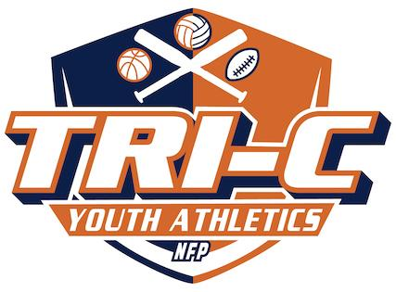

Tri-C Youth Athletics Scholarship Application
Requirements:
- Must be a resident of Carterville, Cambria, or Crainville
- Must be attending Carterville High School and will graduate in May 2021
- Must be admitted in a 2/4-year undergraduate program or be enrolling for the upcoming Fall 2021 semester
- Must attach an essay with the application (typed or handwritten legibly). Ineligible forms will not be considered.
- Return application and essay to tricathletics3@gmail or PO Box 69 Carterville, IL 62918 by April 6, 2021

Personal Information:
First Name: |  |  |  |  |  |  | Last Name:
Address |  |  |  |  |  |  | Phone Number:
City: |  |  |  |  | State: |  |  |  | Zip Code:
Date of Birth: |  |  |  |  |  |  | Email:
Year of Graduation:

Education and Tri-C Youth Athletics Experience and Involvement Information:
High School GPA: |  |  | ACT Total:
Tri-C Employment (Dates):
Tri-C Participant (Dates & Type of participation i.e. played Sport or Umpire):

Employment/Community Service Information:
Current Employer:
Dates of Employment:
Community Service (each activity with Dates:

Extracurricular Activities
Activity Roles and Responsibilities

Essay Question:
In the Space provided, tell us about experiences that have influenced your decision to pursue a collegiate career and how Carterville High School has helped you to prepare for College. Describe your education and career goals and how this scholarship will be used to meet those goals. (If you need to attach another sheet please do so).

