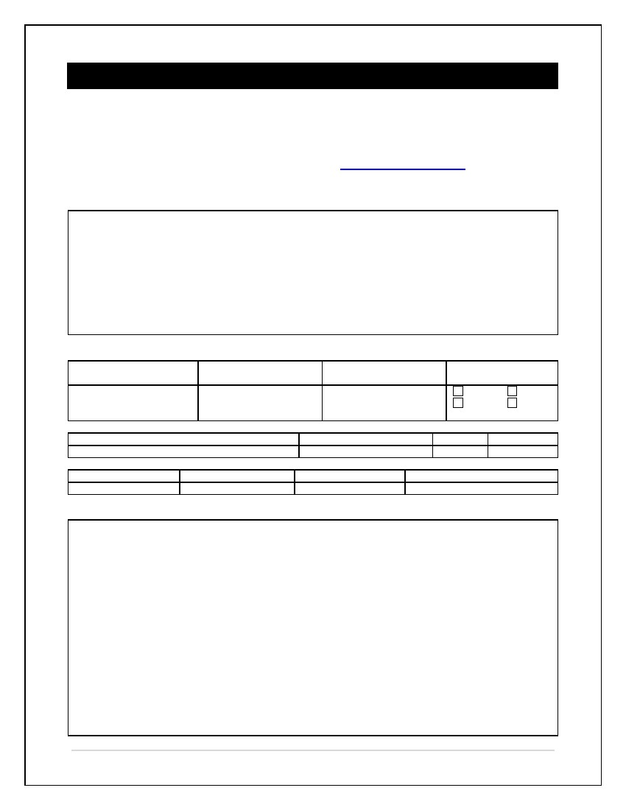
SOMERVILLE LITTLE LEAGUE
Full and Partial Scholarship Request Form
Somerville Little League (SLL) will not deny any child a chance to play baseball or softball due to financial hardship. Full or partial scholarships are available. Complete and return this form and the required information to Somerville Little League. (e-mail: joe@somervillelittleleague.org
SCHOLARSHIP ELIGIBILITY REQUIREMENTS
To be eligible for a full and//or partial scholarship, you must provide Somerville Little League the following:

- An explanation of the financial hardship (please explain in the FINANCIAL HARDSHIP EXPLANATION section) supporting documents may also be requested.
- A copy of an approved Free and Reduced Price Schools Meals Application by the local school.
- Proof of residency – indicating that the player(s) reside(s) within the City of Somerville boundary
- Proof of age - - indicating that the player(s) meet(s) Little League requirements in order to play in the SLL
CONTACT INFORMATION
Legal Guardian’s Last
Name
Legal Guardian’s First
Name
Player
How much can you afford to pay ?
Home Address
City
State
Zip

Daytime Phone
Evening Phone
Mobile Phone
E-mail Address
FINANCIAL HARDSHIP EXPLANATION

1 of 2 | P a g e

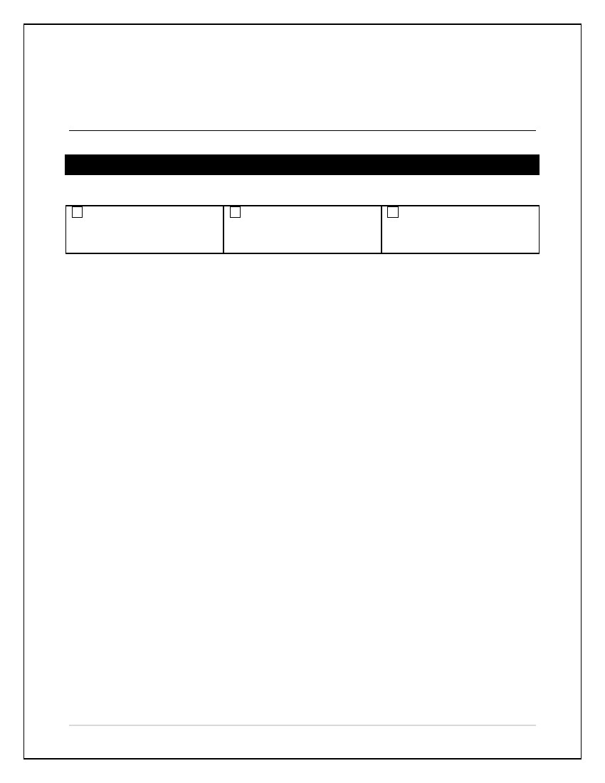
I/We, as the Parent or Legal Guardian of the player(s) named above, attest to the truth for the above information to the best of My/Our knowledge.
Parent or Legal Guardian Signature
Date
FOR SLL USE ONLY
Date Reviewed:
Full Scholarship Granted
Amount: $
Partial Scholarship Granted
Amount: $
Request Denied

2 of 2 | P a g e

