Towne & Country Little League

Safety Manual for Managers and Coaches

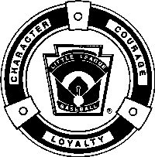

2023

Towne & Country 343-19-16

TOWNE & COUNTRY LITTLE LEAGUE MISSION STATEMENT

Towne & Country Little League follows all Rules and Regulations in the current Little League Rule book. All rules must be enforced at practices and at games. Our league is a Non-Profit Organizations that is run by a Board of Directors elected by our membership of volunteers. It is our mission to provide a safe and friendly environment for the youth of our area to learn the game of baseball and to become good citizens.

President Kevin Dunne 312-310-7788 kdunne0421@gmail.com
Safety Officer Chris Palomo 210-461-6175 cpalomo853@gmail.com

Board of Directors

Vice President Tommy Smith

Secretary Kevin Dunne

Player Agent Kevin Dunne

Coaching Coordinator Kevin Dunne

Treasurer Tommy Smith

SAFETY CODE FOR
TOWNE & COUNTRY LITTLE LEAGUE

Dedicated to Injury Prevention

The Towne & Country League Safety Officer is a member of the Board of Directors and shall have the responsibility for setting safety procedures, completing the Annual Facility Survey and report to the board on any items that need to be corrected. The Safety Officer must submit a Safety Budget to cover items that need to be done for the safety of our children. It is the Safety Officers responsibility to publish a Safety Manual outlining policies in our league and distribute this Manual to all volunteers. This manual should be reviewed by the District Safety Officer.

CODE OF CONDUCT

The Board of Directors of Towne & Country Little League has mandated the following Code of Conduct for all members of the league.

Every Board Member, Manager, Coach and any other persons, volunteers or hired workers, who provide regular service to the league and/or have repetitive access to, or contact with players or teams will be required to sign a Volunteer Application. The President or his duly appointed assistants will annually conduct a sexual offender background check on every applicant. Furthermore, the President and/or his assistants will conduct criminal background checks on these applicants on a random basis.

Failure to complete and submit the Volunteer Application Form by those required to do so will result in their being barred from involvement in Towne & Country Little League. Failure by Towne & Country to conduct the proper background checks may result in suspension or termination of the league’s charter and/or tournament privileges.

SUGGESTIONS
We are always open to suggestions. Anyone who sees anything that would improve our league safety may call or e-mail the president or the safety officer at any time. If you have a suggestion, write it down and turn it in at the concession stand so that the Board of Directors can look at it.

No board member, manager, coach, player or spectator shall, at any time:

- Lay a hand upon, push, shove strike, or threaten to strike an official.

- Heap personal verbal or physical abuse upon any official for any real or imaginary belief of a wrong decision or judgment.

- Show objectionable dissention at an official’s decision by throwing of gloves, helmets, hats, bats, balls, or any other forceful unsportsmanlike action.

- Use unnecessarily rough tactics in the play of a game against the body of an opposing player.

- Physical attack any board member, official manager, coach, player or spectator.

- Use profane, obscene or vulgar language in any manner at any time.

- Appear on the field of play, stands, or anywhere on the complex while in an intoxicated state.

- Gamble upon any play or outcome of any game with anyone at any time.

- Smoke on the playing field or in any dugout.

- Publicly discuss in a derogatory manner any play, decision or personal opinion on any players during the game.

- As a manager or coach, mingle with or fraternize with spectators during the course of the game.

- Speak disrespectfully to any manager, coach, official or representative of the league.

- Tamper or manipulate any league rosters, schedules, draft positions or selections, official scorebooks, rankings, financial records or procedures.

- Challenge an umpire’s authority. The umpires shall have the authority and discretion during a game to penalize the offender according to the infraction up to and including expulsion from the game.

2
The League Safety Officer will post helpful Safety Hints from the ASAP Newsletters on the League Bulletin Board. Also check the Little League website: littleleague.org for past editions of the ASAP Newsletter for many helpful ideas on how to keep you and your players safe.

At least one manager or coach from each team must attend: NOTE: Both clinics can be combined and taught at the same time.
- Fundamental Clinic that includes hitting, sliding, fielding & pitching each year. Every manager and coach must attend a clinic at least every 3 years.
- First Aid clinic. Every manager and coach must attend a basic First Aid Clinic at least every 3 years. Anyone interested in CPR training may contact the Safety Officer to make arrangements for this additional training.

All Towne & Country Umpires must have attended an umpire training class that includes first aid training.

It will be the Safety Officer’s responsibility to contact the manager of any team that does not have someone with this training and make arrangements to attend a make up clinic.

TIME TO START THE SEASON
Once Managers and Coaches have been selected and had Background Checks done and teams are selected, Team Rosters are submitted on the Little League Data Center at www.LittleLeague.org
Now you have your team roster and you are ready to start the season. Before you hold any practices, meet with the parents of the players on your team and tell them what you expect of them and what they can expect from you. You will need help in many areas during the season. Someone to help with uniforms, someone to coordinate team pictures or fund raisers. Take advantage of everyone that wants to help. Find someone to be the team safety representative. This person need not have medical training but would be another set of eyes that would help spot potentially dangerous situations.

If this person or any other parent will be in contact with your players on a regular basis, the league must be notified and they will need to fill out a volunteer application and have a background check run on them. Do not allow anyone to interact with your team until you know that the league officials tell you that they have been checked.

SPORT PARENT CODE OF CONDUCT
The essential elements of character-building and ethics in sports are embodied in the concept of sportsmanship and six core principles: trustworthiness, respect, responsibility, fairness, caring, and good citizenship. The highest potential of sports is achieved when competition reflects these “six pillars of character”.
I therefore agree:
I will not force my child to participate in sports.
I will remember that children participate to have fun and that the game is for youth, not adults.
I will inform the coach of any physical disability or ailment that may affect the safety of my child or the safety of others.
I will learn the rules of the game and the policies of the league.
I and my guests will be a positive role model for my child and encourage sportsmanship by showing respect and courtesy, and by demonstrating positive support for all players, coaches, officials and spectators at every game, practice or other sporting event.
I and my guests will not engage in any kind of unsportsmanlike conduct with any official, coach, player, or parent such as booing and taunting; refusing to shake hands; or using profane language or gestures.
I will not encourage any behaviors or practices that would endanger the health and well being of the athletes.
I will teach my child to play by the rules and to resolve conflicts without resorting to hostility or violence.
I will demand that my child treat other players, coaches, officials and spectators with respect regardless of race, creed, color, sex or ability.
I will teach my child that doing one’s best is more important than winning, so that my child will never feel defeated by the outcome of a game or his/her performance.
I will never ridicule or yell at my child or other participant for making a mistake or losing a competition.
I will emphasize skill development and practices and how they benefit my child over winning. I will also de-emphasize games and competition in the lower age groups.
I will promote the emotional and physical well being of the athletes ahead of any personal desire I may have for my child to win.
I will respect the officials and their authority during games and will never question, discuss, or confront coaches at the game field, and will take time to speak with coaches at an agreed upon time and place.
I will demand a sports environment for my child that is free from drugs, tobacco and alcohol and I will refrain from their use at all sports events.
I will refrain from coaching my child or other players during games and practices, unless I am one of the official coaches of the team.
Just like you met with the parents, prior to your first practice with your new team, meet with the players and explain to them what you expect from them and what they can expect from you.

3
WHAT IS EXPECTED FROM PLAYERS
- to be on time for all practices and games.
- to always do their best whether in the field or on the bench.
- to be cooperative at all times and share team duties.
- to respect no only others, but themselves as well.
- to be positive with teammates at all times,
- to try not to become upset at their own mistakes or those of others.
We will all make our share this year and we must support one another.
- to understand that winning is only important if you can accept losing, as both are important parts of any sport.
Arrangements should be made in advance of all games and practices for emergency medical services. Each team must have someone with first aid training and a first aid kit at every practice and game. Make sure that a telephone is available and know the numbers to call. Carry your players Medical Consent forms with you at all times and have emergency numbers available to contact EMS (911) and your player’s parents.

Only Little League approved equipment that has been inspected by the League Equipment manager will be issued to your team and only Little League approved equipment may be used during practice or games. Inspect equipment often and be sure that it fits properly. If equipment is damaged, return it immediately to the Equipment Manager for replacement, or tell the player owner not to bring it back again.
Batters must wear approved protective helmets during practice, and during games.

Catchers must wear catcher’s helmet, mask, throat protector, long model chest protector, shin-guards and male catchers must wear a protective supporter at all times. Catchers must wear catcher’s helmet and mask with a throat protector in warming up pitchers.

Play area should be inspected for holes, damage, glass and other foreign objects prior to every practice and every game by one of the umpires and at least one coach or manager

Dugouts and bat racks should be positioned behind screens. Only players, managers, coaches and umpires are permitted on the playing field during play and practice sessions.

Procedure should be established for retrieving foul balls batted out of the playing area.

During practice and games, all players should be alert and watching the batter on each pitch. During warm-up drills players should be spaced so that no one is endangered by wild throws or missed catches.

Except when runner is returning to a base, head first slides are not permitted (12 years old and older.)

During sliding practice bases should not be strapped down and should be located away from the base anchoring system

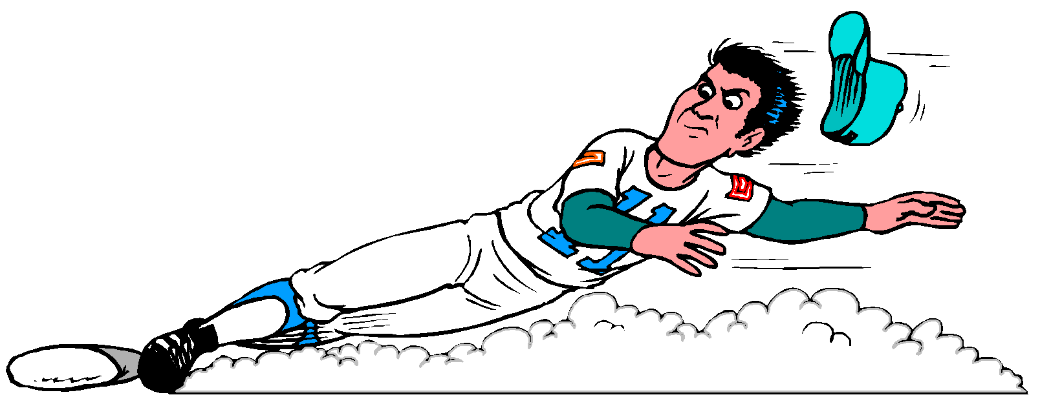
At no time should “horse play” be permitted on the playing field.
Parents of players who wear glasses should be encouraged to provide “Safety Glasses”.

Players must not wear watches, rings, pins, jewelry or other metallic items. Medic Alert items are allowed.

There is no “On Deck Circle” except for Junior Boys. All batters must remain in the dugout until it is their turn to bat.

Please do not swing bats anywhere but on the field in the designated areas.

4
CONCESSION STAND SAFETY

Train all concession personnel in the safe preparation and service of food.
NO ONE UNDER AGE 14 will be allowed to help in concession.

A. Wash hands with soap before serving food to anyone.
B. Those involved in food preparation should wear hair restraints.
C. Disposable gloves should be worn by all food handlers.
D. Person preparing food should not handle ticket sales or money. If need arises for that person to help serve food, make sure they wash their hands with soap before handling food each time.
E. Remind food handlers to wash hands with soap after using restroom.
F. All serving and cooking utensils will be washed
with soap and hot water.
G. Leftover food will be stored in air tight containers and stored in refrigerators.
H. Counter tops and soda fountains will be cleaned with anti-bacterial cleaning solution at the end of each serving day.
I. Bar-B-Que grills will be placed in a safe area.

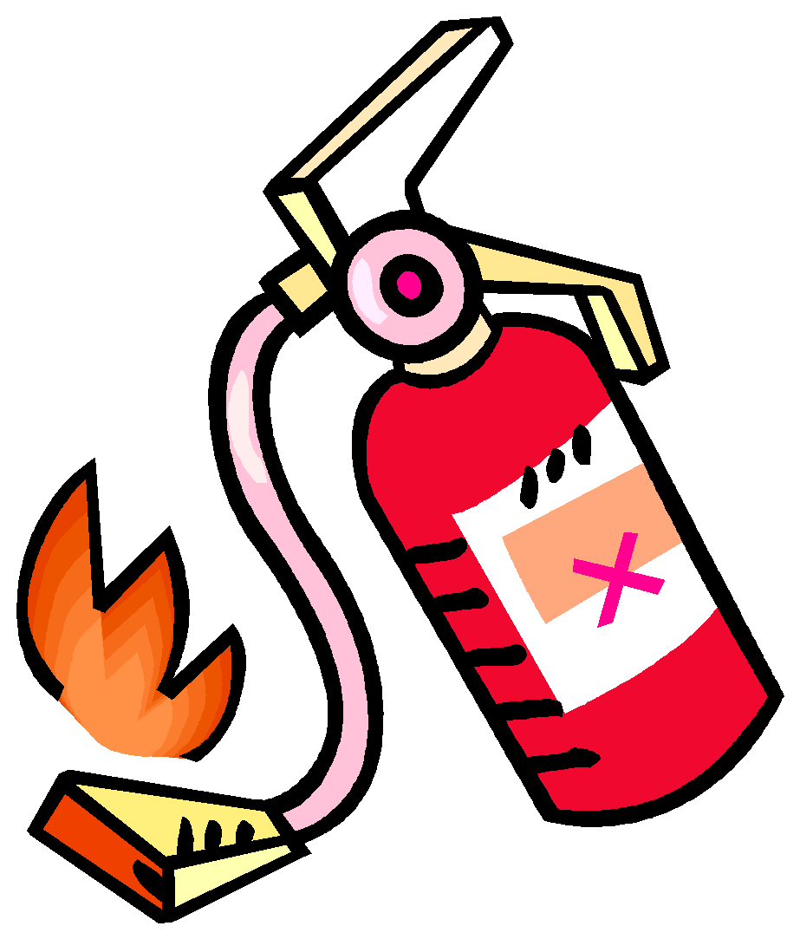
KNOW WHERE FIRE EXTINGUISHER IS LOCATED

All workers must know where the fire extinguisher is located and know how to operate it.

COMMUNICABLE DISEASE PROCEDURES

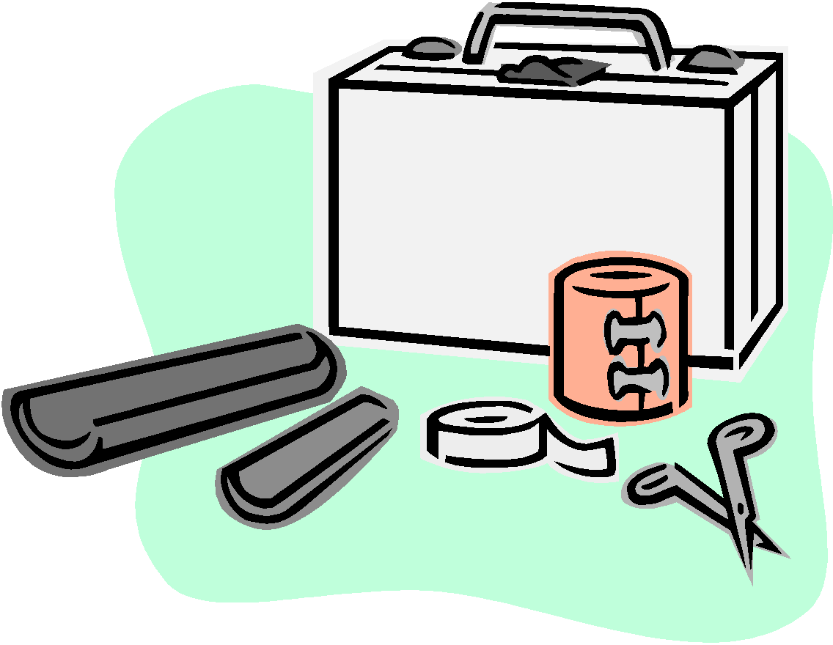
1. Bleeding must be stopped, the open wound covered, and the uniform changed before the athlete may continue
2. Routinely use gloves to prevent mucous membrane exposure when contact with blood or other body fluid is anticipated (provided in first-aid kit).
3. Immediately wash hands and other skin surface if contaminated with blood.
4. Clean all blood contaminated surfaces and equipment
5. Managers, coaches and volunteers with open wounds should refrain from all direct contact until the condition is resolved.
6. Follow accepted guidelines in the immediate control of bleeding and disposal when handling bloody dressings, mouth guards, and other articles containing body fluids.

Lightning Evacuation Procedures
If lightning strikes, it can rip apart a roof, explode a solid brick wall or start a fire. More importantly, though, lightning can kill you. It is the second most common weather related cause of death and injury in the United States.

If you are caught outdoors and unprotected:
- Get in a hard-topped vehicle.
- Never use a tree as a shelter.
- Avoid high areas and tall objects.
- Keep away from metal objects, including bikes, machinery, fencing and BATS.
- Spread out – don’t stand in a crowd of people.
- If you feel a tingling sensation or your hair stands on end, lightning may be about to strike. Immediately crouch down and cover your ears. Do not lie down or place your hands on the ground.

Flash Facts about Lightning
  - Generates temperatures as high as 50,000 degrees Celsius.
  - Travels as far as 40 miles.
  - Kills nearly 100 people in the U.S. each year.
  - Often strikes twice in the same place!

5
Accident Reporting Procedures:

What to report - An incident that causes any player, manager, coach, umpire, or volunteer to receive medical treatment and /or first aid must be reported to the Safety Officer. (See Page1). These include even passive treatments such as the evaluation and diagnosis of the extent of the injury or periods of rest.

When to report - All such incidents described above must be reported to the Safety Officer within 48 hours of the incident.

How to make the report - Reporting incidents can come in many forms, most typically, they are telephone conversations. At a minimum, the following information must be provided:

- The name and phone number of the individual involved.
- The date, time and location of the incident.
- As detailed a description of the incident as possible.
- The preliminary estimation of the extent of any injuries.
- The name and phone number of the person reporting the incident.

Safety Officer’s Responsibilities -Within 48 hours of receiving the incident report, the Safety Officer will contact the injured party or the party's parents and (1) verify the information received; (2) obtain any other information deemed necessary; (3) check on the status of the injured party; and (4) in the event that the injured party required other medical treatment (i.e., Emergency Room visit, doctor's visit, etc.) will advise the parent or guardian of the Little League's insurance coverage and the provisions for submitting any claims.

If the injuries are more than minor in nature, the Safety Officer shall periodically call the party to (1) check on the status of any injuries, and (2) to check if any other assistance is necessary in areas such as submission of insurance forms, etc. until such time as the incident is considered "closed" (i.e., no further claims are expected and/ or the individual is participating in the league again).

Field Equipment Procedures

The following applies to use of all field equipment used by Towne & Country Little League and apply to anyone who has been issued a key by the league to use this equipment.

All individuals with keys to the League equipment sheds (i.e., Managers, Umpires, etc.) are aware of their responsibilities for the orderly and safe storage of rakes, shovels, bases, etc.
Children should not be allowed near chemicals or equipment. Do not allow children to “hitch” a ride on any of the lawn equipment or golf cart.

Before you use any machinery (i.e., lawnmowers, weed whackers, lights, scoreboards, public address systems, etc.) please have the equipment manager explain how this equipment is to be operated.

All chemicals or organic materials stored in the league sheds shall be properly marked and labeled as to its contents. All chemicals or organic materials (i.e., chalk, fertilizer, etc.) Stored within these equipment sheds will be separated from the areas used to store machinery and gardening equipment (i.e., rakes, shovels, etc) to minimize the risk of puncturing storage containers.
Any witnessed “loose” chemicals or organic materials within these sheds should be cleaned up and disposed of as soon as possible to prevent accidental poisoning.

Remember, safety is everyone's job. Prevention is the key to reducing accidents to a minimum. Report all hazardous conditions to the Safety Officer or another Board Member immediately. Don’t play on a field that is not safe or with unsafe equipment. Be sure your players are fully equipped at all times, especially catchers and batters. And, check your team's equipment prior to each practice or game.

We are always open to suggestions from managers, coaches, parents and fans. Anyone that has an idea, please write it down and submit it to the league so they can always provide a safe place for our families.

Some Common Sense Safety Rules for our Fans and Visitors

ABSOLUTELY, NO DRUGS OR ALCOHOL WILL BE ALLOWED
ON THE PREMISES. VIOLATORS WILL BE PROSECUTED!

6
Pets are not allowed in the complex. This is a City Ordinance.

Reduce your speed when you enter our parking lot.

Always be on the lookout for children running between cars in our parking lot.

We rarely have children ride their bicycles to games but if they do, we ask that they be parked and locked during the game. We do not allow anyone to ride bicycles around the complex.

Roller blades, Skateboards, Rip Sticks, Scooters and Roller Skates are banned from our facility.

Parents, please do not throw balls back and forth or allow your children that are not in a game to throw balls outside the field. Ample space is provided for our players to warm up prior to the games without endangering our spectators with the possibility of being hit by a ball.

BATTING CAGES
Each team will be given a time to use the Batting Cages. These times are scheduled and any changes to this schedule must be negotiated between the coaches. Do not use more than your allotted time.

BATTING CAGE RULES

1. No team or player is allowed in the cages without adult supervision.
2. Batting helmets are required in the tunnels.
3. Only ADULTS are allowed to operate the machines.
4. No climbing on nets, fences, gates or other equipment.
5. Only 1 player is allowed in the tunnel while balls are being pitched / batted.
6. Do not walk between the tunnels. Enter and exit from the ends only.
7. All balls must be collected in the buckets following each practice.
8. Do not hit ball or throw balls into the fence.
9. No horseplay at the facility.
10. Do not throw balls outside the tunnels.
11. Turn off pitching machines when practice is finished.
12. All trash must be collected following each practice.
13. DO NOT REMOVE EQUIPMENT FROM THE CAGES.

USE OF THE BATTING CAGES IS A PRIVELAGE. FAILURE TO FOLLOW THESE RULES MAY COST YOU THAT PRIVELAGE.

COVID SAFETY PLAN ADDENDUM

- Kids will wear masks at all times (dugout, grounds, etc.) except when playing on the field.
- Adults will wear masks at all times except when social distancing is possible.
- Concession workers will wear mask and protective gloves, wash hands frequently.
- Concession stand will be cleaned frequently as well as before and after a shift.
- Restrooms will be cleaned requently.
- Hand sanitizer will be provided for every dugout.
- No community water, kids will bring their own water bottles.
- Every child will have their own helmet.
- It is recommended every child have a bat but sanitizer is available in dugout if not.

