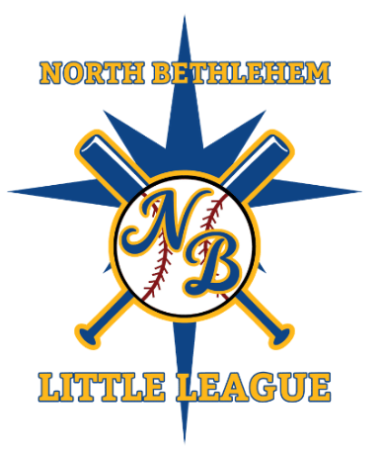
North Bethlehem Little League
Return to Play Procedures

As our Little League program returns to the field, it is recommended that our organization adheres to guidelines provided by the Centers for Disease Control and Prevention (CDC) and other government entities.

Each family has a choice to be all in for committing to our safety plan. No family is being forced to return and should make whatever decision they feel is best for themselves. All NBLL families must sign a waiver before returning to play.
1. All individuals (players, coaches, and fans) should measure their body temperature to ensure there is no fever present before participating in any baseball activities. Anyone with symptoms of fever, cough, or worsening respiratory symptoms, or any known exposure to a person with COVID-19, should not attend any baseball/softball activities.
2. No handshakes or personal contact celebrations should happen during baseball activities. After the game, teams will line up on the baselines and tip their caps to the opposing team.
3. Everyone should bring their own personal drinks. No sharing of drinks or food among players, coaches and fans. All players' water bottles should be clearly labeled.
4. During practices, players’ bags should be hung on the inside of the fence at least 6-feet apart from others. Coaches should monitor distance between bags or markings should be placed at each field. No one should put their gear in the dugouts. During games, players’ bags should be hung on the outside of the fence again at least 6-feet apart. Dugouts are reserved for 2-3 players at most who are next up to bat and those players must stay 6-feet from each other. Other players should be outside the fence lines practicing physical distancing at their bags.
5. Coaches should be mindful of their spacing in the dugout area during games and wear a mask when in close contact with a player or talking among themselves.
6. Hand sanitizer will be available at each field and players should regularly use it coming on and off the field. We also highly encourage players to bring their own personal hand sanitizer and keep in their bags.
7. Gum, sunflower seeds, or any other chewing of food is not permitted during practices or games. This is for both coaches and players. Spitting is not allowed.
8. Players (particularly pitchers) are not allowed to lick their fingers and if they do and it’s noticed, the ball will immediately be taken out of play and that player is required to use hand sanitizer.
9. There is absolutely no sharing of baseball equipment. Gloves, helmets, bats, catchers’ gear, etc...nothing should be shared
11. Baseballs should be rotated on a regular basis to limit contact. Foul balls retrieved by players and coaches only...fans should not touch the baseballs. During games, each team on defense shall use their own set of baseballs.
12. During games, the umpire should stand behind the pitcher and not behind the catcher.
13. When using the batting cages/stations, players should not be standing around together waiting. One player in the cage/station, one player outside the cage waiting. Only the coach throwing the batting practice should pick-up the balls in the batting cage.
14. Fans will need to practice physical distancing when attending games. When available sit far down the baselines and/or behind the outfield fences. Please limit contact to those that live in the same household when attending. Fans should bring their own seating. The bleachers at both City Line and Northeast will be roped off
15. The concession stand at this time will not be open.

