NLLL - BOARD MEETING - MINUTES

NOVEMBER 14, 2024 / 7:00 PM / JONESTOWN LEGION

ATTENDEES: Brad Rhen, Nate Geibe, Marissa Bortz, Mike Burdge, Jeff Mazalewski, John Shireman, Jerome Noel, Matt Wengert, Justin Bortz, Jake Kane

AGENDA:
- Call to order.
- Roll Call
- Approval of previous minutes
- New Board Positions
- Reports
- Treasure
- Committees
- Coordinators
- Board Report
- Unfinished Business
  - Registration
  - Sub Sale minimums/buyouts!
- New Business
  - Executive Committee
  - Thome offseason and communications
  - Winter workouts
  - Intermediate and Costs
  - Opening Day
  - Charter Fee
  - By Laws
  - Non-Profit and taxes
  - Treasurer committee
- Announcements and upcoming events
- Adjournment

MEETING MINUTES:
- Motion to approve previous meeting minutes. Second, Approved.

- Michael Brunner resigned as President of Northern Lebanon Little League on November 3rd, 2024.
- John Shireman nominates Justin Bortz to fill the vacant position of President – Northern Lebanon Little League. Jerome Noel seconds. Unanimous approval.
- TREASURY UPDATE:
  - The league has three outstanding bills:
    - Charlie’s Septic $222.60
    - Umpires (Fall Ball): $865.00
    - Last Mowing of Lions/Yost: $50 to Geibe Mowing
  - CURRENT BANK ACCOUNT BALANCE: $29,523.51 (as of 10/31/24)
  - Jerome Noel is in possession of the league checkbook and JBT debit card.
  - League agrees that JBT debit card should go to Matt Wengert for Concessions.
  - Jerome Noel to join Treasury committee with Travis Smith departure.
  - Only Jerome and Mazalewski can sign checks. Need to add Burdge.
  - It is pointed out that checks have Mike Brunner’s address on them.
  - TREASURY COMMITTEE: Michael Burdge, Jeff Mazalewski, Jerome Noel
- League agrees to use Group Text as primary communication method over email.
  - Important Matters like Motions/votes need to be recorded in their own email thread.
- League agrees to invite Jake Kane, Ben Biggar and Matt Citino to fill the three remaining board vacancies.
  - We will give the new members time to think about what roles they want to help with.
- OPENING DAY COMMITTEE: Jerome Noel, John Shireman, Jake Kane, Mike Burdge, Dwayne Elder.
  - Will identify options for Opening Day dates and locations.
  - It is discovered that the proposed date for Opening Day at South Hills Park (4/19/2025) is Easter weekend.
  - Jerome Noel to chair
  - OPENING DAY: 4/19 is bad because its Easter weekend if at South Hills
  - Make it more of a carnival, bounce houses, food trucks, face painting, dunk tank.
  - Alternate North/South locations from year to year. Mention in State of League address.
  - North Lebanon Township fields? Dwayne says not enough parking.
  - Sell burgers and hot dogs, soda, and Gatorade…big profit for league $$
    - Need volunteers.
  - Food trucks, etc.
- FUNDRAISING:
  - John Shireman volunteers to run a secondary fundraiser.
    - Gun Bingo - all in favor? Yes, do it. MOTION - Shireman, second by Noel, all approve. Need a committee. Include Jessica Noel.
  - We discuss sub sale Minimums and agree they should stay the same as last year (24 sandwiches per child/40 per family, each sold counts as $2.40 towards buyout).
- Small Game of Chance License? Do we have one? No, we do not.
  - Ask Dwayne, If not John Shireman can help.
- REGISTRATION:
  - Agreed on $50 buyout per player (if prepaid during registration)
  - Agreed to keep registration fees the same as last year (Tball: $65, Rookies: $80, Minors & Majors: $100)
    - Add note about buyouts for families with more than 3+ kids. Have third kid register to do sub sale if first two do the buyout.
  - Intermediate Division: Board agrees not to offer this division since it has not worked for 2+ years.
- Jeff Mazalewski states renovations at Lions Park are in the works and we may not be able to host All-Star tournaments again this year. More to come…
- Better quality uniforms (check with Dwayne), Noel also knows a guy.
- Asked about name change? Still a polarizing topic
  - Agreed to table until next meeting.
- League Logo brought up: Agreed to bring back old logo and design an alternate logo.
- Charter Fee can be reduced if field count is reduced.
  - $50 fee per field (through Little League)
- Matt W. took down batting cage nets at Lions. Thanks Matt
- Need a ramp for Lions Park? Jerome recommends metal. John S. says they’re about $180. Will discuss more at next meeting.
- Another tractor bill for flat tire coming from Dwayne.
  - Reach out to Shireman for future tractor maintenance.
- EXECUTIVE COMMITTEE: 3-5 people? Prez, VP, Treasurer (Burdge), Secretary, John Shireman’s volunteers..For emergency purposes; Discipline. like conflicts at games, etc. Need to outline its purpose in the Bylaws. Hopefully, it is never needed.
  - Tabled for next meeting. Will vote on if we need one.
- Winter workout locations? Yost Church? Fredericks Church? Our Lady of the Cross?
  - We will need to purchase soft balls for indoor.
- Winter Workout Committee? Would need a location and a lot of volunteers. Jake Kane will assist. Shireman will talk with Travis Thome. Ben Biggar can help. Shireman will reach out to church in Fredericksburg /old elementary school. Parking is an issue at Fredericksburg church/old elementary school.
- NEXT MTG - 12/12/24. Eagle Hotel. They want to be our sponsor…and will offer a kickback night. 7pm.
- CONCESSIONS: Matt needs keys and cash boxes. Need to buy new ones. Matt will bring options to next meeting.
  - Where is our stuff from Quentin Church?
    - Matt Sanders has keys, need to reach out to him.
      - Marissa will reach out to him.
- FIELDS: J2 Shed in bad shape. Yost bleachers boards are going bad. New nets and fence repairs at other fields. - Per Matt Wengert. Jonestown Park fences need work. Marissa’s on it.

ACTION ITEMS:
- JBT Debit Card to Matt Wengert for Concessions
- John Shireman to reach out to Travis Thome (NLHS)
- Small Game of Chance License? John Shireman can help.
- Taxes are behind…Dwayne is on it.
- Non-Profit Status? Follow-up with Dwayne
- Burdge to manage two shed moves (Yost and Lions Park). Will reach out to Myerstown Shed.
- Justin to reach out to Umpire Guy (Todd G.) for statement from last year.
  - 11K LAST YEAR ESTIMATE
- Figure out cost per kid.
- Tweak flyer…Market it differently, advertise it different. Update Website, market it better. Get rid of all-stars, move main info up the flyer…slim it up. -Justin
- Get the league involved in parades - Marissa.
- Talk to NCBA after registration about dividing up fields as needed (due Feb. ‘25)
- Need monthly financial statements.
- Need to transfer bank account info from Brunner to Bortz
- Brad Rhen and Mike Burdge need to be added to JBT account.
  - Burdge to reach out to Isaiah at JBT, but he needs meeting minutes showing Brunner resigned, Bortz new president.
- Need a league PO Box, Mike Burdge makes a motion to open on in Jonestown, John Shireman’s seconds, unanimous approval. -Open it as NLLL. Need three keys for Prez, VP and Treasurer.
- Add meeting minutes to the website. - Justin
- Add league year calendar to website - Justin.
- Add Constitution to website - Justin.
- Add Bylaws to website -
- “State of the League” email blast to league. Highlight field improvements, new sheds, etc.
- Justin will talk with Brad about Facebook notification for registration tomorrow.
- Get Treasury laptop setup. -Justin
- Yost batting cage net needs to come down. Nate Geibe
- Mazalewski and team to take down shed at Lions.
- Need to reimburse Noel for pitcher mound.
- Laptop paid with check.
- Send Shireman list of 12YOs from North from last year.

NEXT MEETING AGENDA:
- Uniform samples!
- Talk
- Field Discussion
  - What fields are we losing?
  - Fields under construction?
- Executive Committee discussion - Review what constitution says.
- Sub Sale Date
- Opening Day? check locations, decide on a date. Aim for 4/12…but where?
- Charter Fees
- Bylaws Approval
- Concessions Cash Boxes - Matt W. will provide options at next meeting.

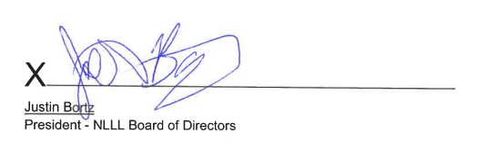

X
Matthew Schreckengost
Secretary - NLLL Board of Directors

11/14/24

ATTENDANCE
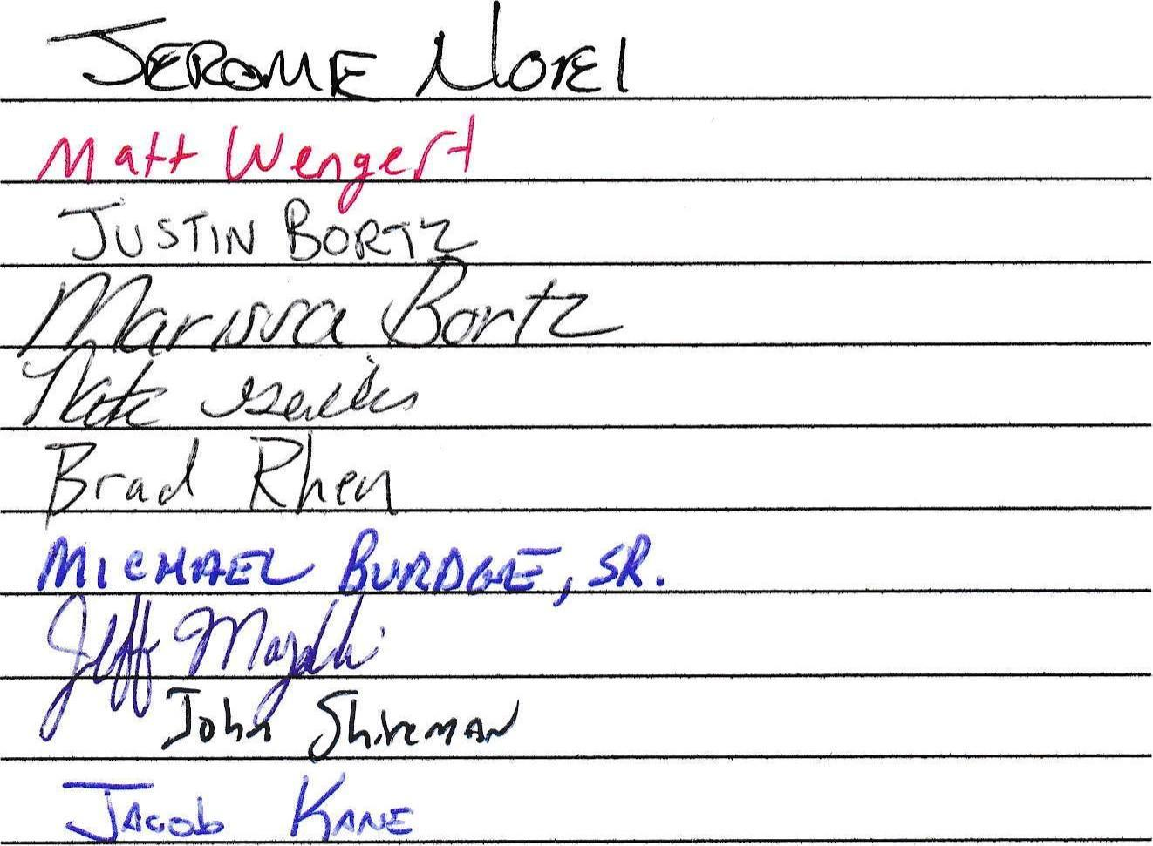

Michael Brunner
Resignation Letter

11/3/2024
Northern Lebanon Little League

Dear NLLL Board of Directors

Kindly accept this letter as my formal resignation as President of Northern Lebanon Little League.

It has been my pleasure working with each one of you getting this league to where it is today. Without everyone’s hard work, none of our accomplishments would have been possible.

I will meet with the Treasury Committee and Jerome to make the transition as seamless as possible.

Best regards,

Michael Brunner

