NLLL - BOARD MEETING AGENDA

MAY 8, 2025 / 6:00 PM – 8:00 PM / North Lebanon Township Park - Pavilion
725 Kimmerlings Rd, Lebanon, PA 17046

Opening: (5 minutes)
- Call to order
- Roll Call
- Approval of previous minutes
Regular Business:
- Reports from officers (10 minutes)
  - Treasury Report (Burdge & Maz)
  - Concessions Report (Wengert)
- Unfinished business
  - Tball & Championship Day Events (20 minutes)
    - June 6/7 – Need volunteers
  - Fields: (Marissa, Nate, Dwayne, Matt C.) (10 minutes)
    - Field Improvements & Maintenance
      - Summer/Fall Improvement Plans
        - Batting Cage at Jonestown Park, Batting Cage at NLES, Batting Cage at NL Township, Raise Plate at J1, Lions & NLT3, Fix lips at Lions Park (after Sprinklers installed), DiamondTex for Cornwall Elem & Miners Village, etc.
  - Fundraising (10 minutes)
    - R&K Fundraiser – Total Sales/Profit Report
    - Secondary Fundraiser – Gun Lottery/Bingo Updates (John Shireman)
      - Small Game of Chance License
      - Date/Time/Location?
  - Taxes -- Status (Dwayne) (2 minutes)
- New business items
  - Playoff Structure (Majors and Minors) (10 minutes)
  - All-Stars (30 minutes)
    - Teams (12U, 11U, 10U, 8U? – Same as last year?)
      - LL Fees: $300 for 12U, $150 for 11U/10U/8U
    - Coach Selection
    - Bears Cup – Etown Tournament – Enter? ($400 per team)
      - 8U is 6/14-6/15…I don’t think we have enough time for this.
      - 10U is 7/5 – 7/6…we should have enough time for this.
    - Uniforms – Budget/Options/Order Date
  - Memorial Day Parade (Marissa) (5 minutes)
Closing:
- Announcements and upcoming events
  - Next Board Meeting – Thursday, June 12, 2025. 6:00PM (Location TBD)
    - Key Topics: All-Stars, Vote on Lebanon City release to ELCO, Fields, Fall ball, Season Recap, Budget, Etc.
- Adjournment

North Lebanon Little League Board of Directors Official Minutes
NLLL Meeting Notes 5/8/25
Attendance
Matt Schreckengost
Bobbi Jean Elder
Marisa Bortz Justin Bortz
Mike Burdge
Nate Geibe
Matt Wengert
Matt Cetino
Jacob Kane
New Business Meeting has started at 6:30 pm
- Mar MEETING MINUTES APPROVED
- Treasury Report 79,405.61 in accounts
- Tee ball tournament will be tournament will be week after memorial da.y.
- June 7 will be date for Majors final.
- Fields: Develop community use agreement with Cornwall Boro for fields.
- Fields Fix or replace bleachers at Yost field
- Concessions Update: Supplies will be purchased Saturday prior to games. One parent from both teams will participate.
- Fundraising: Total Subs sold 6,035. Profit 17,604.50. Motion to approve prizes for top sellers approved for $175 total
- Major and minors play same playoff format as last year: Double elimination for Majors and single for minors
- All stars: 12U coach Joey Noel, Assistant Matt Schreckengost and Ben Biggar
- 11U Coach Mike Burge
- 10U coach Matt Tropp Assistant Jeff Maz
- 8U coach Nate Griebe Assistant Marissa
- Motion to approve a NLLL affiliated 9U team approved.
Next Meeting - TBD

1
North Lebanon Little League Board of Directors Official Minutes
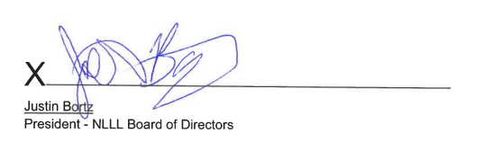
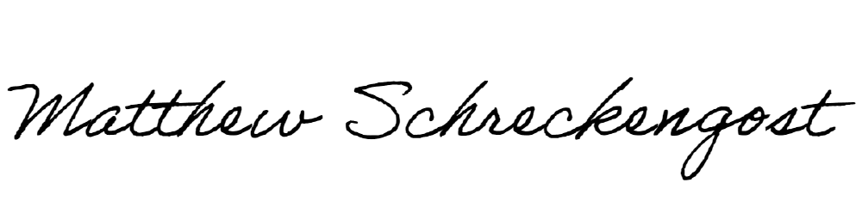
X
Matthew J. Schreckengost
Secretary NLLL Board of Directors
North Lebanon Little League Board of Directors Official Minutes
NLLL Meeting Notes 5/21/25
Attendance
Matt Schreckengost
Bobbi Jean Elder
Marisa Bortz
Mike Burdge
Nate Geibe
Matt Wengert
Matt Cetino
Jacob Kane
Joey Noel
Ben Biggar
John Shireman
Dwayne Elder
New Business Meeting has started at 8:30 pm
- May MEETING MINUTES APPROVED
- Treasury Report 45,568.28 in accounts
- All Stars will not receive uniforms until the family pays buyout money.
- Coaches will request payments from parents.
- Fields: Diamond Tex delivered to Cornwall.
- Concessions Update: Excess food will be sold to North Lebanon Football
- Fundraising: Small games of chance application received and will be completed by John Shireman.
- All Stars Adam Wetzel will be 10U head coach, Jeff Maz, Brittany Pedrick for assistant
- Motion to approve a NLLL affiliated 9U team approved.
Next Meeting -June 12
1
North Lebanon Little League Board of Directors Official Minutes
X
Matthew J. Schreckengost
Secretary NLLL Board of Directors

