NLLL - BOARD MEETING AGENDA

MARCH 13, 2025 / 6:45 PM – 9:00 PM / Orioles Club - Lebanon, PA
544 E Cumberland St, Lebanon, PA 17042

Opening: (5 minutes)
- Call to order
- Roll Call
- Approval of previous minutes
Regular Business:
- Reports from officers (5 minutes)
  - Treasury Report (Burdge & Maz)
- Unfinished business
  - Tball Update - Polling the Coaches, majority rules (2 minutes)
  - Fields: (Marissa, Nate, Dwayne, Matt C.) (20 minutes)
    - Community Field Days – game plan?
    - Field Improvements & Maintenance
      - Any new things to add to the list of repairs?
    - Dumpster at Yost: $90/mth + fees. Can do seasonal holds (Nov – Feb, no fees)
  - Concessions Update (Matt W.) (20 minutes)
    - Updates: Review Concessions Procedures
  - Opening Day Updates - Noel & Team (20 minutes)
    - Basket Fundraiser
    - Pictures
  - Uniforms (5 minutes)
    - Youth Hats for Tball & Rookies players, Adult Hats for Minors & Majors - right?
  - Fundraising (10 minutes)
    - Primary Fundraiser –In-Progress
    - Secondary Fundraiser (Optional) – Gun Bingo Updates (John Shireman)
      - Small Game of Chance License
      - Date/Time/Location?
    - Gin Mill Night?
    - Eagle Hotel Night?
  - Sponsors – Status (Dwayne) (5 minutes)
  - Taxes -- Status (Dwayne) (2 minutes)
  - Safety Update – (Bobbi Jean) (5 minutes)
    - Coach Background Checks and Abuse Awareness are nearly complete
    - Potential bills for deaf player interpreter services
  - Coaches Clinic - 3/22 @ Yost, 10am. Coach Biggar and Noel running. Anyone else? Coach the virgin Tball and Rookie coaches…
  - DONATION FOR KOCHENDERFER? (2 minutes)
- New business items
  - Any?
Closing:
- Announcements and upcoming events
  - Next Board Meeting – Thurs., May 8, 2025. 6:30PM - NL township Pavilion after sub pickups
    - Key Topics: All-Stars (Coaches, Jerseys, Teams, Etc.), Issues, Budget, Etc.
- Adjournment

North Lebanon Little League Board of Directors Official Minutes
NLLL Meeting Notes 3/13/25
Attendance
Matt Schreckengost
Dwayne Elder
Jerome Noel
Marisa Bortz
Justin Bortz
Jeff Mazalewski
Mike Burdge
Nate Geibe
Matt Wengert
Brad Wren
Matt Citino
Jacob Kane
Ben Biggar
New Business Meeting has started at 7:00 pm
- FEB MEETING MINUTES APPROVED
- Treasury Report 57,744.86 in accounts
- Tee ball tournament will be tournament for teams to opt in and fun day for everyone else. Location TBD.
- Fields: Community Day Sat15 Mar north fields, 22 Mar South fields.
  - Dumpster approved at Yost. 90 dollars per month. o Purchase portable mound for Lions Lake
- Concessions Update: Supplies will be purchased Saturday prior to games. One parent from both teams will participate.
- Opening Day Updates: Helicopter, 5 Food Trucks, Picture will be taken on site, Board
Members provide baskets. ($50) o First game 0830, Food truck will start at 0800 / Scheduling Deejay for 300 dollars
  - Three blow ups rental for kids approved.
- Fundraising: Drop off subs and Seltzer order forms at Opening Day, No games scheduled on Sub pick up day.
- Uniforms ordered, no date for delivery • Sponsors:
- Safety Update: List of coaches provided needing certificates.
- Coaches clinic mandatory for first year coaches.
- Donate 300 dollars to Kochenderfer Church for use of church for winter workouts.
- Motion to approve $400 worth of tee-ball bats.
Next Meeting
May 8 2025
1
North Lebanon Little League Board of Directors Official Minutes
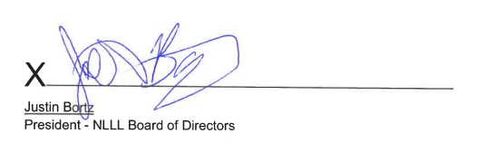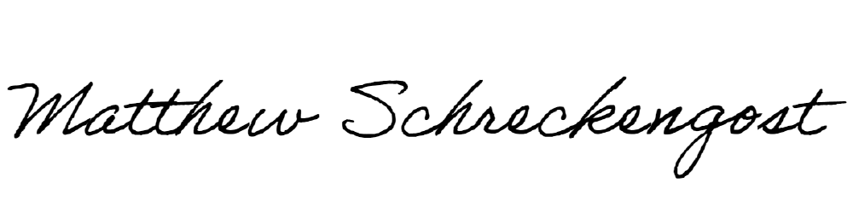
X
Matthew J. Schreckengost
Secretary NLLL Board of Directors

