NLLL - BOARD MEETING AGENDA

June 12, 2025 / 8:00 PM – 9:30 PM / Lions Park - Pavilion
124 Lions Drive, Fredericksburg, PA 17026

Opening: (5 minutes)
- Call to order
- Roll Call
- Approval of previous minutes
Regular Business:
- Reports from officers (20 minutes)
  - Treasury Report (Burdge)
    - How much will All-Stars cost (Uniforms, Tournament Fees, Umps, etc.)?
    - Did new sponsor checks ($25) get sent to applicable families?
  - Concessions Report (Wengert)
  - Safety Report – Coach Complaint (Burdge)
- Unfinished business
  - Fields: (Marissa, Nate, Dwayne, Matt C.) (15 minutes)
    - Field Improvements & Maintenance
      - Summer/Fall Improvement Plans
        - Batting Cage at Jonestown Park,
        - Batting Cage at NLES
        - Batting Cage at NL Township,
        - Raise Plate at J1, Lions & NLT3
        - Fix lips at Lions Park and LEVEL infield (after Sprinklers installed)
        - Build Shelves in Equipment Shed
        - Bring the LIGHTS to Jonestown Park (State grants?)
        - Field dry supply almost exhausted…
        - Need new sheds.. J2 is jacked (leaks/mold)…J1 is bad, Yost door is jacked. Could use bigger sheds at Miners Village, Cornwall Elem, etc.
        - Tractors for Miners Village, Cornwall or Rexmont/Goosetown?
  - Fundraising (10 minutes)
    - Fall Ball Fundraiser – Discount Cards
    - 2026 Secondary Fundraiser – Gun Lottery/Bingo Updates (John Shireman)
      - Small Game of Chance License
      - Date/Time/Location?
  - All-Stars (10 minutes)
    - Tournament Dates/Locations
    - All-Star Tee-Shirts?
  - Taxes -- Status (Dwayne) (2 minutes)
- New business items
  - VOTE on Lebanon City release to ELCO (10 minutes)
  - Fall Ball Plan – Keep In-House? (10 minutes)
  - Season Survey – What questions to ask the public? (5 minutes)
  - 2026 Bylaws Planning (5 minutes)
    - Fill holes regarding: All-Star coach and player selection processes, All Star Tryout Deadlines, All-Star uniform process, Discipline for ejected coached, Coach Conduct Policy, Fix tiebreaker for Rookies for ‘26 (use LL International TB?), 5 pitches for T-Ball playoffs in ‘26, Clear up Call-Up processes, Coach Sign-up Deadlines – how to enforce?, etc.
    - Will need a Bylaws Review Committee again – separate meeting. Don’t drag it out today…
Closing:
- Announcements and upcoming events
  - Next Board Meeting – Thursday, July 10, 2025 (Time/Location: TBD)
    - FINAL BOARD MEETING FOR 2025 ADMINISTRATION
    - Key Topics: Plan for 2026 Budget, Field Improvement Plan, Fall Ball planning, Bylaws Improvements, 2026 Board Elections, Etc.
  - 2025-2026 Board Elections: Monday, August 11, Yost Field, 6PM(?)
    - First meeting for new administration will be on Thursday, August 14.
- Adjournment

NLLL Meeting Notes 6/12/25
Attendance
Justin Bortz
Matt Schreckengost
Dwayne Elder
Bobbi Jean Elder
Jerome Noel
Marisa Bortz
Mike Burge
Matt Wengert
Nate Griebe
Jake Kane
Ben Biggar
Jeff Mazalewski

New Business Meeting has started at 8:00 pm
- Motion to approve minutes from May Meeting Motion to approve , Second
- $38,903.45 total account balance at this time.
- Fall ball fundraiser will discount cards motioned passed.
- Off season field improvements.
  - Nate will fix bleachers at Yost(previously approved)
  - Jerome Noel will level infield at Lions Park
- Motion to approve $300 to build shelving for NL Township shed; passed
- Safety Jeff Maz will not face further punishment for incident at Nationals Royals game
- Vote to release Lebanon City from Little League area. Vote not to release has passed.
- New Committee for BY Law review and changes formed; Mike Burge, Jake Kane, Matt Wengert, Ben Biggar, Dwayne Elder.
- Vote to approve FALL BALL rates for next year; vote passes
- Next Board meeting 10 July.

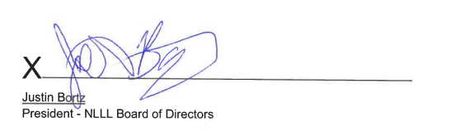
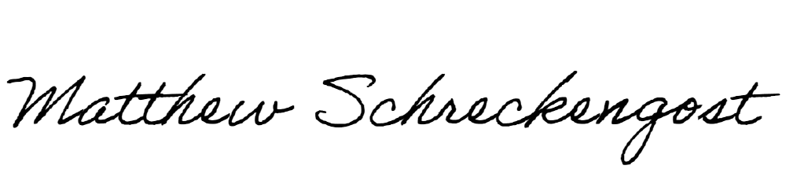
X
Matthew J. Schreckengost
Secretary NLLL Board of Directors

