NLLL - BOARD MEETING AGENDA

JANUARY 9, 2024 / 6:00 PM / Orioles Club - Lebanon, PA
544 E Cumberland St, Lebanon, PA 17042

AGENDA:

Opening: (5 minutes)
- Call to order
- Roll Call
- Approval of previous minutes
Regular Business:
- Reports from officers (10 minutes)
  - Treasury Report (Committee)
    - Any outstanding bills?
    - Review Bank Statements
  - Registration Update (Justin)
    - 233 as of 9:30am today (Tball 71, Rookie 66, Minors 59, Majors 37)
      - Last year at this time we had 239 total w/ 44 majors. Big push came in FEBRUARY (~240 kids registered in FEB last year…hopefully they are aware its closing earlier this year)
    - 2 first-year baseball 7YOs requesting Tball. Yey/Ney?
    - Added an acknowledgement to registration that parents have to read/accept league constitution and bylaws.
- Unfinished business
  - Offseason Workout Update: (Jake)(15 minutes)
    - Program Schedule: Starts 1/24!
    - Program Needs
  - ByLaws – Draft Process Discussion (20 minutes)
  - Evaluations Update (Justin)(10 minutes)
    - We have reservations at the following locations for evaluations:
      - Champs: Saturday, February 8th. 12pm -3pm
        - By reservation only. 20 kids per 30 minute window
      - Champs: Saturday, February 15th. 3pm-6pm
        - By reservation only. 20 kids per 30 minute window
      - Northern Lebanon High School, Saturday, February 22nd. 2pm-6pm
        - We need a batting cage. The auxiliary gym won’t be available. That’s where net used to be.
          - Motion to purchase portable batting cage?
      - Cedar Crest High School - still no date given…
      - We can also Eval at Winter Workouts (if we get a cage…)
  - Concessions Update (Matt W.) (20 minutes)
    - Review Matt’s Document
    - Cash boxes, digital or both?
      - Cant spend 2k, hard no. What about used tablets and WiFi only, no phone line. Much cheaper alternative. NLMFA went this route and acquired Donated iPads.
    - Yost Field Agreement
    - JBT Debit Card goes to Matt W. for Concessions. Done?
  - Opening Day Updates - Noel (5 minutes)
  - Uniforms (3 minutes)
    - Spirtwear Store - Can they support 2 logos? Other sports that use Major League have multiple logos to choose from…
  - Fundraising (5 minutes)
    - Primary Fundraiser – Sub-pick-up Date / Order Forms (Bobbi Jean)
      - Can we get a soft copy of form for review before printing?
    - Secondary Fundraiser (Optional) – Gun Bingo Updates (John Shireman)
    - Texas Roadhouse Night?
  - Sponsors – status (2 minutes)
  - Update on Non-Profit Status, Taxes & Small Game of Chance License (Dwayne) (2 minutes)
  - Fields Discussion (Marissa, Nate, Dwayne, Matt C.) (2 minutes)
    - Field Improvements & Maintenance
      - Any new things to add to the list of repairs?
    - Losing any fields?
      - Fireman’s Park
    - Any fields we can add?
      - Jtown Mennonite School?
      - West Lebanon Township Park
    - Shed Demo @ Lions Park, is it complete? (Mike Burdge)
- New business items
  - Tball Tournament – Keep or replace with fun filled 1 day event? (2 minutes)
    - If strong desire for tournament what about we have a Tball All-Star tournament? 4 teams from each quadrant of the league, best 2-3 kids from each team. Coaches will submit names. Play semifinals in morning, Championship in afternoon (during the 1 day fun filled event…)
  - Trophy Vendor for 2025 – Discussion (Dwayne) (2 minutes)
  - Open Forum Meeting – when and where? (2 minutes) March at the latest.
  - Safety Updates – it looks like we can run coach clearances directly through Little League website. Would this make life easier on the Safety commissioners? (1 minutes)
  - League Year Calendar – Review (2 minutes)
  - Coaching Clinics/Meeting – Feb or March? Who wants to take point?
  - League Meeting - Open to public?
Closing:
- Announcements and upcoming events
  - Next Board Meeting – February 13, 2025. Time TBD. Location TBD
  - Field Work Community Days - Put a plan together (Field crew)
  - REGISTRATION CLOSES ON 2/15/2025! (Late Fee kicks in on 2/1)
- Adjournment

North Lebanon Little League Board of Directors Official Minutes
NLLL Meeting Notes 1/9/25
Attendance
Matt Schreckengost
Dwayne Elder
Bobbi Jean Elder
Jerome Noel
Marisa Bortz
Justin Bortz
Jeff Mazalewski
Mike Burdge
Nate Geibe
Matt Wengert
Brad Wren
Matt Citino
Jacob Kane
New Business Meeting has started at 6:30 pm
- DEC MEETING MINUTES APPROVED
- Treasury Report 34,734.77 in accounts
- Motion to purchase portable batting cage for $350 9 yey 0 ney APPROVED
- Off Season work outs to begin 24 Jan 25 and run up to start of season
- Motion to remove predetermined Assistant Coaches from Majors and Minors and have the coaches be drafted. 6 yey 0 ney APPROVED
- Motion to randomize unevaluated players to teams instead of drafting them 10 yey 0 ney APPROVED
- Motion to return to 2022 logo 8 yey 0 ney APPROVED
Next Meeting
TBD
1
North Lebanon Little League Board of Directors Official Minutes
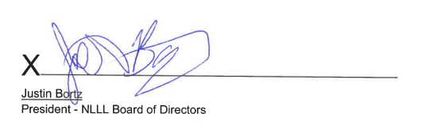

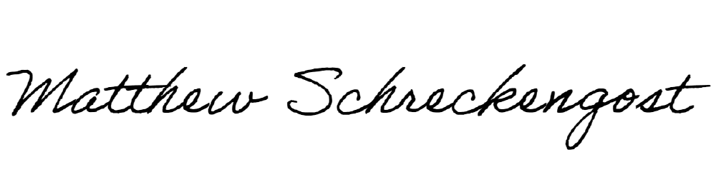
X
Matthew J. Schreckengost
Secretary NLLL Board of Directors
