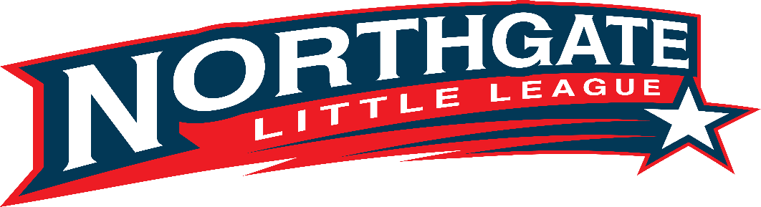 Northgate Little League Code of Conduct 2026
The essential elements of character-building and ethics in sports are embodied in the concept of sportsmanship, and six core principles: trustworthiness, respect, responsibility, fairness, caring, and good citizenship. The highest potential of sports is achieved when competition reflects these six core principles. We, Northgate Little League, have implemented the following Volunteer/Coach and Parent/Player code of conduct for the important message it holds about the proper role said volunteers/participants in our league must demonstrate. All said participants must read, fully understand, and accept our policy in order to participate in our program. As it is stated in our constitution, the board will evaluate any violations or improper conduct that has taken place during any game, practice, or team function. Depending on the severity or frequency of the violation, the Board may assess and order disciplinary action leading up to and including expulsion from Northgate Little League indefinitely. This includes the eligibility of a player and/or coach for consideration to participate in postseason play through the Allstar tournament. The board reserves the right to remove individuals from the consideration of such privilege if any of our guidelines have been violated.
No volunteer, manager, coach, player, family member, or spectator shall at any time violate any of the below standards:
- I will not force my child to participate in sports
- I will remember that children participate to have fun and that the game is for youth, NOT adults.
- I will inform the coach of any physical disability or ailment that may affect the safety of my child or the safety of others.
- I will learn the rules of the game and the policies of the league.
- I (and my guests) will be a positive role model for my child and encourage sportsmanship by showing respect and courtesy, and by demonstrating positive support for all players, coaches, officials, and spectators at every game, practice, or other sporting event
- I (and my guests) will not engage of any kind of unsportsmanlike conduct with any official, coach, player, or parent such as booing and taunting; refusing to shake hands, or using profane language or gestures.
- I will not encourage any behaviors or practices that would endanger the health and well-being of the athletes/minors.
- I will teach my child to play by the rules and resolve conflicts without resorting to hostility or violence.
- I will demand that my child treat other players, coaches, officials, and spectators with respect regardless of race, creed, color, sex, or ability.
- I will teach my child that doing one’s best is more important than winning, so that my child will never feel defeated by the outcome of a game or his/her performance.
- I will praise my child for competing fairly and trying hard, and make my child feel like a winner every time.
- I will never ridicule or yell at my child or other participants for making a mistake or losing a competition.
- I will emphasize skill development and practices and how they benefit my child over winning. I will also de-emphasize games and competition in the lower age groups
- I will promote the emotional and physical well-being of athletes ahead of any personal desire I may have for my child to win.
- I will respect the officials and their authority during games and will never question, discuss, or confront coaches at the game field, and will take time to speak with coaches at an agreed upon time and location.
- I will demand a sports environment for my child that is free from drugs, tobacco, and alcohol and I will refrain from their use at all events.
- I will refrain from coaching my child or other players during games and practices, unless I am one of the approved coaches of the team.
- I will not lay a hand upon, push, shove, or threaten to strike an official, or anyone rather.
- Be guilty of an objectionable demonstration of dissent at an official’s decision by throwing any equipment, or any unsportsmanlike action.
- Be guilty of a physical or verbal attack upon any player, coach, board member, or spectator, which includes the use of vulgar language or putting force upon another.

- Never challenge an umpire’s authority; the umpire shall have the authority and discretion during a game to penalize the offender according to the infraction up to and including expulsion from the game. The same goes for challenging the authority of any board member, if the situation arises that they must get involved in a game situation due to a disagreement or unruly spectator/player/coach behavior.

- Listen to and respect the directions of coaches and umpires during all league activities. Never argue with or allow my parents/players to snow disrespect towards the umpire or coaches. Be positive with your teammates, and don't criticize.

- The following offenses will be enforced with all coaching staff/parents/players/spectators:

Display of poor sportsmanship or disrespectful behavior, including arguing or baiting the umpire

Loss of temper and/or self-control through verbal implications or physical behavior

Demonstrating an obvious lack of integrity by intentional manipulation of the rules

Playing children less than the minimum play requirements per the Little League rules

Use of bad language, including derogatory remarks made toward players, umpires, or other adults

Allowing players to trash talk opponents, umpires, or spectators

Following an umpire to discuss disagreements after the conclusion of a game, intimidate them, or threaten
them in any way (including contest not involving your child)

Provide each player with their minimum amount of play time

Refrain from negatively venting about my child’s coach/team/program on social media, including that of someone else’s child/parent/coach from another team

- As a player, I will:
Encourage good sportsmanship from fellow players, coaches, officials, and parents.

Be a team player and support my teammates.

Be on time and attend every practice and game that I can, and will notify my coaches if I cannot.

Work hard to improve my skills.

Do my best to listen and learn from my coaches.

Encourage my parents to be involved and supportive with my team in some capacity.

Congratulate the other team after each game as a demonstration of sportsmanship.

Refrain from using violence, unfriendly language, or insults to others, including my teammates and coaches.

Be generous when I win and gracious when I lose.

Obey the rules of the game and always work for the good of the team.

Accept the decisions of the coaches and officials with grace and never challenge or question calls.

Refrain from challenging or questioning on-field calls by officials and/or managers and coaches.

Conduct myself with honor and dignity.

Applaud the efforts of my teammates and opponents.

Refrain from throwing any equipment as a result of anger or frustration
Compose myself with control toward my teammates, as well as any coaches/umpires

Refrain from negatively venting about another player or a team on social media

Understand Allstars is a privilege, and if I am selected, this privilege may be revoked due to poor behavior
I (player/coach/parent) also agree that if I fail to abide by the aforementioned rules and guidelines, I will be subject to disciplinary action that could include, but is not limited to the following, based on the infraction:
· Verbal Warning
· Coach/Parental/Player suspension for games (Current Game and The Next game)
· Coach/Parental/Player season suspension (this does include the possible removal of post season privileges if the coach/player has been selected to participate in Allstars)
· Coach/Parental/Player removal from league indefinitely

I therefore agree to the above expectations (depending on my role within the league, sign all that pertain, 1 per family) with my signature(s) below:

Date______________
Print player(s) name(s) - circle sport and division
Player/Participant Print/Signature Player #1
____________________________________________________
Player/Participant Print/Signature Player #2
____________________________________________________
Player/Participant Print/Signature Player #3
____________________________________________________
Player/Participant Print/Signature Player #4
____________________________________________________
Coach/Volunteer Print/Signature
____________________________________________________
Parent/Guardian Print/Signature
____________________________________________________

