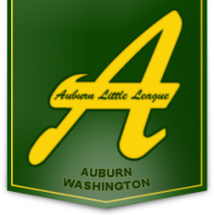
2021 Sponsor Application
Auburn WA Little League
Serving the Youth of Auburn, Washington
Auburn Little League P.O. Box 57 Auburn, WA 98071
Sponsor Business Name: _______________________________________________________

Sponsor Contact Name: _______________________________________________________

Phone: (Bus/Cell) _______________________________________________________

Email: _______________________________________________________

Sponsor Website: _______________________________________________________

Sponsor Mailing Address: _____________________________________________________

ALL STAR Level $1,000 MAJOR Level $500 MINOR Level $250 SUPPORTER $50

MAJORS/JUNIORS TEAM $1400 One-time setup $100

MINORS TEAM $1100 One-time setup $100

INDIVIDUAL TEAM $550

I am interested in having a booth at the Opening Day Ceremonies

$_____________ TOTAL Enclosed (Please make checks payable to Auburn Little League with this form)

______________________________ _________________________________
Print Name of Sponsor Signature of Sponsor

Please complete this form and include two business cards (if available) Auburn Little League is a not for profit 501(c) (3) organization. Our IRS# is 91-1504104. Please retain a copy of this application for your records.
Please mail to our PO Box or call and we will pick it up.

Thank you for your 2021 Sponsorship donation, feel free to contact me at any time. Working together to grow our league while supporting the local businesses of Auburn WA.

Auburn Little League
Sponsorship Coordinator

