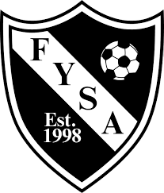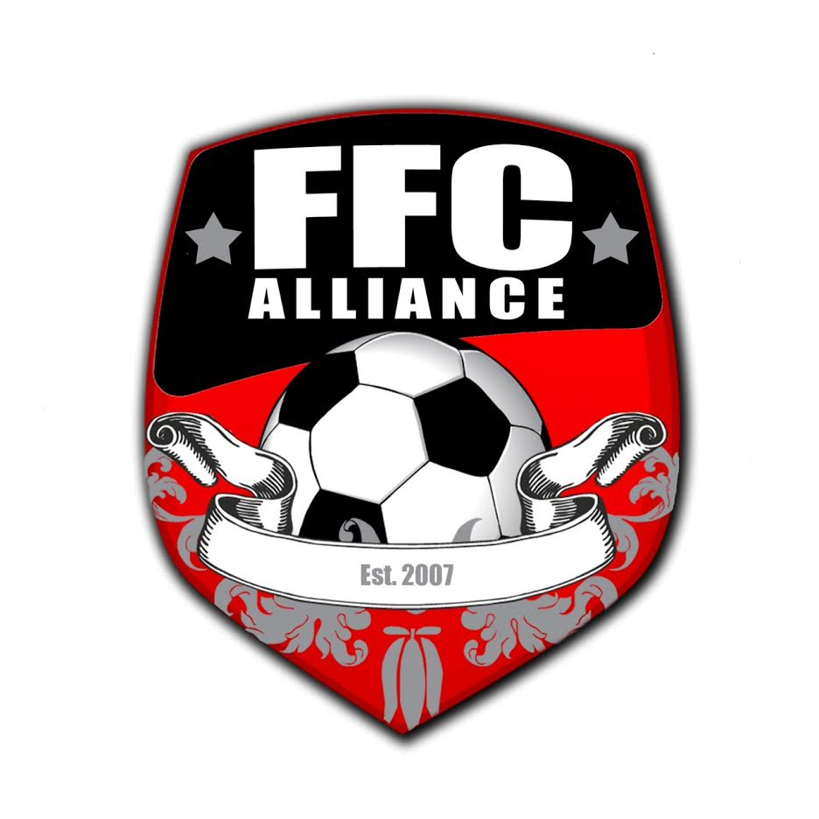

Field Sponsorship Agreement

Area Businesses now have the opportunity to sponsor one of fourteen soccer fields at the Hemphill Park soccer complex. Each 3’x 3’ sponsorship sign will be located near each field entrance. Field sponsors will also be included on a master sign located on the FYSA concession stand, as well as, listed on the FYSA website.
Field Sponsorships will be available for ONE or THREE year commitments.
- 3 Years totaling $1250.00. Can be paid in full, or as follows;
Years 1-2 $450/Year and Year 3 $350.
- 1 Year totaling $500. Must be paid in FULL at the time of agreement.

Contact Person: _______________________________________________

Name of Business/Sponsor: ______________________________________

Address: _____________________________________________________

Business Phone: (___)______________ Cell Phone: (___)______________

Email: _______________________________________________________

Please attach or email the Business/Sponsor’s Logo.

Business/Sponsor Signature:______________________________ Date: _____________

Guidelines for Field Sponsors

- Field Sponsorships will run from Fall of the year purchased through the Spring of the sponsorship term, at which time the business/sponsor will have the first right of refusal to renew their sponsorship at the rate proposed by the FYSA Board at that time.

- FYSA reserves the right to reject any potential business/sponsor, and will not permit the sponsorship of alcohol or tobacco companies.

- FYSA will assume the responsibility for maintaining and repairing signage.

- The business/sponsor will be responsible for any costs incurred for changes made to signage after a proof has been approved (New phone #, Logo, etc.).

- FYSA reserves the right to determine the size, composition, and location of signage.

- All signage will remain property of FYSA and may be available for purchase at the conclusion of the contract.

- The business/sponsor acknowledges that the purpose of FYSA is to promote youth sports in a healthy and positive way.

Thank You for Your Support!

